KWAME NKRUMAH UNIVERSITY OF SCIENCE AND TECHNOLOGY
COLLEGE OF SCIENCE
DEPARTMENT OF COMPUTER SCIENCE


TITLE:
DESIGN AND IMPLEMENTATION OF A MULTI-LINGUAL E-COMMERCE SITE
A Project Work Submitted in Partial Fulfilment of the Requirements For
BACHELOR OF SCIENCE IN COMPUTER SCIENCE
BY:
WILLIAM KPABITEY KWABLA (2565814)

SUPERVISOR:
MR. KWAKU AGYAPONG PABBI
May, 2018
©

DECLARATION
I hereby declare that this project work is the result of my original research and that no part of it has been presented to the university or elsewhere. As such, all use of previously published work (from magazines, internet and journals) has been acknowledged within the main report to an entry in the references list.

AUTHOR: William Kpabitey Kwabla SIGNATURE: ……………………….
STUDENT ID: 2565814 DATE: ……………………………….
SUPERVISOR: Mr. K.A Paabi SIGNATURE: ………………………
H.O.D: Dr. M. Asante SIGNATURE: ………………………
DATE: ……………………………….

ACKNOWLEDGEMENT
I have learned a lot and really enjoyed working on this project. I thank God Almighty who by His Grace and Mercy I have been able to complete this project.
My appreciation to my parents and guardians who have motivated me in diverse ways to come this far in my educational journey.
I am deeply indebted to my supervisor, Mr. KWAKU AGYAPONG PABBI, for his valuable guidance, stimulating suggestions, patience and for encouraging me to go ahead with my project. Thanks to him for his advice and useful feedback regarding the final year project either in documentation parts or technical parts. In addition, his guideline and briefing on how to produce a good quality report for this project also provided to me. I am grateful.
I would like to sincerely thank all those who helped me with their valuable support during the entire process of this dissertation.

ABSTRACT
The objective of this project is to develop a general-purpose multi-lingual e-commerce store where any product (such as books, CDs, computers, mobile phones, electronic items, and home appliances) can be bought from the comfort of home through the Internet.
However, for implementation purposes, this project will deal with an Information Technology (IT) online book store. It provides the user with different catalog of IT books available for purchase in the store.
In order to facilitate online purchase a shopping cart is provided to the user. The system is implemented using a three-tier approach, with a backend PostgreSQL database, a middle tier of Django, and a web browser as the front-end client.
This document will discuss each of the underlying technologies to create and implement a multi-lingual e-commerce website and outlines all the process followed to come up with the application that is from analysis to testing.

DECLARATION i
ACKNOWLEDGEMENT ii
ABSTRACT iii
LIST OF ABBREVIATIONS viii
LIST OF TABLES xi
LIST OF FIGURES xii
CHAPTER ONE 15
1.0 INTRODUCTION 15
1.1 BACKGROUND TO THE STUDY 15
1.2 OVERVIEW OF E-COMMERCE 16
1.3 PROBLEM STATEMENT 18
1.4 MOTIVATION FOR THE PROJECT 19
1.5 GENERAL OBJECTIVES OF THE STUDY 19
1.6 SPECIFIC OBJECTIVES OF THE STUDY 19
1.7 SCOPE OF PROJECT 20
1.8 DEFINITION AND EXPLANATION OF TERMS. 22
1.9 PROJECT ACTIVITY PLANNING 24
1.10 PROJECT BENEFICIARIES 27
1.11 LIMITATIONS OF THE PROPOSED SYSTEM 28
1.12 STRUCTURE OF REPORT (CONTENT OF VARIOUS CHAPTERS) 29
1.13 CONCLUSION 31
CHAPTER TWO 32
2.0 LITERATURE REVIEW 32
2.1 INTRODUCTION 32
2.2 OVERVIEW OF E-COMMERCE AND ONLINE SHOPPING 32
2.3 CURRENT RESEARCH ISSUES IN E-COMMERCE BUSINESS 33
2.4 PAST TECHNOLOGIES THAT WERE EMPLOYED IN ECOMMERCE 34
2.5 PRESENT TECHNOLOGIES AVAILABLE IN FOOD ORDERING AND TABLE RESERVATIONS 37
2.6 HIGHLIGHTS OF SIMILAR IMPLEMENTATIONS FROM VENDORS 39
2.6.2 WALMART 41
2.6.3 JUMIA GHANA 42
2.6.4 AHONYA 43
2.6.5 AZALIABOOKS 44
2.6.6 ESHOPAFRICA 45
2.6.7 ZOOBASHOP 46
2.6.8 TELEFONIKA 47
2.6.9 CHEKI 48
2.6.10 BAAHE 49
2.7 REVIEW OF EXISTING IMPLEMENTATIONS (DESIGNS AND FEATURES) 50
2.8 BENEFITS AND CHALLENGES OF IMPLEMENTATIONS 57
2.8.1 BENEFITS 57
2.8.2 CHALLENGES 58
2.9 TRENDS IN THE INDUSTRY / FUTURE DIRECTION 58
2.9.1 DATA-AS-A-SERVICE AND ECOMMERCE 59
2.9.2 CHATBOTS 59
2.9.3 DRONE DELIVERY 60
2.9.4 DROID DELIVERY 61
2.9.5 AUGMENTED REALITY TECHNOLOGY 62
2.9.6 BLOCKCHAIN 63
2.9.7 BITCOIN 63
2.10 SUMMARY 64
CHAPTER THREE 65
3.0 PROJECT METHODOLOGY 65
3.1 INTRODUCTION 65
3.2 DEVELOPMENT METHODOLOGY 65
3.2.1 WATERFALL METHOD 66
3.2.2 INCREMENTAL METHOD 66
3.2.3 SPIRAL METHOD 66
3.2.4 PROTOTYPING METHOD 67
3.3 INCREMENTAL DEVELOPMENT METHODOLOGY 67
3.3.1 ADVANTAGES OF THE INCREMENTAL DEVELOPMENT METHODOLOGY 69
3.3.2 LIMITATIONS OF THE INCREMENTAL DEVELOPMENT METHODOLOGY 70
3.4 CASE STUDY AREA / PROJECT CASE STUDY 70
3.5 DEVELOPMENT TOOLS 71
3.6 SUMMARY 77
CHAPTER FOUR 77
4.0 SYSTEMS ANALYSIS AND DESIGN 77
4.1 INTRODUCTION 77
4.2 GENERAL SYSTEM ARCHITECTURE 77
4.2.1 ONE TIER ARCHITECTURE 79
4.2.2 TWO TIER ARCHITECTURE 80
4.2.3 THREE TIER ARCHITECTURE 81
4.2.4 N-TIER ARCHITECTURE 82
4.3 GENERAL APPLICATION ARCHITECTURE 83
4.3.1 THE MODEL-VIEW-CONTROLLER DESIGN PATTERN 83
4.4 REQUIREMENT SPECIFICATION 85
4.4.1 FUNCTIONAL REQUIREMENTS 86
4.4.2 NON-FUNCTIONAL REQUIREMENTS 87
4.5 USE CASE MODELLING 89
4.5.1 USE CASE DIAGRAMS 89
4.5.2 SEQUENCE DIAGRAM 100
4.5.3 ACTIVITY DIAGRAM 105
4.5.4 CLASS DIAGRAM 107
4.6 DATABASE DESIGN 108
4.6.1 ENTITY RELATIONSHIP MODEL 109
4.7 NORMALIZATION 110
4.7.1 NORMALIZATION RULE 111
4.8 USER INTERFACE DESIGN 113
4.9 SUMMARY 116
CHAPTER FIVE 117
5.0 SYSTEM IMPLEMENTATION 117
5.1 INTRODUCTION 117
5.2 MAPPING LOGICAL DESIGN ONTO PHYSICAL PLATFORM 117
5.2.1 HARDWARE REQUIREMENTS 118
5.2.2 SOFTWARE REQUIREMENTS 118
5.3 CONSTRUCTION 119
5.3.1 USER INTERFACES 121
5.4 TESTING 135
5.4.1 UNIT TESTING 136
5.4.2 INTEGRATION TESTING 136
5.4.3 SYSTEM TESTING 137
5.4.4 ACCEPTANCE TESTING 138
5.4.3 RESULTS OF TESTING 138
5.5 EVALUATION OF THE PROJECT 141
5.5.1 EVALUATION OF SOLUTION 142
5.5.2 EVALUATION OF METHODOLOGY 143
5.6 CONCLUSION 143
CHAPTER SIX 144
6.0 FINDINGS AND CONCLUSION 144
6.1 INTRODUCTION 144
6.2 SUMMARY OF PROBLEMS 144
6.3 ACHIEVEMENTS AND CHALLENGES 145
6.3.1 ACHIEVEMENTS 145
6.3.2 CHALLENGES 146
6.4 FUTURE WORK 146
6.5 RECOMMENDATIONS 146
6.6 CONCLUSION 147
REFERENCES 149
APPENDIX 153

LIST OF ABBREVIATIONS
1NF – FIRST NORMAL FORM
2NF – SECOND NORMAL FORM
3NF – THIRD NORMAL FORM
ATM – AUTOMATED TELLER MACHINE
API – APPLICATION PROGRAMMER INTERFACE
ANSI – AMERICAN NATIONAL STANDARDS INSTITUTE
ASC X12 – ACCREDITED STANDARDS COMMITTEE X12
B2C – BUSINESS TO CONSUMER
B2B – BUSINESS TO BUSINESS
B2G – BUSINESS TO GOVERNMENT
C2C – CONSUMER TO CONSUMER
BCNF – BOYCE AND CODD NORMAL FORM
CSS – CASCADING SYTLE SHEETS
CRM – CUSTOMR RELATIONSHIP MANAGEMENT
CD – COMPACT DISK
CERN – EUROPEAN ORGANIZATION FOR NUCLEAR RESEARCH
D2C – DIRECT TO CONSUMER
ERD – ENTITY RELATIONSHIP DIAGRAM
EDI – ELECTRONIC DATA INTERCHANGE
FAQ – FREQUENTLY ASKED QUESTIONS
GPS – GLOBAL POSITIONING SYSTEM
HTML – HYPERTEXT MARKUP LANGUAGE
HTTP – HYPER TEXT TRANSFER PROTOCOL
IDE – INTEGRATED DEVELOPMENT ENVIRONMENT
LTS – LONG TERM VERSION
MVC – MODEL, VIEW, CONTROLLER
MVT – MODEL, VIEW, TEMPLATE
NET – NETWORK
NSF – NATIONAL SCIENCE FOUNDATION
ORDBMS – OBJECT RELATIONAL DATABSE MANAGEMENT SYSTEM
OO – OBJECT ORIENTED
ORM – OBJECT RELATIONAL MAPPER
PDF – PORTABLE DOCUMENT FORMAT
PC – PERSONAL COMPUTER
RC – RELEASE CANDIDATE
SQL – STRUCTURED QUERY LANGUAGE
SRS – SOFTWARE REQUIERMENTS SPECIFICATION
SVG – SCALABLE VECTOR GRAPHICS
SSL – SECURE SOCKET LAYER
SGML – STANDARD GENERALIZED MARKUP LANGUAGE
UPC – UNIVERSAL PRODUCT CODE
UML – UNIFIED MODELLING LANGUAGE
UI – USER INTERFACE
URL – UNIFORM RESOURCE LOCATOR
VAN – VALUE ADDED NETWORK
W3C – WORLD WIDE WEB CONSORTIUM
WSGI – WEB SERVER GATEWAY INTERFACE
XHTML – EXTENSIBLE HYPERTEXT MARKUP LANGUAGE
XML – EXTENSIBLE MARKUP LANGUAGE

LIST OF TABLES
Table 1.0: The time interval for the development of the system. 26
Table 2.0 Review of features of existing implementations 50
Table 4.0 Use case symbols and their meanings. 90
Table 4.1 Customer Registration 93
Table 4.2 Customer login 93
Table 4.3 View Products 94
Table 4.4 Placing Orders 95
Table 4.5 Shop Manager Login 96
Table 4.6 Edit Products 97
Table 4.7 Edit Product Category 98
Table 4.8 Report Generation 99
Table 4.9 Send SMS/Email 100
Table 4.10 Sequence diagram symbols and their meanings 101
Table 5.0 Table of Hardware Requirements 119
Table 5.1 Table of Software Requirements 119

LIST OF FIGURES
Figure 1.0: Gantt chart Representation of the Project Activity Planning 27
Figure 2.0 Amazon Homepage 40
Figure 2.1 Walmart Homepage 41
Figure 2.2 Jumia Ghana Homepage 42
Figure 2.3 Ahonya Homepage 43
Figure 2.4 Azaliabooks Homepage 44
Figure 2.5 eShopAfrica Homepage 45
Figure 2.6 Zoobashop Homepage 46
Figure 2.7 Telefonika Homepage 47
Figure 2.8 Cheki Homepage 48
Figure 2.9 Baahe Homepage 49
Figure 3.0 Incremental Development Methodology 69
Figure 4.0 One-Tier Architecture (Standalone Application) 79
Figure 4.1 Two-tier Architecture (Client-Server Application) 80
Figure 4.2 Three-Tier Architecture (Web-Based Application) 81
Figure 4.3 N-Tier Application (Distributed Application) 82
Figure 4.4 E-Shopper Application Architecture (MVT Application Design Patten) 85
Figure 4.5 Use case diagram for customer 91
Figure 4.6 Use case diagram for shop owner 92
Figure 4.7 Use case diagram for system 92
Figure 4.8 Sequence diagram for the customer use case 103
Figure 4.9 Sequence diagram for the manager use case 104
Figure 4.10 Activity diagram for the customer’s use case 105
Figure 4.11 Activity diagram for the manager’s use case 106
Figure 4.12 Class diagram for the e-commerce system 108
Figure 4.13 ER diagram for the customer model 110
Figure 4.14 Normalized database for all tables 113
Figure 5.0 Database Schema for categories table 119
Figure 5.1 Database Schema for product table 120
Figure 5.2 Database Schema for orders table 120
Figure 5.3 Database Schema for Customer Profiles table 120
Figure 5.4 Database Schema for Product Review table 121
Fig 5.5 Homepage of the application with a slideshow of some of the books sold. 124
Figure 5.6 Homepage with a dropdown of 21 languages available for customers to choose before they start shopping. 124
Fig 5.7 Homepage and URL after Spanish is selected. 125
Fig 5.8 Shop or Product list page with Categories 125
Figure 5.9 Product Detail Page 126
Figure 5.10 Cart Page 126
Figure 5.11 Checkout Page with cart. 127
Figure 5.12 Checkout Page with empty cart in Spanish. 127
Figure 5.13 Proceed to Payment Page 128
Figure 5.14 PayPal Payment page 128
Figure 5.15 PayPal Successful Payment page 129
Figure 5.16 Successful Payment Page 129
Figure 5.17 Cancelled or Unsuccessful Payment Page. 130
Figure 5.18 Customer Register Account Page 130
Figure 5.19 Customer Login Page 131
Figure 5.20 Customer Create Profile Page 131
Figure 5.21 Customer Profile Dashboard 132
Figure 5.22 Customer Logout Page 132
Figure 5.23 Live Chat Support 133
Figure 5.24 Contact Us Page 133
Figure 5.25 Successful Contact Us Message sent page 134
Figure 5.26 Shop Owner or Manager Login Page 134
Figure 5.27 Shop Manager or Owner Dashboard to accept orders, add products, add categories, add coupons with Analysis of people visiting the website 135
Figure 5.28 Testing for a Customer checkout details. 139
Figure 5.29 Testing for a Customer login details. 140
Figure 5.30 Testing for a Customer Register details. 140
Figure 5.31 Testing to ensure that the admin enters the right login in details…………………………………………………………………………………….141

CHAPTER ONE

1.0 INTRODUCTION
This chapter will introduce the project concept, outline the general objectives as well as the specific objectives that will eventually lead to the development of the project and the scope of the project. The chapter will also outline the timeline for the development of the project; specifying when each developmental phase will start and end, the limitations of the project and finally describe briefly what the subsequent chapters will entail.

1.1 BACKGROUND TO THE STUDY
Technology has not only affected our mode of communication, transportation and education. It has also given businesses (buying and selling) a touch of the magic wand. Technology has made it easy for people to conduct businesses from the comfort of their mobile devices. Some buy whiles others also sell online to a vast number of customers worldwide.
Ecommerce began to gain traction in the early nineties and has grown rapidly ever since. Ecommerce offers many advantages over traditional brick and mortar stores. Consumers can easily search for the products and services they are looking for. Online retailers, or e-tailers, are incredibly convenient, in that they are available twenty-four hours a day. Today, most brick and mortar retailers such as Walmart also have an ecommerce option. While an ecommerce consumer does not get the immediate gratification of having their purchase immediately in hand, they can place orders from the comfort of their own home without having to deal with the hustle and bustle of a shopping mall. Some stores offer a combination, allowing a customer to order their merchandise online, and pick it up almost immediately at their local store. E-tailer sites like Amazon paved the way for many others. Amazon is arguably one of the most successful e-tailer sites around. It began as an online bookstore with a primary focus on the customer experience. It was so successful that it did not take long before it expanded beyond the sale of books. Today, you can order almost anything from Amazon. They have also crossed over from strictly being an e-tailer to an e-tailer and subscription site with its Amazon Prime offering.
Online shopping remains the most popular type of e-commerce. Sellers create online or mobile stores which are similar to face-to-face retail shops. Buyers visit these stores, browse through items available, and if they like the items’ quality and price, they will select it, make payments online and the goods or services will be delivered to them. Currently, the global leader in this space is www.amazon.com, which does not only serve as a seller but also creates opportunity for others to use its platform to sell their goods and services.

1.2 OVERVIEW OF E-COMMERCE
E-commerce (electronic commerce or EC) is the buying and selling of goods and services, or the transmitting of funds or data, over an electronic network, primarily the internet. E-commerce covers a wide range of businesses ranging from retail sites, music sites, auction sites or the exchange of goods and services between corporations.
The beginnings of e-commerce can be traced to the 1960s, when businesses started using Electronic Data Interchange (EDI) to share business documents with other companies. In 1979, the American National Standards Institute developed ASC X12 as a universal standard for businesses to share documents through electronic networks. After the number of individual users sharing electronic documents with each other grew in the 1980s, in the 1990s the rise of eBay and Amazon revolutionized the e-commerce industry. Consumers can now purchase endless amounts of items online, both from typical brick and mortar stores with e-commerce capabilities and one another.
There are four types of E-Commerce business models. The four types of E-Commerce business models are B2C which stands for Business-to-Consumer, B2B which stands for Business-to-Business model, C2C which stands for Consumer-to-Consumer, and B2G which stands for Business-to-Government. When working, selling, or buying with any of these models, it is important to be familiar with what each model contains. B2C represents most of E-Commerce websites. Businesses that sell to consumers are considered B2C. Online stores and shopping are all examples of B2C. B2B are businesses selling products to other businesses. B2B are usually larger companies that are supplying a service to other businesses. For example, office max is a business that sells office supplies to other businesses. Also, they are almost always doing business over the web. C2C is a website that consumers sell to other consumers. People are brought together to sell and buy products for this model. For example, eBay is a common place for consumers to sell and buy items. B2G consists of businesses working with the government. For example, the IRS is a way for businesses to pay their taxes through the web. These four E-Commerce business models are very common in this day-in-age.
The benefits of e-commerce include its around-the-clock availability, the speed of access, the wide availability of goods and services for the consumer, easy accessibility, and international reach. Its perceived downsides include sometimes-limited customer service, consumers not being able to see or touch a product prior to purchase, and the necessitated wait time for product shipping.
The e-commerce market continues to grow: Online sales accounted for more than a third of total U.S. retail sales growth in 2015, according to data from the U.S. Commerce Department. Web sales totaled $341.7 billion in 2015, a 14.6% increase over 2014. E-commerce conducted using mobile devices and social media is on the rise as well: Internet Retailer reported that mobile accounted for 30% of all U.S. e-commerce activities in 2015. And according to Invesp, 5% of all online spending was via social commerce in 2015, with Facebook, Pinterest and Twitter providing the most referrals. (Zaroban, 2018)

1.3 PROBLEM STATEMENT
A key role of e-commerce over brick-and-mortar retail is the ability to easily expand your business's geographical borders. But according to a PayPal report, U.S.-based small businesses could be doing a lot more to reach global online shoppers. Modern e-commerce websites are restricted to more often than not; to the language of the country the developers are from. In particular, e-commerce merchants aren't tailoring the shopping experience to local customers outside their home country: Only 19 percent translate their website copy from English, and less than half list foreign currency options on their sites. Global customers are much more likely to make purchases when product descriptions and prices are available in their native language/currency, PayPal found.
The E-commerce business in Ghana is growing at a fast pace and most of these Ghanaian online retailers face the same language barrier problem because they develop their online shops only in English. This limits the market share and customer base because Ghana is a diverse country with different people from different countries who speak different languages.
These problems are faced by Online Shoppers and it is my hope that by the end of this project, all these issues would be addressed and resolved.

1.4 MOTIVATION FOR THE PROJECT
Few years ago, I was trying to buy an old book online and all the websites I visited were in languages of the owners and none of the online shops was available in English even though the book was written by an English author. None of them also provided alternative languages for me to choose from. I had to give up on buying the book because of the language barrier. Upon thorough research I realized almost most all online shops are developed only in the native languages of the owners and this makes the owners lose customers from other countries who do not understand the language.
I challenged myself to solve this problem by developing a multilingual e-commerce website for my final year project which will make it easier for everyone to shop online without language being a barrier and also provide shop management with an effective and efficient system to handle client’s data, request, maximize income through the expansion of the shops to different customers around the globe.

1.5 GENERAL OBJECTIVES OF THE STUDY
The main aim of the project is to develop a simple and easy-to-use online shopping system with the functionality of making the shop available in different languages for different people across the globe.

1.6 SPECIFIC OBJECTIVES OF THE STUDY
In order to attain the general objective, the following list of specific objectives is set:
- To make buying easier for online shoppers by making the website available in
different languages for them.
- To make selling easier by providing shop management with an effective and efficient system to handle client’s data and request.
- To help expand the market of shops and make it available to a worldwide audience.
- To provide customers access to discounts and special pricing.

1.7 SCOPE OF PROJECT
This project is developed for three types of users and they are Visitors, Customers (Registered Member) and Online shop owners. The application consists of following main sections (inclusions):

VISITOR FEATURES
- Multi Lingual (English, British English, Spanish, French, Chinese, Dutch, German,
Portuguese, Japanese, Welsh, Italian, Hebrew, Korean, Russian, Hindu, Greek, Catalan,
Irish, Turkish, Arabic, Afrikaans)
- View Home Banners or Slide Show Gallery
- Browse Products
- View Product Details
- View FAQs
- Become a Member through Registration process
- View Static Pages (Contact Us, About Us, Privacy Policy, Disclaimer, Terms & Conditions)
- Debit and Credit Card Payments with PayPal
- Coupons
- Live Chat Support
- Product Recommendations

1.7.2 REGISTERED MEMBER PANEL
- Login to site
- Manage Account
- My Profile
- My Orders
- Newsletter
- Buy Product (Checkout)
- Logout

1.7.3 ONLINE SHOP OWNERS
- Login
- Dashboard
- Administrator User Management
- Site Member (Customer) Management
- Product Management
- Banner Manager
- Order Manager
- Shipping Management
- FAQ Management
- Email Templates
- Static Page Content Management
- Location Management (Country/State/City)
- System Settings
- Logout

1.7.4 EXCLUSIONS FROM SCOPE
The following is a list of activities that are clearly excluded scope of development for this project:
- Mobile Money Payments.

1.8 DEFINITION AND EXPLANATION OF TERMS.
E-commerce: The act of doing business transactions over the Internet or similar technology.
Brick-and-mortar store: A conventional store with a physical presence.
Brokerage site: A type of Web site that brings buyers and sellers together to facilitate transactions between them; the site earns revenue in the form of commissions on sales made via the site.
Digital wallet: A program or online service that holds a buyer’s information (such as electronic payment, billing, and shipping information) that can be used to speed up online purchase transactions.
Dot-com: An Internet-only store with no physical presence.
Meta tag: A special HTML or XHTML tag containing information about a Web page that is added by the person creating the Web page and is used primarily by search sites.
Online auction site: A Web site where potential buyers bid on an item and, at the end of a set time period, the highest bidder buys the item as long as all bidding criteria (such as minimum selling price) have been met.
Online payment service: A type of payment service accessed via the Internet and used to make electronic payments to others, such as via deposited funds, a bank account, or a credit card.
Search engine optimization (SEO): The process of evaluating a Web site and making changes to improve search site results. Search engine optimization is one way that a website can make themselves more easily found online when being searched for through search engine websites like Google.
Shopping cart software: E-commerce software designed to add ordering capabilities to an existing Web site.
Storefront software: E-commerce software that facilitates the creation of an online store.
Subscription site: A site that sells access to its online content.
Order: This is a request to supply or deliver food booked by diners far in advance before due date and time.
Back-end: This is a specialized subordinate process or a module that is not directly accessible by the user. This part of the application allows the administrator to interact with the software. This part of the software is where menu details that would be available to the user to place order is entered. Reports generation and basic managerial operations occur at the back-end. We usually refer to this part of the system as the server side of the software application.
Front-end: In software development, front-end is that part of the software that the user interacts with in performing his or her functions. It usually consists of Graphical User Interface which makes it easy for users to either login, place food order, reserve a table etc. It is sometimes referred to as the client side of the application
Responsive display: Is an approach to web design and development whereby websites and web applications respond to a screen size of the device on which they are being accessed. The response includes layout changes, rearrangement of content, and in some cases selective display or hiding of content elements. Using a responsive web design approach, you can optimize web pages to achieve great user experience on a range of devices from smartphones to desktop.

1.9 PROJECT ACTIVITY PLANNING
Planning is an essential part of any successful web design project. By outlining the scope of your project at its onset, you will be better equipped to identify and avoid roadblocks that would otherwise steer your progress off track. One of the most effective tools for planning your project is the schedule. A project schedule allows you to outline, assess, and communicate the essentials of a job, and includes its deliverables, timeframe, and the resources allotted to individual tasks.
The Gantt chart is one of the most popular scheduling documents for managing projects in the creative industry. A Gantt chart is a simple two-dimensional schedule that outlines the anticipated timeline of your client’s project. They are most suitable for jobs spanning a few months.
This project is expected to span a period of six months starting from the 20th October, 2017 to 20th March, 2018 by which I hope to have finished the project and its associated documentation.
This project is expected to go through these development phases before its completion:
- Analysis Phase
This phase involves studying the existing systems which will help in getting clearly the requirements for the proposed system. This phase is where the team will define the problem it intends to solve. I will use the various techniques in information gathering to obtain user and system requirements.

- Design Phase
After the necessary requirements for the proposed system are gathered from the analysis phase, the design phase then sets in. This phase basically involves detailed specification of the proposed system. This phase is where most of the work will be done and it will include such things as coding and database design of the proposed system.
- Implementation and Testing Phase
During this phase, the newly developed system is tested and implemented. In implementing this system, the actual system is installed on a selected vender where the various configuration will be set by the administrator. During the system testing, I shall talk about unit testing, Incremental integration testing, integration testing, functional testing and the whole system testing. This phase also includes associated documentation of the new system that would be delivered to our supervisor.

Table 1.0: The time interval for the development of the system.
PHASE | TIME INTERVAL
Analysis | 20th October, 2017 – 14th November, 2017
Design | 23rd November, 2017 – 23rd December, 2017
Coding | 1st January, 2018 – 15th April, 2018
Implementation | 16th April, 2018 – 30th April, 2018
Documentation | 14h October, 2017 – 30th May, 2018

Activities
Analysis Phase
Design Phase
Coding
Implementation /Testing
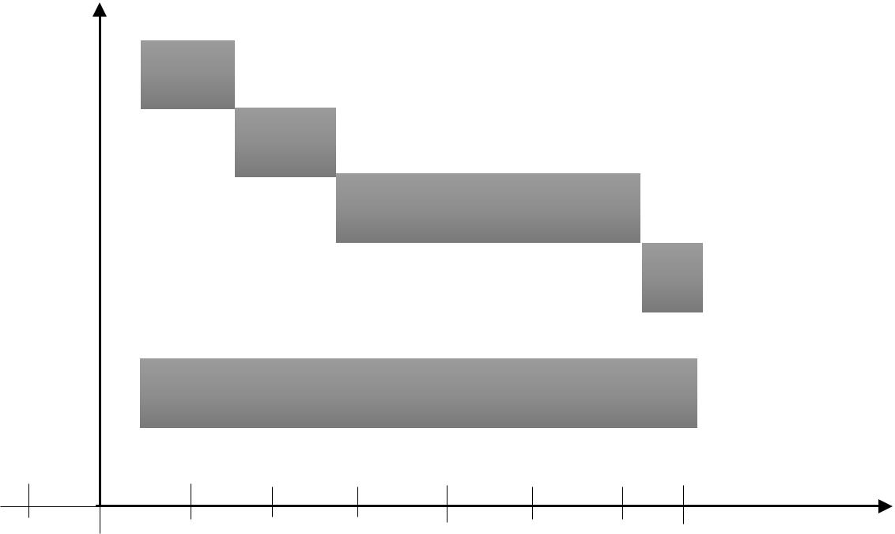

Documentation

Sept Oct Nov Dec Jan Feb Mar Apr May Months


2017 2018

Figure 1.0: Gantt chart Representation of the Project Activity Planning

1.10 PROJECT BENEFICIARIES
At the end of this project, I hope to have acquired some benefits for:
- Customers who do not understand the English language since the project has a feature that converts the content of the entire website to his/her desired language. It also offers them convenience to shop 24 hours a day and seven days a week without having to leave their homes or offices.
- Shop Owners are also huge beneficiaries of the system. Since they are able to explore other markets and countries by putting their shops on the electronic highway making people from different countries access the website and patronize their products or services without limiting them to only a physical location of their store. This also helps owners cut down cost because they don’t need to build, staff or maintain a store or print and distribute mail order catalogues. Automated order tracking and billing systems cut additional labor costs.
I also perceive the following benefits after successful completion of the project:
- To have enhanced my programming skills since this project will expose me to the use of some new programming techniques.
- To have better insight as to what a software system documentation really entails and how to document properly.
- To have developed better working ethics including being time conscious as well as developing the right attitude towards team work.

1.11 LIMITATIONS OF THE PROPOSED SYSTEM
Every research has challenges and this project is no exception and some of the limitations of this project are:
- The application will require internet connection and also the user must be a computer literate. The Owners has to incur debt in hosting their site online shop so that people can browse the site and place orders.
- The set back of the system is that the customers targeted are adults with access to computer systems and mobile phones with internet capabilities. People who cannot afford these resources cannot engage in shopping online.
- Time Constraint is also going to be a major challenge in developing this system. I will be doing everything possible to finish the project on time so as to submit the final work and documentation to my supervisor. Within this six (6) month of developing the system, there will be things that will happen along the way which will be inevitable. Going for lectures, writing mid-semester examinations, assignments and writing of examination will all interfere with the smooth development of this system and might cause delay in delivery of the final output.
- Because the system will be responsive, I need to acquire some tablets, android phones, laptops etc. during the system development in order to do the testing to see that it is actually working. All these hardware parts have to be either bought or borrowed from friends because I as the developer does not have most of the equipments.

1.12 STRUCTURE OF REPORT (CONTENT OF VARIOUS CHAPTERS)
This document contains six chapters including this chapter. The following describes the structure of the report which will comprise of the contents of the various chapters in the system development.
Chapter one entails introduction to the proposed system, motivation for the proposed system, the general objectives as well as specific objectives to be achieved at the end of the project. It also consists of the project scope as to who the proposed system applies to as well as what the system can do and what it cannot do. This chapter consist of the project activity planning which details out the allocated time scheduled for each development stage. This include a Gantt chart giving a pictorial view of the project activities.
Chapter two introduces literature review where an overview of the subject area will be discussed. Past and present technologies that applies to the proposed system will also be discussed. This chapter will also include the review of existing implementations including highlights from similar vendors. The benefits and challenges of implementing the system will also be discussed. This chapter concludes with a summary of the chapter content.
In chapter three, the development methodologies and development tools that will be used in the design and implementation of the system will be looked at. A brief description of the various methodologies including the advantages, limitations and also the general system architecture of the proposed system. I will also introduce the programming language we shall use in developing the backend as well as the frontend of the system.
Chapter four will explain the system’s analysis and its design. This chapter will contain details of the various methods used in requirements capture and specification such as interviews, observations, questionnaires, etc. It will also include details on the system and application architectures. The proposed system’s requirements specification that is, the event driven applications will be looked at in this chapter. This will take a critical look at the functional and non-functional requirements of the proposed system. Use Case modelling including the various diagrams which will be used where appropriate will be explained. The proposed system’s database design and its associated details together with the user interface will be looked at as well.
Chapter five will introduce the implementation of the system. It will talk about mapping logical design onto physical form as well the various construction involved. The results of testing the system will be explained in this chapter. Evaluation of the project will also be detailed out in this chapter.
Chapter six which happens to be the final chapter will consist of findings and conclusion. This will include summary of various problems faced in the development of the system, achievements and challenges, recommendations as well as enhancements that can be made to the system in future.

1.13 CONCLUSION
In conclusion, this chapter basically introduced us to the proposed system that would be develop for E-commerce Businesses. A look at the general objective as well as the specific objectives expected to be accomplished at the end of the project, the scope which basically talked about the inclusions and exclusions of the proposed system as well as who the system applies to and the project activity planning where the various phases in the development was introduced. The limitations of the proposed system were also looked at in this chapter as well as using Gantt chart to represent the project activity and the time interval for the completion of the project. The chapter also talked about the structure of this report which details the content of the various chapters.

CHAPTER TWO

2.0 LITERATURE REVIEW

2.1 INTRODUCTION
Literature Review is a summary of previous research on a topic and can also be a part of a larger report of a research project. This chapter explains facts or statements which will be used as guidance in developing the system. It will include reviewing the subject area, past and present technologies, research issues that are currently available, highlights of similar implementation from vendors, review of existing implementations, benefits and challenges of implementations and the trends in the industry or future directions for E-Commerce.

2.2 OVERVIEW OF E-COMMERCE AND ONLINE SHOPPING
Before setting out a business, one needs to know his target audience or market. These business transactions occur either as business-to-business, business-to-consumer, consumer-to-consumer or consumer-to-business.
Business to consumer (B2C) is business or transactions conducted directly between a company and consumers who are the end-users of its products or services. The business-to-consumer as a business model differs significantly from the business-to-business model, which refers to commerce between two or more businesses. While most companies that sell directly to consumers can be referred to as B2C companies, the term became immensely popular during the dotcom boom of the late 1990s, when it was used mainly to refer to online retailers, as well as other companies that sold products and services to consumers through the internet.
Business to consumer (B2C) is among the most popular and widely known of sales models. The business-to-consumer aspect of electronic commerce (e-commerce) is the most visible business use of the World Wide Web. The idea of B2C was first utilized by Michael Adrich in 1979, who used television as the primary medium to reach out to consumers. Traditionally, B2C referred to mall shopping, eating out at restaurants, pay-per-view and infomercials. However, the rise of the Internet created a whole new B2C business channel in the form of e-commerce or selling goods and services over the internet. Online stores and 0shopping are all examples of B2C.
An online store is a virtual store on the Internet where customers can browse the catalogue and select products of interest. The selected items may be collected in a shopping cart. At checkout time, the items in the shopping cart will be presented as an order. At that time, more information will be needed to complete the transaction. Usually, the customer will be asked to fill or select a billing address, a shipping address, a shipping option, and payment information such as credit card number. An e-mail notification is sent to the customer as soon as the order is placed.
This project is a Business to Consumer(B2C) E-commerce model where businesses will sell products (Books) to customers.

2.3 CURRENT RESEARCH ISSUES IN E-COMMERCE BUSINESS
E-commerce has eliminated a lot of barriers for aspiring business owners. It is easier than ever to set up an online shop and market your goods to shoppers across the globe. But just because it's easy to get into the e-commerce game, doesn't mean it's easy to stay on top. Here are a few common research issues online retailers are facing right now:
- International sales
Once an e-commerce merchant has established itself as a national retailer, the next frontier is to expand overseas. However, the number of legal and shipping hurdles required to sell internationally can make some smaller businesses hesitant to jump into the global market because other countries have different commerce regulations.
- Payment fraud
One of the biggest concerns today's consumers have is the risk of fraud when they're shopping online. With highly sophisticated malware and savvy cybercriminals, customers' card and bank information can easily be stolen if a merchant doesn't take the proper security measures.

- Shipping and tracking
Same and next day delivery, easy tracking options, and hassle-free return policies are just a few of the standards that e-commerce giants have set in place for the industry. Customers have come to expect this level of service, no matter what site they're purchasing from, which places a lot of pressure on small retailers

2.4 PAST TECHNOLOGIES THAT WERE EMPLOYED IN ECOMMERCE
Ecommerce was introduced 40 years ago and, to this day, continues to grow with new technologies, innovations, and thousands of businesses entering the online market each year. The convenience, safety, and user experience of ecommerce has improved exponentially since its inception in the 1960’s.
- 1960 – 1982
Paving the way for electric commerce was the development of the Electronic Data Interchange(EDI). EDI replaced traditional mailing and faxing of documents with a digital transfer of data from one computer to another.
Trading partners could transfer orders, invoices and other business transactions using a data format that met the ANSI ASC X12, the predominant set of standards in North America.
Once an order is sent, it is then examined by a VAN (Value-Added Network) and finally directed to the recipient’s order processing system. EDI allowed the transfer of data seamlessly without any human intervention.
Michael Aldrich, an English inventor, innovator and entrepreneur is credited with developing the predecessor to online shopping. The idea came about during a stroll with his wife and Labrador when Aldrich lamented about their weekly supermarket shopping expedition. This conversation sparked an idea to hook a television to their supermarket to deliver the groceries. Immediately after the discussion Aldrich quickly planned and implemented his idea.
In 1979 Aldrich connected a television set to a transaction processing computer with a telephone line and created what he coined, “teleshopping,” meaning shopping at a distance.
- 1982 – 1990
It was apparent from the beginning that B2B online shopping would be commercially lucrative but B2C would not be successful until the later widespread use of PC’s and the World Wide Web, also known as, the Internet. In 1982, France launched the precursor to the Internet called, Minitel.
The online service used a Videotex terminal machine that was accessed through telephone lines. The Minitel was free to telephone subscribers and connected millions of users to a computing network.
By 1999, over 9 million Minitel terminals had been distributed and were connecting approximately 25 million users in this interconnected network of machines. The Minitel system peaked in 1991 and slowly met its demise after the success of the Internet 3 years later. Eventually, in 2011, France Telecom announced its shutdown of the Minitel service system. Sadly, it had not become what it had hoped to be, the Internet.
- 1990 - 2000
In 1990 Tim Berners Lee, along with his friend Robert Cailliau, published a proposal to build a “Hypertext project” called, “Worldwide Web.” The inspiration for this project was modelled after the Dynatex SGML reader licensed by CERN.
That same year, Lee, using a NeXTcomputer created the first web server and wrote the first web browser. Shortly thereafter, he went on to debut the web on Aug. 6, 1991 as a publicly available service on the Internet. When Berner’s Lee decided he would take on the task of marrying hypertext to the Internet, in doing that, the process led to him developing URL, HTML and HTTP.
When the National Science Foundation lifted its restrictions on commercial use of the NET in 1991, the Internet and online shopping saw remarkable growth. In September 1995, the NSF began charging a fee for registering domain names. 120,000 registered domain names were present at that time and within 3 years that number grew to beyond 2 million. By this time, NSF’s role in the Internet came to an end and a lot of the oversight shifted to the commercial sector.
From the beginning, there were many hesitations and concerns with online shopping but the development of a security protocol – the Secure Socket Layers (SSL) – encryption certificate by Netscape in 1994 provided a safe means to transmit data over the Internet. Web browsers were able to check and identify whether a site had an authenticated SSL certificate and based on that, could determine whether or not a site could be trusted.
Now, SSL encryption protocol is a vital part of web security and version 3.0 has become the standard for most web servers today.

2.5 PRESENT TECHNOLOGIES AVAILABLE IN E-COMMERCE AND ONLINE SHOPPING.
Beginning in 2007 with the introduction of the iPhone, to the present day, e-commerce has been transformed yet again by the rapid growth of online social networks, widespread adoption of consumer mobile devices such as smartphones and tablet computers, and the expansion of e-commerce to include local goods and services. The defining characteristics of this period are often characterized as the “social, mobile, local” online world.
E-Commerce business have evolved over the past years with new technologies making online shopping easier for customers.
Disintermediation, Predictive analysis, Real-time customization, one-click checkouts, E-wallets are some of the more prominent innovations that have transformed the e-commerce industry.

2.5.1 DISINTERMEDIATION
Millennials now deal directly with the brands, so it’s only natural that the relationship between end users and brands have becoming less circuitous. These same brands and manufacturers have pull out all the stops to make the sale with the end user (Direct-to-consumer or D2C), to the detriment of their traditional distribution channels, the distributors and merchants.
Conversely, distributors and merchants now cement their relationship with the customer by becoming indispensable and by offering added value: warranties, complementary services and, of course, independence from the brands. This trend, called disintermediation, have taken hold in both B2C and B2B commerce, where automated processes and CRM systems are being used more than ever to maintain relationships and to simplify the ordering process.

2.5.2 PREDICTIVE ANALYSIS
Predictive analysis is a technology that has quickly gained popularity with merchants. By exploiting the massive amount of data (Big Data) collected through interactions and customer profiles or personas, merchants use predictive analysis to better understand consumers’ purchasing habits, preferences, and, yes, even their next purchases, based on the behavior of other customers with similar profiles.

2.5.3 REAL-TIME CUSTOMIZATION
Each shopper now has access to unique content: product recommendations and add-ons chosen based on their preferences, geographic location, market trends, demographic group, past purchases, and brand interactions—all completely automatically. Even better, their next visit is entirely different because it will be based on the previous one and on the merchant’s current promotions.

2.5.4 ONE-CLICK CHECKOUTS
Mobile shopping carts are the most popular of the bunch and are responsible for completing almost half of all sales in ecommerce. The popularity of mobile couponing is feeding these conversions, but one-click checkouts have become a game-changer in ecommerce because they cater to a user’s behavior and past shopping experience to generate strong conversion thresholds.

2.4.5 E-WALLETS
The upgrades to consumers’ mobile devices and merchants’ point-of-sale systems have spell the end of the traditional wallet for many people now, especially since “mobile” payments are possible using more than just a smart phone—watches, rings, and other devices and “wearables” are now connected and capable of making payments. Merchants have set themselves up to accept these new payment methods.
Payment processors are hopping on the e-wallet bandwagon as quickly as they can. Apple Pay, Samsung Pay, PayPal, Stripe, Google, SlydePay Wallet have made checking out a simpler and more secure now. The biggest hang-up at the present is the lack of integration between retailers. Checkouts have got one-click easier during online shopping than at our favorite brick and mortar stores, restaurants and pharmacies.

2.6 HIGHLIGHTS OF SIMILAR IMPLEMENTATIONS FROM VENDORS
There are several implementations of online shops and I would like to highlight ten of them from different vendors and they are:

2.6.1 AMAZON
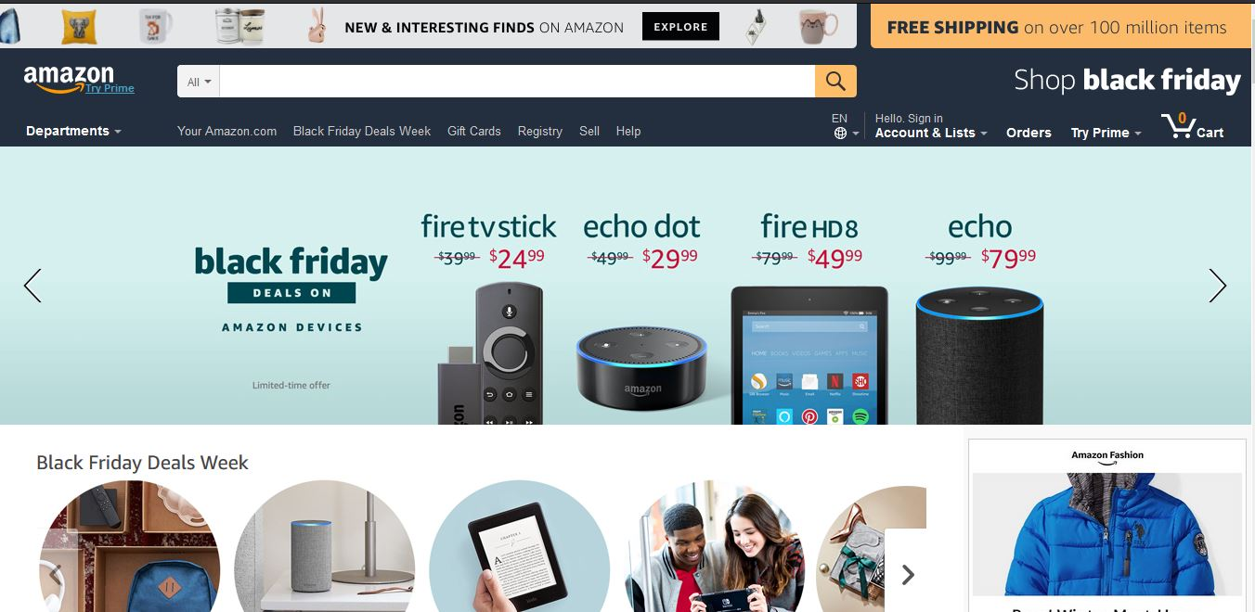

Figure 2.0 Amazon Homepage
Amazon.com, Inc., doing business as Amazon is an American electronic commerce and cloud computing company based in Seattle, Washington that was founded by Jeff Bezos on July 5, 1994. The tech giant is the largest Internet retailer in the world measured by revenue and market capitalization, and second largest after Alibaba Group in terms of total sales. The amazon.com website started as an online bookstore and later diversified to sell DVDs, Blu-rays, CDs, video downloads/streaming, MP3 downloads/streaming, audiobook downloads/streaming, software, video games, electronics, apparel, furniture, food, toys, and jewelry. The company also produces consumer electronics—Kindle e-readers, Fire tablets, Fire TV, and Echo—and is the world's largest provider of cloud infrastructure services (IaaS and PaaS). Amazon also sells certain low-end products like USB cables under its in-house brand AmazonBasics.
Amazon has separate retail websites for the United States, the United Kingdom and Ireland, France, Canada, Germany, Italy, Spain, Netherlands, Australia, Brazil, Japan, China, India, and Mexico. In 2016, Dutch, Polish, and Turkish language versions of the German Amazon website were also launched. Amazon also offers international shipping to certain other countries for some of its products. (Amazon (company), 2017)

2.6.2 WALMART
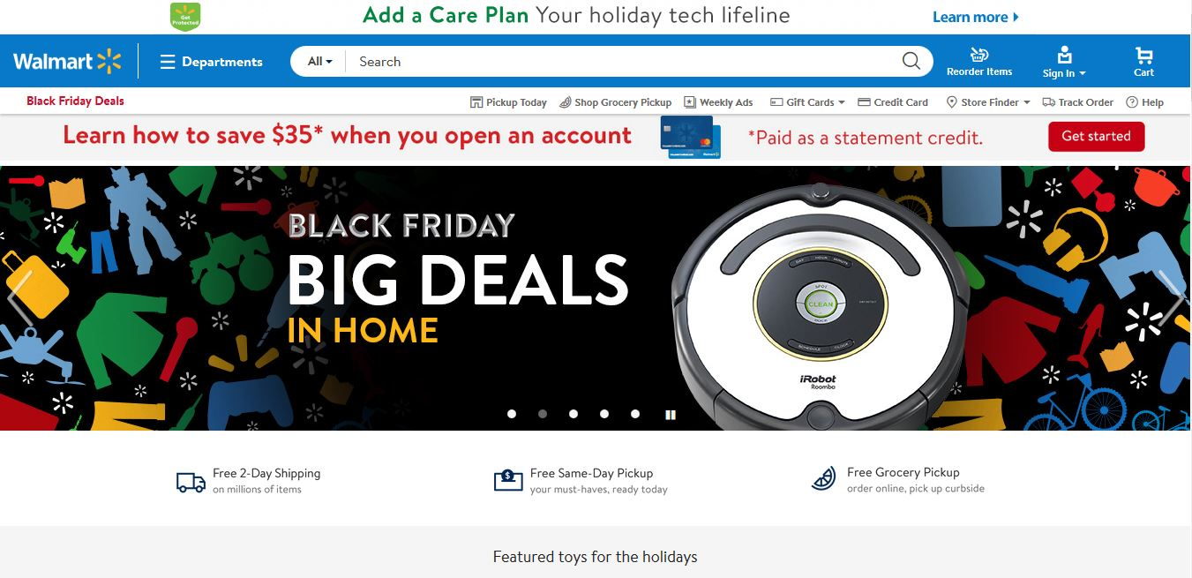

Figure 2.1 Walmart Homepage
Wal-Mart Stores, Inc., doing business as Walmart, is an American multinational retail corporation that operates as a chain of hypermarkets, discount department stores, and grocery stores. Headquartered in Bentonville, Arkansas, the company was founded by Sam Walton in 1962 and incorporated on October 31, 1969. It also owns and operates Sam's Club retail warehouses. As of January 31, 2017, Walmart has 11,695 stores and clubs in 28 countries, operating under 63 different names. The company operates under the name Walmart in the United States and Canada. It operates as Walmart de México y Centro America in Mexico and Central America, as Asda in the United Kingdom, as the Seiyu Group in Japan, and as Best Price in India. It has wholly-owned operations in Argentina, Chile, Brazil, and Canada.
Walmart is the world's largest company by revenue – approximately US$480 billion according to the Fortune Global 500 list in 2016 – as well as the largest private employer in the world with 2.3 million employees.

2.6.3 JUMIA GHANA
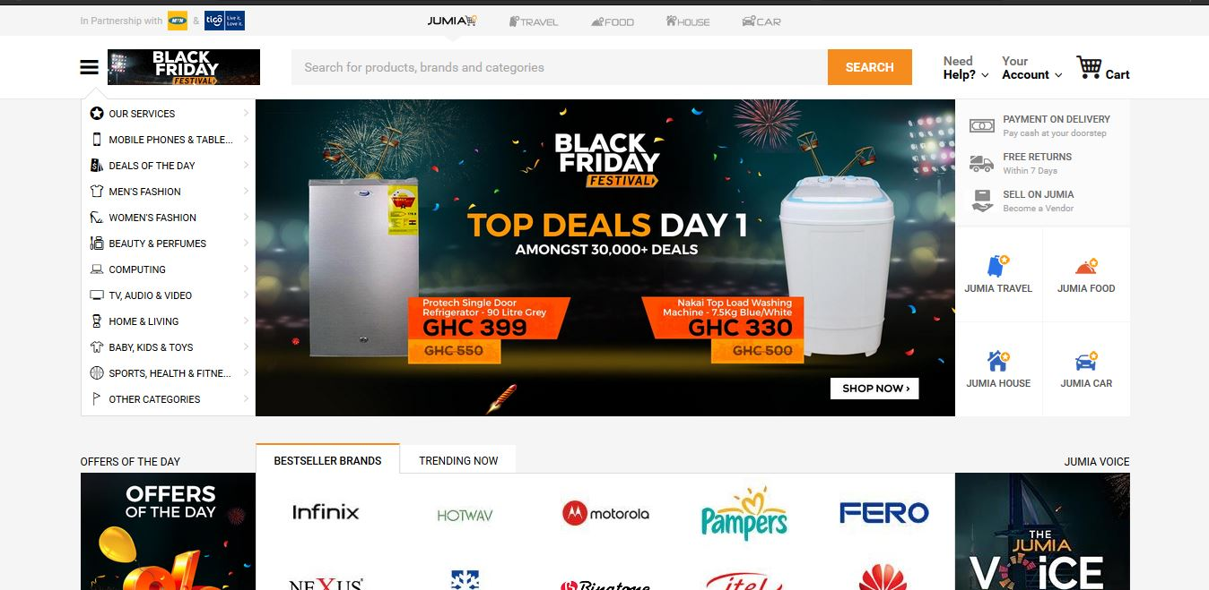

Figure 2.2 Jumia Ghana Homepage
Jumia.com is an open business-to-consumer (B2C) platform enabling businesses to reach Africa's vast and growing consumer market. Jumia.com has established itself as the destination for quality, branded products, catering to an increasingly sophisticated African consumer(s). It is the most visited B2C online retail website in Africa.
You can shop the widest selection of electronics, fashion, home appliances, kids’ items and more in Ghana and have them shipped directly to your home or office at your
convenience! They offer free returns and various payment options including cash on delivery. With affordable prices and great products.

2.6.4 AHONYA
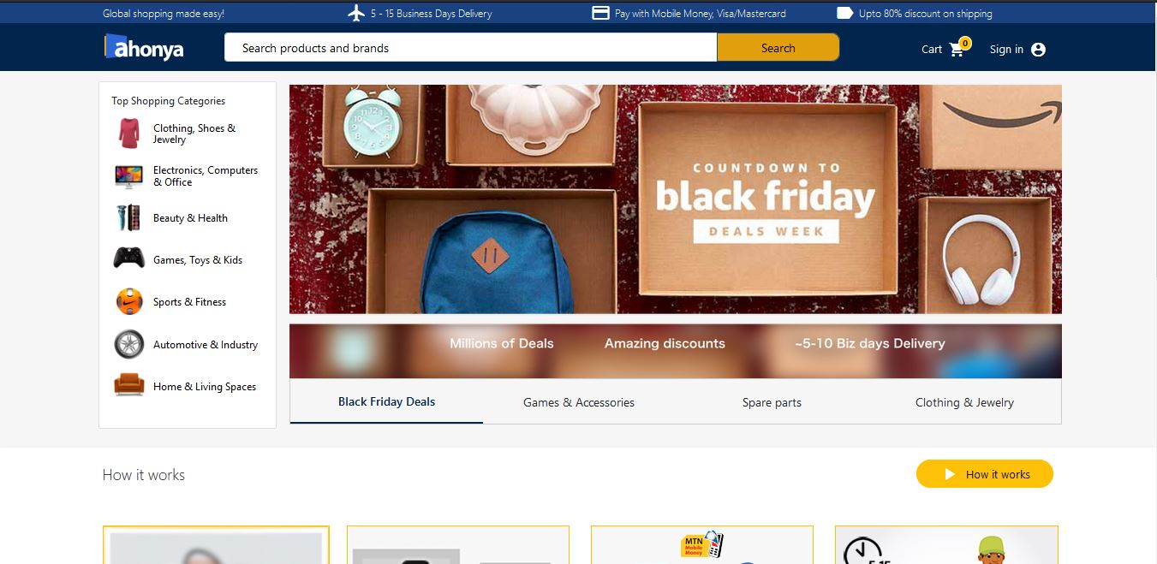

Figure 2.3 Ahonya Homepage
Ahonya.com allows you to shop for genuine electronics and fashion items on US & UK stores and have it delivered to your doorstep. On www.ahonya.com, they have selected and listed over 10million products from US & UK stores. Just search and buy the products you love across multiple categories. Find products on any US & UK store, provide them with the link and they will buy and deliver it to you in 5-10 days.

2.6.5 AZALIABOOKS
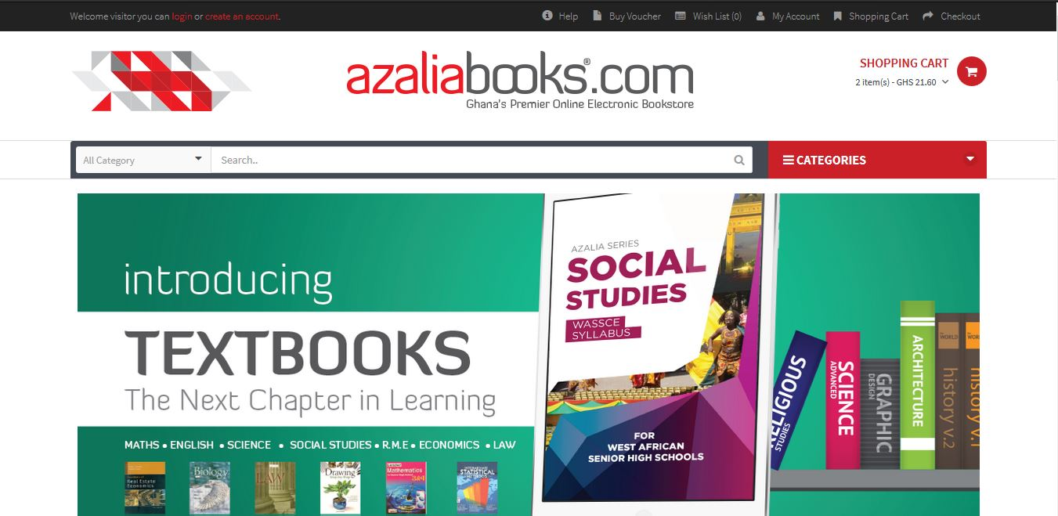

Figure 2.4 Azaliabooks Homepage
Azaliabooks.com is a website owned and operated by AZALIA. Their sole purpose is to promote the works of writers, publishers, photographers and other professionals in the creative arts industry, in order to explore, inspire and enrich lives. On this website, you can shop for electronic books (e-books) of all genres including educational materials, Christian literature, fiction & non-fiction novels, magazines, newspapers, etc. It also serves as an excellent online market for selling the soft copy of books.

2.6.6 ESHOPAFRICA
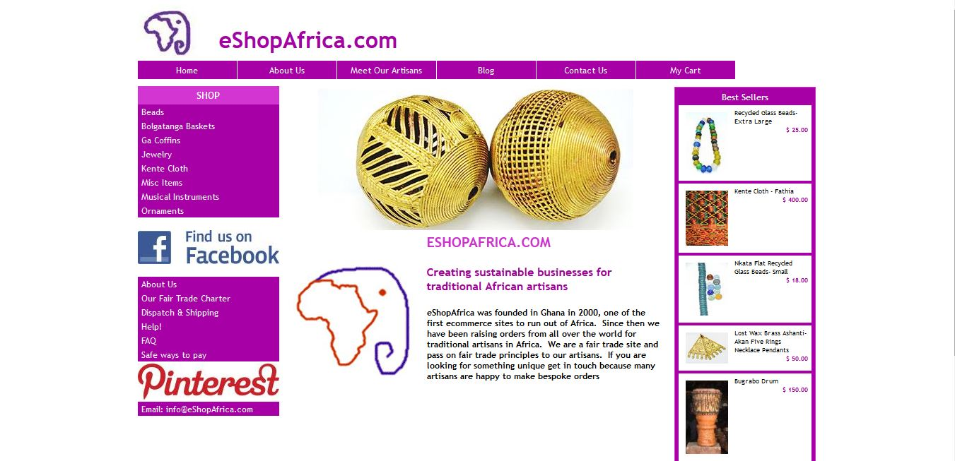

Figure 2.5 eShopAfrica Homepage
eShopAfrica.com is a fair trade social business creating sustainable businesses for traditional African artisans. Based in Accra, Ghana. eShopAfrica.com has been trading online since 2001 and was one of the first e-commerce sites based in Africa. The company is registered in Ghana as an export only company promoting products from the non-traditional sector. They invest in their artisans enabling them to find new markets and grow their businesses in a sustainable way. Where possible we support artisans from the least developed sectors of society including artisan groups and community organizations.

2.6.7 ZOOBASHOP
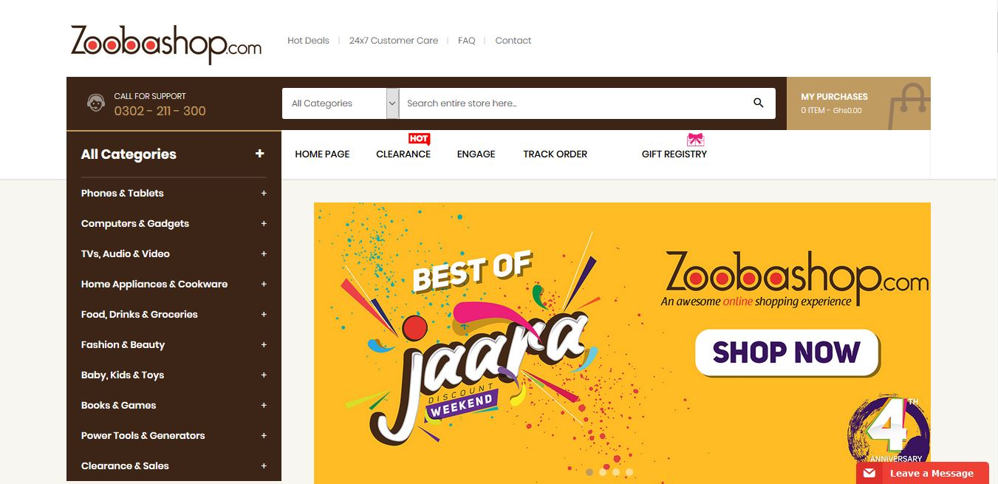

Figure 2.6 Zoobashop Homepage
Zoobashop.com is a wholly Ghanaian owned online retail. They sell products from different categories like electronics, home appliances, fashion, accessories, books, foods, baby products and many more. You can shop with your debit & credit cards (Visa & MasterCard branded ATM cards), cash on delivery, mobile money among others.

2.6.8 TELEFONIKA
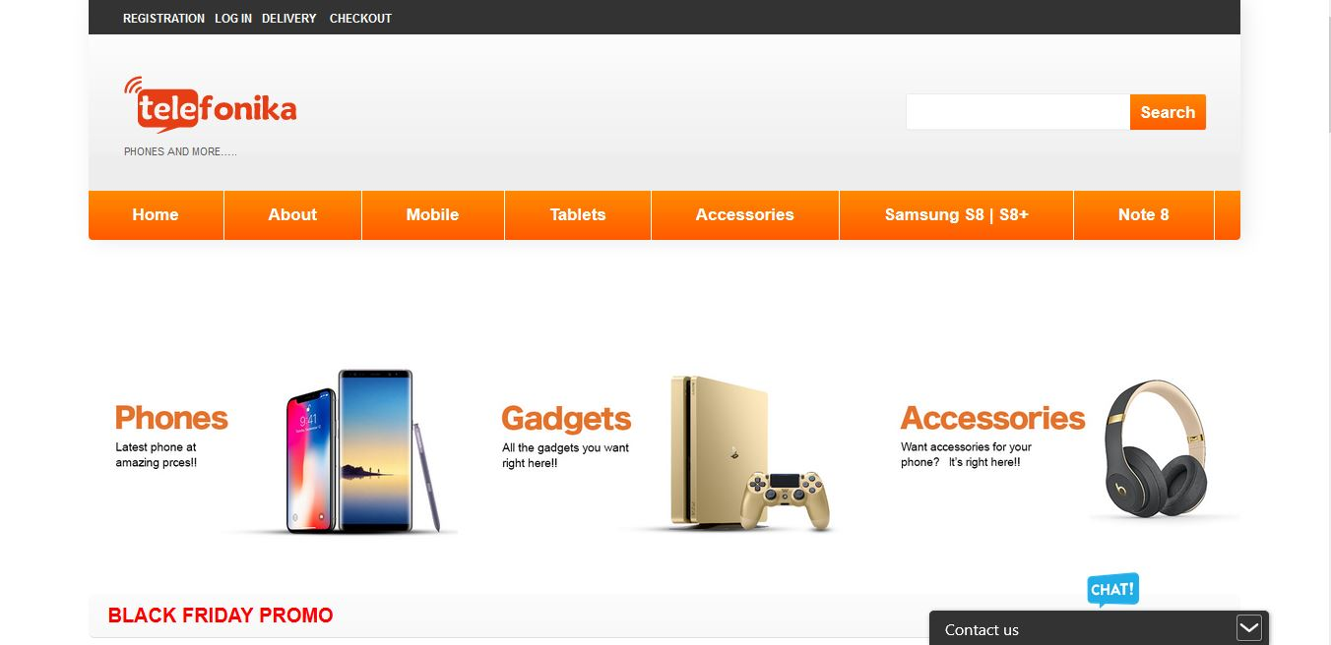

Figure 2.7 Telefonika Homepage
Telefonika is a telecommunication company, trading in mobile phones and accessories, telecommunication equipment, electronic products and gadgets which started in the year 2000 in Osu and has grown over the years and now has (10) branches in vantage parts of Accra.
At Telefonika, they take pride in paying attention to details and providing after-sale service for all our products and services. Their service center is well staffed with professional technicians from diverse parts of the world, who have been trained and are well versed in mobile telecommunication and IT systems to meet their client needs.
Their focus is beyond phones and accessories; they take value in meeting the needs of our customers. Because they are passionate about their work and their clients, and delivering quality service is their ultimate goal. that is why we have become a household name among individuals and institutions alike.

2.6.9 CHEKI
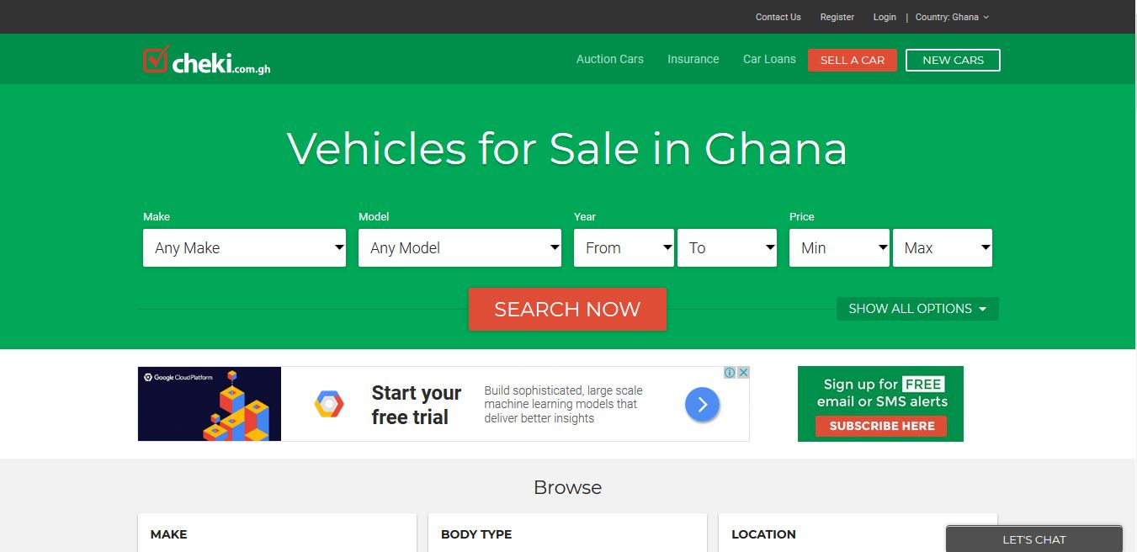

Figure 2.8 Cheki Homepage
Established in 2010, cheki.com. is Ghana’s number one Auto website with more car buyers and car sellers than any other site in Ghana.
Cheki.com.gh is an online marketplace where all of Ghana’s leading car dealers, importers and private sellers post their cars for sale in Ghana. They do not sell cars directly but rather offer a state of the art advertising medium for users to buy and sell their cars, 4WDs, vans, bikes and trucks and other vehicles.
They also offer a one stop destination for all buyers of Japanese import cars to Ghana, by centrally hosting all the cars of many leading Japanese car dealers and importers to Ghana.

2.6.10 BAAHE
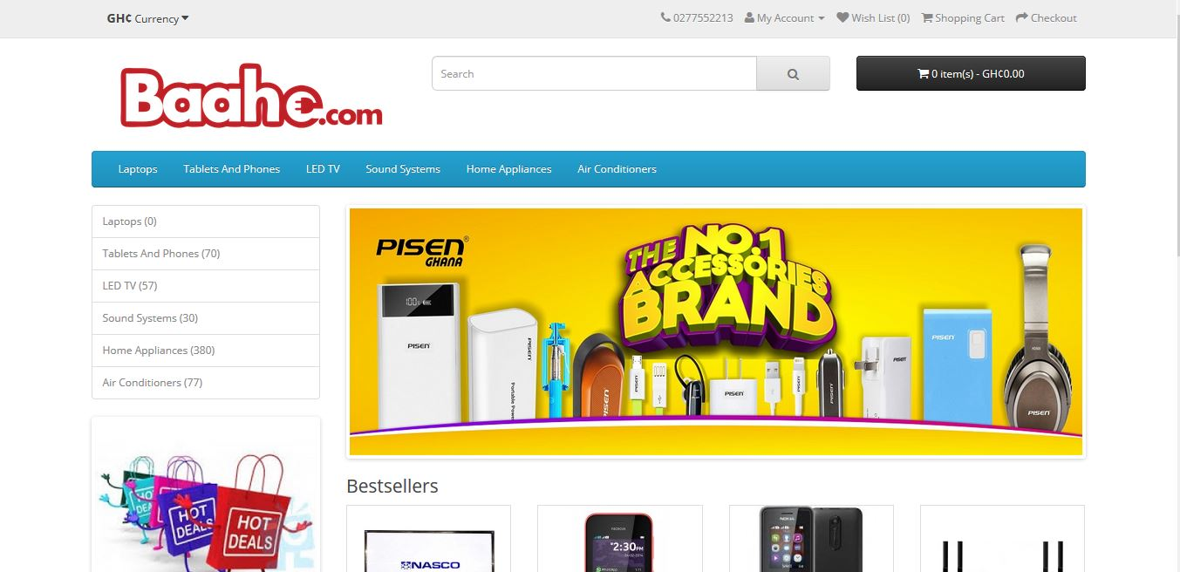

Figure 2.9 Baahe Homepage
Baahe.com excels in bridging the gap between high quality consumer electronics goods and every consumer in Ghana and beyond. Their mission is to deliver quality consumer electronic goods and appliances right to your doorstep conveniently through our online retail shop. They believe in service to mankind in any possible way therefore our dedication to meeting everyone's electronic needs with prompt and amazing customer service.

2.7 REVIEW OF EXISTING IMPLEMENTATIONS (DESIGNS AND FEATURES)

Table 2.0 Review of features of existing implementations
Vendors | Design & Features | Gap / Limitations
Amazon | - Bi - Lingual (English, Spanish)  - Shopping Cart  - Checkout  - Product recommendations  - Payment Gateway  - User account  - Detailed product description  - Customer reviews of the product  - Free or competitive shipping options  - Advanced navigation and search functions  - A fast guest check-out option  - Security Features  - High-Resolution Photos  - Mobile-Friendly  - Wish Lists  - Special Offers  - Live Chat Functionality and Contact Details  - Social Media Integration | Available in only two languages (English and Spanish)
Walmart | - Uni-Lingual (English)  - Shopping Cart  - Checkout  - Product recommendations  - Payment Gateway  - User account  - Detailed product description  - Customer reviews of the product  - Free or competitive shipping options  - Advanced navigation and search functions  - A fast guest check-out option  - Security Features  - High-Resolution Photos  - Mobile-Friendly  - Wish Lists  - Special Offers  - Live Chat Functionality and Contact Details  - Social Media Integration | - Available in only English
Jumia Ghana | - Uni-Lingual (English)  - Shopping Cart  - Checkout  - Payment Gateway  - User account  - Detailed product description  - Customer reviews of the product  - Free or competitive shipping options  - Advanced navigation and search functions  - A fast guest check-out option  - Security Features  - High-Resolution Photos  - Mobile-Friendly  - Wish Lists  - Special Offers  - Live Chat Functionality and Contact Details  - Social Media Integration | - Available in only English  - No product recommendations
Ahonya | - Uni-Lingual (English)  - Shopping Cart  - Checkout  - Payment Gateway  - User account  - Detailed product description  - Customer reviews of the product  - Free or competitive shipping options  - Advanced navigation and search functions  - A fast guest check-out option  - Security Features  - High-Resolution Photos  - Mobile-Friendly  - Wish Lists  - Special Offers  - Live Chat Functionality and Contact Details  - Social Media Integration | - Available in only English  - No product recommendations
eShopAfrica | - Uni-Lingual (English)  - Shopping Cart  - Checkout  - Payment Gateway  - User account  - Detailed product description  - Free or competitive shipping options  - Advanced navigation and search functions  - A fast guest check-out option  - Security Features  - High-Resolution Photos  - Mobile-Friendly  - Wish Lists  - Special Offers  - Live Chat Functionality and Contact Details  - Social Media Integration | - Available in only English  - No product recommendations
Zoobashop | - Uni-Lingual (English)  - Shopping Cart  - Checkout  - Payment Gateway  - User account  - Detailed product description  - Customer reviews of the product  - Free or competitive shipping options  - Advanced navigation and search functions  - A fast guest check-out option  - High-Resolution Photos  - Mobile-Friendly  - Wish Lists  - Special Offers  - Live Chat Functionality and Contact Details  - Social Media Integration | - Available in only English  - No product recommendations
Telefonika | - Uni-Lingual (English)  - Shopping Cart  - Checkout  - Payment Gateway  - User account  - Detailed product description  - Customer reviews of the product  - Free or competitive shipping options  - Advanced navigation and search functions  - A fast guest check-out option  - Security Features  - High-Resolution Photos  - Mobile-Friendly  - Wish Lists  - Special Offers  - Live Chat Functionality and Contact Details  - Social Media Integration | - Available in only English  - No product recommendations
Cheki | - Uni-Lingual (English)  - Shopping Cart  - Checkout  - Payment Gateway  - User account  - Detailed product description  - Customer reviews of the product  - Free or competitive shipping options  - Advanced navigation and search functions  - A fast guest check-out option  - Security Features  - High-Resolution Photos  - Mobile-Friendly  - Wish Lists  - Special Offers  - Live Chat Functionality and Contact Details  - Social Media Integration | - Available in only English  - No product recommendations
Baahe | - Uni-Lingual (English)  - Shopping Cart  - Checkout  - Payment Gateway  - User account  - Detailed product description  - Customer reviews of the product  - Free or competitive shipping options  - Advanced navigation and search functions  - A fast guest check-out option  - Security Features  - High-Resolution Photos  - Mobile-Friendly  - Wish Lists  - Special Offers  - Live Chat Functionality and Contact Details  - Social Media Integration | - Available in only English  - No product recommendations

Upon careful analysis of the above applications from different vendors, I came out with the following findings;
- It was realized that almost all the e-commerce sites have these designs and features Shopping Cart, Checkout, Payment Gateway, User account, Detailed product description, Customer reviews of the product, Free or competitive shipping options, Advanced navigation and search functions, fast guest check-out option, Security Features, High-Resolution Photos, Mobile-Friendly, Wish Lists, Special Offers, Social Media Integration, Live Chat Functionality and Contact Details which makes online shopping easier.
- It was realized that almost all e-commerce websites are Uni-Lingual, that is, are available in only the English language and they do not provide an interface for other developers to use features of their platform such as product pictures, categories of product in their project.
- It was also realized that most of these e-commerce websites in Ghana do not provide product recommendation for customers. This sophisticated additional feature offers good pairings or suggests similar products for users as a means of ‘upselling’ their products. Think about the consumer purchasing a phone who might be persuaded to get a cover or a set of earphones for that phone because a) they are already spending money and b) it’s a clever pairing. This technique results in extra revenue generation and also helps customers ‘filter’ their choices by perhaps going for something similar to what they’re already looking at.

2.8 BENEFITS AND CHALLENGES OF IMPLEMENTATIONS
My main aim is to address some of the shortfalls of the existing systems and to provide a friendlier, robust and reliable service for the e-commerce industry. The system will ensure the following benefits and will also have some challenges:

2.8.1 BENEFITS
- Provide a general-purpose e-commerce store where customers can buy any product (such as books, CDs, computers, mobile phones, electronic items, and home appliances) from the comfort of home through the Internet. The advantage here is that the online shop owners has the flexibility to customize the system to suit the needs of its business.
- Provide a platform for the e-commerce businesses in Ghana to go global so that they can increase their patronage by consumers. This has an added advantage of increasing the revenues of the e-commerce business in Ghana that use my system.
- Provide platform for online shop owners to get their monies before successful order is placed. In this part of our world, if people do not pay before the order is placed, some might end up not showing up for their orders and the shop owners may incur debt. I hope to employ PayPal payment gateway platform to enable customers pay before their orders are placed successfully.

2.8.2 CHALLENGES
Every implantation has challenges and this project is no exception and some of the challenges of this project are:
- Time to complete this project. This is as a result of the fact that I have to make time for classes and also for developing the project.
- Implementing the mobile money payment system. This is due to the fact that most of these mobile money merchants do not have APIs to make integration of mobile money into my system.

2.9 TRENDS IN THE INDUSTRY / FUTURE DIRECTION
As e-commerce technology continually evolves, customer experience is becoming increasingly essential to the conversion of sales. Some retailers are currently planning to create and sustain customer value by providing sophisticated digital experiences that deliver orders more quickly, blend physical and digital capabilities, and simplify ordering procedures. Data-as-a service and ecommerce, Chatbots, Drones, droids, augmented reality goggles, Blockchain and bitcoin are some of the more prominent innovations on the horizon that are expected to transform the e-commerce industry.

2.9.1 DATA-AS-A-SERVICE AND ECOMMERCE
If 92% of Internet users regularly read product reviews and comments from other buyers, it’s because uncertainty is a huge obstacle to online purchasing. The more information there is available about a product (pictures, reviews, descriptions, specifications, etc.), the less reluctant people will be to buy it online. However, constantly refreshing the information on each individual product on a website is a near-impossible task for any merchant who doesn’t have esque resources.
In the future, many retailers will start working with data aggregators that compile data on millions of products: pictures, descriptions, price comparisons, specifications, UPC codes, reviews, and comments. There are even aggregators that contain data on millions of pieces of clothing that can be used to suggest the perfect size! A merchant will be able to link its site to these databases to automatically update product information. Say goodbye to uncertainty and to poor product descriptions!

2.9.2 CHATBOTS
Chatbots otherwise known as messenger bots is a piece of software that can be used by the retailer to chat with customers via text or voice.
In the future, many consumers will have their first interaction with a chatbot, a fully automated chat agent that will answer their questions and act as the first point of contact with the brand. A chatbot increases the number of platforms on which a brand can transact by offering guided, interactive browsing at all times.
Chatbots will soon become as commonplace as automated phone systems, only much more interactive and interesting. At the same time, store sales staff will become more important than ever, as they’ll be increasingly involved in the online experience.
For example, Fast food chain Taco Bell unveiled its TacoBot on the popular messaging platform Slack, which allows customers to order food by messaging TacoBot, which asks all the right questions. Also, Burger King and Pizza Hut customers can order food directly through Facebook Messenger and Twitter by messaging the restaurant chains’ bots.

2.9.3 DRONE DELIVERY
The growing popularity and availability of drone delivery is expected to be one of the most innovative technologies in the retail industry over the next decade. Though regulations (primarily concerning airspace governance) have yet to be established in some parts of the world and are therefore delaying the widespread use of drones, the new delivery system has already played a big role in delivering products to aid disaster relief efforts. The existing delivery technology for these efforts easily translates to the online retail industry, with major retail and delivery companies exploring how they can incorporate drone technology and future e-commerce solutions.
Most drones have a cruising altitude of 400 feet and can fly at roughly 60 miles per hour. Radius distances vary from 10 to 15 miles away depending on the prototype, and drones can generally carry packages up to 5 pounds. In time, drones could enable some companies to offer same-day shipping, or even same-hour delivery in highly populous areas. These faster delivery times along with a growing number of online shoppers worldwide will likely encourage more online purchases in the future.
For example, Australia Post is currently testing drones to commercially deliver parcels to civilian addresses, and sites in the U.S. and Europe have been quick to build airports specifically for drones (internally referred to as “droneports”).

2.9.4 DROID DELIVERY
A more grounded solution, droid delivery is slowly gaining attention as well. Droids are little robots, typically built with six wagon wheels that travel along sidewalks at a pedestrian pace (usually about four miles per hour, though most are capable of speeds more than twice as fast). The most popular delivery droid so far has been created by Star ship Technologies, a startapp assembled by the founding engineers of Skype. This particular droid weigh between 20 and 30 pounds, is capable of transporting roughly 20 pounds of goods in 30 minutes or less and is designed to complete the final mile of a delivery. They can climb small sets of stairs, are equipped with nine cameras to stream live video back to their base, a microphone for two-way communication with customers, GPS tracking (for both their base and shoppers), and censors that help it navigate any obstacles or foot traffic on sidewalks. Environmentalists like these little delivery droids because they use less energy than most lightbulbs and because they not only reduce vehicle emissions but are also generally quicker to deliver products. In fact, nearly 30% of transportation costs are incurred during the last mile, when delivery drivers must search for a parking space and leave their car idling while they make the last few steps of the trip walking to the customers’ front door. Delivery droids will make the whole process less expensive and will therefore appeal to retailers and fulfilment companies looking to cut cost and delivery times. Around the world, luxury hotels have implemented delivery droids to boost their hospitality capabilities. For example, hotel droids are able to bring necessities like extra towels, soaps, and even room service meals. In Australia, Domino’s Pizza introduced its own robot to deliver pizzas quickly to customers, avoiding traffic and parking problems.

2.9.5 AUGMENTED REALITY TECHNOLOGY
In terms of discovering products, retailers have implemented the use of augmented reality to increase online sales. In-home augmented or virtual reality technology comes in the form of headsets or goggles that create an interactive, 3-D shopping experience for the user. It provides retailers an in-home extension of their physical stores and can potentially increase sales with simplistic user experiences and built-in upselling features. Goggle technologies or virtual reality headsets (such as Microsoft HoloLens, Sony Smart Eyeglass, Oculus Rift) are growing in popularity due to their multi-use properties in terms of retail marketing. With goggles, shoppers can look into their mirror at home and transform it into an interactive dressing room. The goggles can then help the shopper choose correct clothing sizes with a virtual view of how the garments will fit as well as suggest matching accessories. By utilizing this technology to accurately choose garment sizes, the percentage of online return shipments may also decrease.
Home design will also be transformed with the use of goggle technologies. Leading furniture companies will be able to display what their products will look like within a shopper’s home and allow the shopper to interact with the furniture in order to choose what styles they like best. For example, a customer will be able to select and visualize a couch, moving it to different sides of the room to see how they like it or even try a different size to make sure it fits in a specific space.

2.9.6 BLOCKCHAIN
Blockchain is essentially a shared ledgering technology that allow companies and their partners to accurately manage and track complex digital transactions, as well as securely store the digital values or objects involved in those transactions. Wal-Mart is one of the first retailers to plan an international implementation of blockchain as it looks to impose better tracking of its pork and produce transactions in China.
More retailers, especially the largest international ones, may be ready to use blockchain for similar applications, though doing so requires an embrace of digital economy principles that may still be a stretch for some.

2.9.7 BITCOIN
Bitcoin is a digital currency which allows transactions to be performed without banks or any other middlemen. Transactions from consumer’s wallets are processed, verified and publicly recorded by so-called bitcoin enthusiasts. And, there aren’t any transaction fees.
Bitcoin is a new cryptocurrency, which created by an unknown programmer (or a group of programmers) under the pseudonym Satoci Nakamoto. This happened in 2009. Nobody knows where this man is and what his name is in the real world. Cryptocurrency Bitcoin has the basic functions and properties of conventional money from different countries. It could exchange, stored and used to purchase. However, Bitcoin is cryptocurrency, which is a type of digital currency. Its emissions and accounting based on different cryptographic methods. A decentralized operation occurs, in a distributed computer network. Cryptocurrency - this is the real software, the growth rate of which depends on supply and demand, not by subsequent investors. Each member of the network can make instant transactions cryptocurrency without intermediaries. That is, the buyer sends the money directly to the seller. No need to go to the bank, you simply send Bitcoins to the person. Coins in the system are the cryptographic (mathematical) hash functions. Each of them is completely unique and cannot be used twice. Bitcoin can be used to purchase goods and services on the Internet anonymously. Moreover, it is easier and cheaper to make international payments because Bitcoin is not tied to a particular country. To store Bitcoins, have a few options. Offline purse is being installed and is created on your PC. Usually, it is encrypted to prevent tampering. But, there are some cons, if you forget the password to log into a purse or on your computer hard drive died you lost your money. Online Bitcoin wallet has advantages over the offline version. You can access it using not only PCs but also tablet or phone. One of the main problems of these wallets is that all the data stored on the server. Many online stores or retail outlets that accept bitcoin currency side by side with local currency, debit cards or credit cards, opens the window of opportunity for users to compare the benefits of shopping via bitcoin payment.

2.10 SUMMARY
In this chapter, I started with the overview of the subject area which is Ecommerce and online shopping. I proceeded with current research issues in Ecommerce business. I then took a look at the technologies available both past and present and later reviewed and highlighted similar implementations from ten vendors namely Amazon.com, Walmart.com, Jumia.com, Ahonya.com, Azaliabooks.com, eShopAfrica.com, Zoobashop.com, Telefonika.com, Cheki.com and Baahe.com. I went further to look at the benefits and challenges of my implementation and finally concluded with the trends and Future Direction in the ecommerce business.

CHAPTER THREE

3.0 PROJECT METHODOLOGY

3.1 INTRODUCTION
This chapter takes a look at the development tools employed in developing this project. It also describes the selected methodology used as well as its advantages and limitations and also identifies the online shops that will be used as case study.

3.2 DEVELOPMENT METHODOLOGY
In software engineering, a system development methodology refers to the framework that is used to structure, plan, and control the process of developing an information system. Software development methodologies define the processes we use to build software. These methodologies are also referred to as Software Development Process Models. Each methodology follows a series of steps unique to its type, to ensure success in the process of software development.
A software process is a set of related activities that leads to the production of a software product.
There are a lot of software processes but they all include four activities:
- Specification
- Development
- Validation
- Evolution

These are fundamental to software engineering. A wide variety of Software Development methodology has evolved over the years. Each of these methodologies has its own recognized strengths and weaknesses. The following are the most widely used methodologies for software development.

3.2.1 WATERFALL METHOD
The waterfall model is a sequential approach, where each fundamental activity of a process represented as a separate phase, arranged in linear order. This model requires planning and scheduling activities before starting working on them, it is plan-driven.
Plan-driven process is one in which all the activities are first planned, and then each progress is measured against the plan.
The Agile process on the other hand involves planning incrementally and it is much easier to change the processes to reflect a change in requirement.

3.2.2 INCREMENTAL METHOD
The Incremental method of development is based on the idea of developing an initial implementation, exposing this model to user to receive feedback. This model evolves in the form of versions as the requirements change until an acceptable system has been developed.

3.2.3 SPIRAL METHOD
The spiral model is a risk-driven method where the process is represented as spiral rather than a sequence of activities and it includes best features from the waterfall and prototyping models. In addition, it introduces a new component called: risk-assessment. Each loop in the spiral represents a phase, thus the first loop might be concerned with system feasibility. The next loop might be concerned with the requirements definition and the next with system design, and the like.

3.2.4 PROTOTYPING METHOD
A prototype is a version of a system or part of the system that’s developed quickly to check the customer’s requirements or the feasibility of some design decisions. Prototypes are useful when a customer or the developer is not sure of the requirements, the algorithms efficiency, some business rules or even response time.
The four basic process activities of specification, development, validation, and evolution are organized differently in the respective development processes. In the waterfall model, they are organized in sequence, but are interleaved in incremental development method. The type of software, the people, and organizational structures involved determines how these activities are carried out. For example, specifications for extreme programming are written on cards. Tests are executable and developed before the program itself. Evolution may involve substantial system restructuring or refactoring.
This project uses the Incremental method in developing the application because the preferences of the users keep changing.

3.3 INCREMENTAL DEVELOPMENT METHODOLOGY
Incremental development is based on the idea of developing an initial implementation, exposing this to user feedback, and evolving it through several versions until an acceptable system has been developed. In incremental development, the activities of a process are not separated but are interleaved with feedback across the activities. An incremental method does not attempt to start with a full specification of requirements. Development begins by specifying and implementing just part of the software, which is then reviewed to identify further requirements. This process is then repeated, producing a new version of the software after each iteration.
During software development, it is possible to have more than an iteration of a cycle at the same time. This process may be described as an "evolutionary acquisition" or "incremental build" approach. This means that, the customer can evaluate the system at an early stage to make sure that the required system is delivered.
In this incremental method, the whole requirement is divided into various builds. During each iteration, the development module goes through the requirements, design, implementation and testing phases. Each subsequent release of the module adds function to the previous release. The process continues till the complete system is ready as per the requirement. The key to a successful use of an iterative software development lifecycle is rigorous validation of requirements as well as verification and testing of each version of the software against those requirements within each cycle of the model. As the software evolves through successive cycles, tests must be repeated and extended to verify each version of the software.
The main principles of the Incremental development methodology are face-to-face meetings, constant cooperation, early and continuous delivery of the working software, transparency. Whenever there are unexpected or frequent changes either from the client’s side or internal, this model becomes the perfect choice for managers and team leaders.
This online shop is a web application and since user requirements may change with time, a series of increments will be released to the user to get his comments and suggestions and adjust the system and release subsequent versions until the final version, which is accepted by the user, is released. Any recommendations or suggestions from the supervisor is factored into the next iteration until the supervisor accepts the final release.

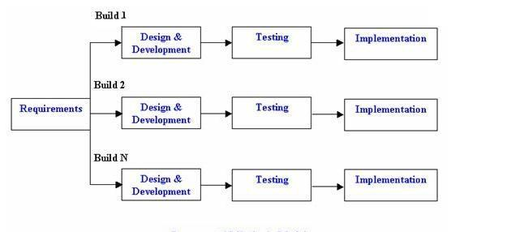

Figure 3.0 Incremental Development Methodology
However, there are advantages and limitations of the incremental development that we need to look at

3.3.1 ADVANTAGES OF THE INCREMENTAL DEVELOPMENT METHODOLOGY
- Risks are identified and resolved during iteration; and each iteration is an easily managed milestone.
- During the life cycle, software is produced early which facilitates customer evaluation and feedback. Because the first release is available to the user, they can give genuine and factual feedback based on the current system.
- Testing and debugging smaller modules and units within the application is much easier.
- It is possible to deliver applications more rapidly and quickly to the customer. Even if the full system functionality is not implemented in the initial release, users can use the system and enjoy all the benefits before a new version is released to cover all the functionalities.
- The cost of accommodating changing customer demands is reduced. The advantage is that it avoids or reduces rework. Because I engage the end user (supervisor) in the release of the increments or versions, the changing demand of the user (in this case the supervisor) is taken care of until I develop the full system.
- Better suited for large and mission-critical projects. This is because it is hard to break a small software system into further small serviceable increments/modules.
- Direct communication and constant feedback from customer (in this case the supervisor) leave no space for any guesswork in the system.

3.3.2 LIMITATIONS OF THE INCREMENTAL DEVELOPMENT METHODOLOGY
- More resources may be required. This is because as new versions are released, I may bear additional cost as my user (in this case the supervisor) suggest new system functionalities to the next release.
- Needs a clear and complete definition of the whole system before it can be broken down and built incrementally.
- The project can get off track if my customer (in this case the supervisor) is not very clear about the outcome of this project.
- System architecture or design issues may arise because not all requirements are gathered in the beginning of the entire life cycle

3.4 CASE STUDY AREA / PROJECT CASE STUDY
E-commerce websites in Ghana will be my target beneficiary for this project even though the application can be customized by any online shop to suit their operations. Ghana has a number of e-commerce websites including Jumia Ghana, Ahonya, Azaliabooks, and Zoobashop etc. Since my system would be for a single vendor, I chose Azaliabooks to be my case study. This is because my online shop would be used to sell Hardcopy Information Technology books and Azaliabooks also sells all kinds of e-books.
Azaliabooks.com is a website owned and operated by AZALIA. Their sole purpose is to promote the works of writers, publishers, photographers and other professionals in the creative arts industry, to explore, inspire and enrich lives. On their website, you can shop for electronic books (e-books) of all genres including educational materials, Christian literature, fiction & non-fiction novels, magazines, newspapers, etc. It also serves as an excellent online market for selling the soft copy of books.

DEVELOPMENT TOOLS
In this project, a number of development tools would be used to complete this project. They are listed as follow
PYTHON
Is an interpreter, object-oriented, high-level programming language and a general-purpose programming with dynamic semantics and it will be used for the back-end. It incorporates modules, exceptions, dynamic typing, very high level dynamic data types, and classes. Python combines remarkable power with very clear syntax. It has interfaces too many systems call and libraries, as well as to various window systems, and is extensible in C or C++. It is also usable as an extension language for applications that need a programmable interface. Python is versatile. It runs websites and is used in many popular desktop applications on PCs and Macs. It can also be found in mobile applications and embedded in many devices. Python is also a popular scripting language for other applications. Python is portable, it runs on many Unix variants, on the Mac, and on PCs under MS-DOS, Windows, Windows NT, and OS/2.
DJANGO
Django is a high-level Python Web framework that encourages rapid development and clean, pragmatic design. Django is a free and open-source web framework which follows the model-view-template architectural pattern. Django is portable, it runs on many Unix variants, on the Mac, and on PCs under MS-DOS, Windows, Windows NT, and OS/2. The reasons why I chose Django for my project are:
- Fast: Django has been designed in a way to help the developers make an application as fast as possible. From idea, production to release, Django helps in making it both cost effective and efficient. Thus, it becomes an ideal solution for developers having a primary focus on deadlines.
- Secure: Django ensures that developers don’t commit any mistakes related to security. Some of the common mistakes include SQL injection, cross-site request forgery, clickjacking and cross-site scripting. To manage effectively usernames and passwords, the user authentication system is the key.
- Scalable: To meet the heaviest traffic demand, the benefits of Django framework can be seen. Therefore, the busiest sites such as Instagram, Bitbucket, Pinterest etc. use this medium to quickly meet the traffic demands.
- Versatile: Content management, scientific computing platforms, and even big organizations, all these aspects are very efficiently managed by the use of Django.
- Actively Developed: One of the biggest risks of open source is whether there is sufficient interest in the project for it to attract developer support in the long term. There is no such risk with Django, not only is the project over 12 years old, it has a long history of consistent releases and it continues to be supported by an active community and a large core team of voluntary contributors who maintain and improve the code base every day. The Django development team maintains a development roadmap on the Django Project website and have a solid track record of meeting roadmap milestones. The Django Project is also supported by an independent foundation, the Django Software Foundation, that is a registered non-profit in the US.
- Stable Releases: Open-source software projects are, in many cases, more actively developed and more secure than competing proprietary software. The downside of the ever-evolving development of an open-source software project is the lack of a stable codebase on which to base commercial development. Django addresses this issue with Long Term Support (LTS) versions of the software and a defined release process. LTS versions are released with a guaranteed (typically three years) support period. In this period the codebase is guaranteed to remain stable; with patches for bugs, security and data loss 100% compatible with the feature release. Django’s release process ensures that official releases are as stable as possible. After a development phase, each release enters an Alpha phase where a feature freeze is applied. The new release then moves through Beta and Release Candidate (RC) stages where bugs are worked out of the release. If no major bugs are found for a period after the release candidate, the final will be released (feature release). After the final has been released, only bugfixes and security patches are applied. These patches, like the LTS versions, are 100% compatible with the feature release.
- First Class Documentation: A piece of software is only as good as its documentation. Django is very well documented and this allows avoiding of hours of trial and errors or effortless implementation. Every specific release of Django is supported by all necessary documentation and code examples. On top of that, the code is all publicly available on GitHub for direct investigation.
HTML
HTML (Hypertext Markup Language) is the code that is used to structure a web page and its content. HTML is used to specify whether a web content should be recognized as a paragraph, list, heading, link, image, multimedia player, form, or one of many other available elements or even a new element that you define. It is the globally accepted programming language for formatting web pages. It is mostly used by small and medium scale businesses that do not really need advanced functionality on their websites. HTML is free, supports all browsers on the client’s machine, easy to use and understand hence, the choice in building the structure of my web pages.
CSS
Cascading Style Sheets (CSS) is a stylesheet language used to describe the presentation of a document written in HTML or XML (including XML dialects such as SVG or XHTML). CSS describes how elements should be rendered on screen, on paper, in speech, or on other media. CSS is one of the core languages of the open web and is standardized across browsers according to the W3C (World Wide Web Consortium) specification.
JAVASCRIPT
JavaScript is a high-level, dynamic, weakly typed, prototype-based, multi-paradigm, and interpreted programming language. JavaScript is a full-fledged dynamic programming language that, when applied to an HTML document, can provide dynamic interactivity on websites. It would be used in conjunction with Django to ensure validation rules on the front-end of the websites.
BOOTSTRAP
Bootstrap is a free and open-source front-end web framework for designing websites and web applications. It contains HTML and CSS based design templates for typography, forms, buttons, navigation and other interface components, as well as optional JavaScript extensions. Unlike many web frameworks, it concerns itself with front-end development only. Bootstrap would be used to design the styling of the application alongside CSS. Bootstrap is important in the application for the following reasons:

- Easy to use: Anybody with just basic knowledge of HTML and CSS can start using Bootstrap.

- Responsive features: Bootstrap's responsive CSS adjusts to phones, tablets, and desktops.

- Mobile-first approach: Mobile-first styles are part of the core bootstrap framework.

- Browser compatibility: Bootstrap is compatible with all modern browsers (Chrome, Firefox, Internet Explorer, Safari, and Opera).

PHOTOSHOP
Adobe Photoshop is the predominant photo editing and manipulation software on the market. Its uses ranges from full featured editing of large batches of photos to creating intricate digital paintings and drawings that mimic those done by hand. It is a graphic designing tool that enables picture manipulation and editing. Photoshop would be used to design user interfaces and the various images that would be required in developing the system.

POSTGRESQL
It is an object-relational database management system (ORDBMS) with an emphasis on extensibility and standards compliance. A fundamental characteristic of an object-relational database is support for user-defined objects and their behaviors including data types, functions, operators, domains and indexes. This makes PostgreSQL extremely flexible and robust. Among other things, complex data structures can be created, stored and retrieved. All the tables and records that would be required in the project would be designed and created with POSTGRESQL. My choice for POSTGRESQL is that it is easy to use, support is easily available on the internet, it is open source and hence inexpensive to get it, supports complex structures, it provides extensive data capacity and is trusted for its data integrity and finally it remains one of the most accepted industry standard database for developing web applications.
PYCHARM
Pycharm is an Integrated Development Environment (IDE) used in computer programming, specifically for the Python language. It is the integrated development environment that would be used to write executable Python and HTML files. Pycharm is used for this project because it allows developers to locate files very quickly and easily with a few key strokes. Multiple selections allow developers to interactively make changes to several lines of codes all at once, it allows developers to switch between several projects in the workspace, it has an integrated debugger and it is also cross-platform and as such can be used on any operating system. Finally, it allows key bindings, menus, snippets and macros. With Pycharm you need to spend little time to tune up your programming environment or hunt plugins for your basic development needs i.e. Python, JavaScript, HTML, CSS. Pycharm does background spellchecking of written text and Python docstrings. It is very handy for writing high quality software with meaningful comments and API descriptions. Pycharm has more robust integrated version control support (Git, SVN).

3.6 SUMMARY
This chapter describes the software process model that was involved in the production of the application, which was the incremental development process model under the agile development as the methodology. It also spoke about the project methodologies where different methodologies were identified. It identified the main activities of the incremental approach as Requirements, Design and Development, Testing and Implementation and made it clear that the software would be released as a series of versions to the user until the final product is accepted.
The advantages and disadvantages of the incremental development over other process models were analyzed. Furthermore, Azaliabooks was identified my case study and briefly description of their operations. Lastly, a list of the development tools used to develop my project was also discussed. There was also a discussion of the Django framework and outlined strong reasons why it is used it to develop the application as well as the other tools such as Python,
PostgreSQL, HTML, CSS, Bootstrap, Adobe Photoshop, JavaScript Django Rest Framework and the Pycharm IDE.

CHAPTER FOUR

4.0 SYSTEMS ANALYSIS AND DESIGN

4.1 INTRODUCTION
System analysis and design deal with planning the development of information systems through understanding and specifying in detail what a system should do and how the components of the system should be implemented and work together. System analysis and design solve business problems through analyzing the requirements of information systems and designing such systems by applying analysis and design techniques.
System analysis and design is the most essential phase in the development of a system since the logical system design arrived at as a result of systems analysis which is in turn converted into physical system design.
This chapter will outline the general system and application architecture, requirements specification, functional and non-functional requirements, use case modelling, the database design, Entity Relationship diagram, Normalization, and User interface design.

4.2 GENERAL SYSTEM ARCHITECTURE
The architecture of applications is usually broken into logical chunks called "tiers", where every tier is assigned a role. A “tier” can also be referred to as a “layer”. There are three layers involved in the application namely Presentation Layer, Business Layer and Data Layer. Each layer is explained in detailed below:

- Presentation Layer:
It is also known as Client layer. Top most layer of an application. This is the layer we see when we use a software. By using this layer, we can access the webpages. The main functionality of this layer is to communicate with Application layer. This layer passes the information which is given by the user in terms of keyboard actions, mouse clicks to the Application Layer. For example, login page of Gmail where an end user could see text boxes and buttons to enter user id, password and to click on sign-in. In simple words, it is to view the application.
- Application Layer:
It is also known as Business Logic Layer which is also known as logical layer. As per the Gmail login page example, once user clicks on the login button, Application layer interacts with Database layer and sends required information to the Presentation layer. It controls an application’s functionality by performing detailed processing. This layer acts as a mediator between the Presentation and the Database layer. Complete business logic will be written in this layer. In simple words, it is to perform operations on the application.
- Data Layer:
The data is stored in this layer. Application layer communicates with Database layer to retrieve the data. It contains methods that connects the database and performs required action e.g.: insert, update, delete etc. In simple words, it is to share and retrieve the data.
There are four categories of application architectures which all have the four layers explained above. The categories of the application architecture are:

4.2.1 ONE TIER ARCHITECTURE
One tier architecture has all the layers such as Presentation, Business, Data Access layers in a single software package. All traditional applications consist only of 1 tier, which resides on the client machine. Applications which handles all the three tiers such as MP3 player, MS Office are come under one tier application. The data is stored in the local system or a shared drive. This tier is also known as Standalone application.
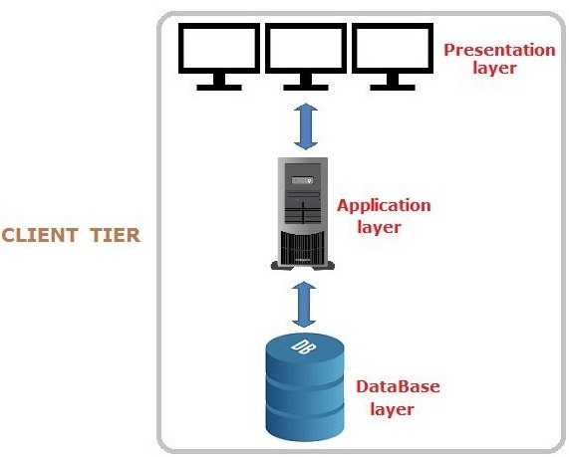

Figure 4.0 One-Tier Architecture (Standalone Application)
Source: (Gaur, 2018)

4.2.2 TWO TIER ARCHITECTURES
The Two-tier architecture is divided into two parts namely Client Application (Client Tier) and Database (Data Tier). Client system handles both Presentation and Application layers and Server system handles Database layer. The communication takes place between the Client and the Server. Client system sends the request to the Server system and the Server system processes the request and sends back the data to the Client System. It is also known as client-server application.
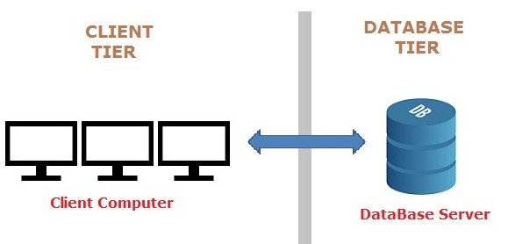

Figure 4.1 Two-tier Architecture (Client-Server Application)
Source: (Gaur, 2018)

4.2.3 THREE TIER ARCHITECTURES
The Three-tier architecture is divided into three parts namely: Presentation layer (Client Tier), Application layer (Business Tier) and Database layer (Data Tier). Client system handles Presentation layer, Application server handles Application layer and Server system handles Database layer. A web browser is the first tier (presentation), an engine using some dynamic Web content technology (such as ASP, CGI, ColdFusion, Dart, JSP/Java, Node.js, PHP, Python or Ruby on Rails) is the middle tier (application logic), and a database is the third tier (storage). The web browser sends requests to the middle tier, which services them by making queries and updates against the database and generates a user interface. It is also known as Web Based application.
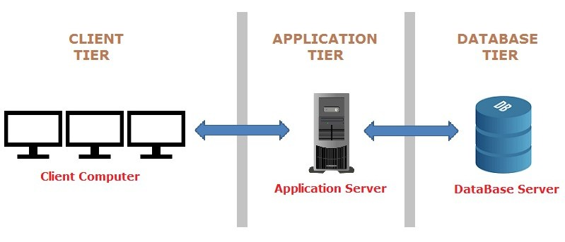

Figure 4.2 Three-Tier Architecture (Web-Based Application)
Source: (Gaur, 2018)

4.2.4 N-TIER ARCHITECTURE
It is similar to three tier architectures but number of application servers are increased and represented in individual tiers in order to distributed the business logic so that the logic will be distributed. N-Tier application is also known as Distributed application.
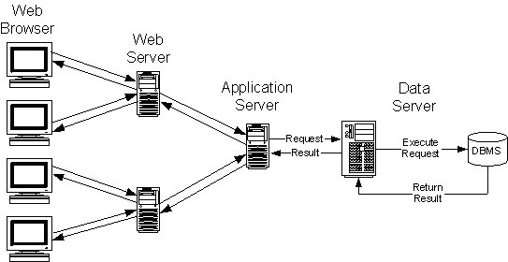

Figure 4.3 N-Tier Application (Distributed Application)
Source: (Kramek, 2018)
Web applications lend themselves to an n-tiered approach by nature. Though many variations are possible, the most common structure is the three-tiered application.
This project uses the three-tiered architecture because it is made up of three layers; the presentation layer would be the web browser; the application layer would be the Django framework and the third layer which is the database layer would be Postgresql.

4.3 GENERAL APPLICATION ARCHITECTURE

4.3.1 THE MODEL-VIEW-CONTROLLER DESIGN PATTERN
Although originally developed for desktop computing, MVC has been widely adopted as an architecture for World Wide Web applications in major programming languages. Several web frameworks have been created that enforce the pattern. These software frameworks vary in their interpretations, mainly in the way that the MVC responsibilities are divided between the client and server. MVC is short for Model, View, and Controller. MVC is a popular way of organizing code. The big idea behind MVC is that each section of code has a purpose, and those purposes are different. Some of the code holds the data of an app, some of the code makes the app look nice, and some of the code controls how the app functions. MVC is a way to organize code’s core functions into their own, neatly organized boxes. This makes thinking about the app, revisiting the app, and sharing the app with others much easier and cleaner.
MVC has been around as a concept for a long time but has seen exponential growth since the advent of the Internet because it is the best way to design client-server applications.
- The model(M) is a model or representation of your data. It’s not the actual data, but an interface to the data. The model allows you to pull data from your database without knowing the intricacies of the underlying database. The model usually also provides an abstraction layer with your database, so that you can use the same model with multiple databases.

- The view(V) is what you see. It’s the presentation layer for your model. On your computer, the view is what you see in the browser for a Web app, or the UI for a desktop app. The view also provides an interface to collect user input.
- The controller(C) controls the flow of information between the model and the view. It uses programmed logic to decide what information is pulled from the database via the model and what information is passed to the view. It also gets information from the user via the view and implements business logic: either by changing the view, or modifying data through the model, or both.
- This application follows the MVC pattern closely, however it does use its own logic in the implementation because the Django framework uses a different logic. Because the “C” is handled by the framework itself and also a lot happens in the Django models, templates and views, Django is often referred to as an MTV framework. In the MTV development pattern:
- M stands for “Model,” the data access layer. This layer contains anything and everything about the data: how to access it, how to validate it, which behaviors it has, and the relationships between the data.
- T stands for “Template,” the presentation layer. This layer contains presentation-related decisions: how something should be displayed on a Web page or other type of document.
- V stands for “View,” the business logic layer. This layer contains the logic that accesses the model and defers to the appropriate template(s). You can think of it as the bridge between models and templates.

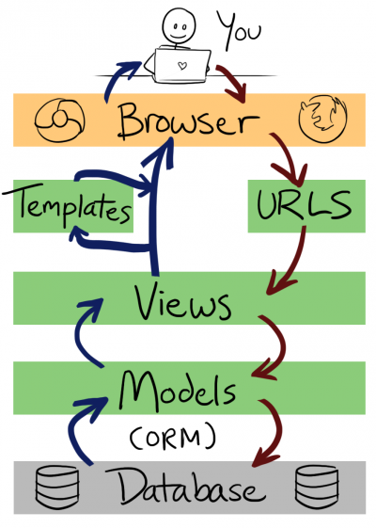

Figure 4.4 E-Shopper Application Architecture (MVT Application Design Patten)
Source: (Openhatch, 2018)

4.4 REQUIREMENT SPECIFICATION
A System Requirements Specification (SRS) (also known as a Software Requirements Specification) is a document or set of documentation that describes the features and behavior of a system or software application. It includes a variety of elements that attempts to define the intended functionality required by the customer to satisfy their different users. What the software will do and how it will be expected to function is fully described under requirements specification. In addition to specifying how the system should behave, the specification also defines at a high-level the main business processes that will be supported, what simplifying assumptions have been made and what key performance parameters will need to be met by the system. It outlines functional and non- functional requirements and may include a set of use cases that describe user interactions that the system must provide. Requirements specification allows a thorough analysis of requirements before design can start hence, reducing later redesign.

4.4.1 FUNCTIONAL REQUIREMENTS
Functional requirements describe in detail a system’s intended capabilities, appearance and interactions with users. It usually consists of a hierarchical organization of requirements, with the business/functional requirements at the highest-level and the detailed system requirements listed as their child items. The functional requirements for a system usually involves the user interface and describe each of the possible user input actions and the system’s response actions. Functional requirements therefore specify particular results of a system and it drives the application architecture of a system. Generally, the requirements are written as statements such as "System needs the ability to do x" with supporting detail and information included as necessary. It serves as a kind of guideline and continuing reference point as the system is being developed.
The system will have the following functional requirements:
- An administrator will be able to login and customize the system to the needs of the shop.
- Through the administrator’s panel, the system allows the manager to generate reports of orders, delete products and orders, and approve comments among others.
- The administrator can create multiple accounts for different users to perform specific actions like accepting orders, managing product stock etc.
- The administrator can check product inventory, accept orders and approve product reviews.
- Online Shoppers will be able to create an account so as to login to their portal and see their Order history etc.
- Online Shoppers will be able to place orders and receive notifications of their others in their emails.
- Online Shoppers can choose the language of their choice first.
- Online Shoppers can review products with comments.
- Online Shoppers can also pay online before their orders are placed successfully

4.4.2 NON-FUNCTIONAL REQUIREMENTS
Non-functional requirements essentially specify how a system should behave or work and also are a constraint upon the system’s behavior. They specify criteria that judge the operation of a system rather than specific behaviors. They also describe various attributes which affect the functionality’s effectiveness. It specifies the requirements that essentially embody the technical environment that the product needs to operate in and include the technical constraints that it needs to operate under. These technical requirements are critical in determining how the higher-level functional requirements will get decomposed into the more specific system requirements. Non-functional requirements do not alter a system’s functionality that is, the functional requirements remain the same regardless of the attributes attached to them. Non-functional requirements make up a significant part of the specification in that, users or clients may judge a system based on its non-functional requirements.
Below are the non-functional requirements our system will achieve:
- Performance
The system will be an interactive one hence the delays involved will be less in that there are no immediate delays in every action-response of the system.
- Reliability
As the system is meant for online shopping, the system will be reliable in that it will consistently perform according to its specification so as to enable users make place orders as and when they want to without any system failure.
- Maintainability
A system should be developed in such a way that it can evolve to meet the changing needs of a customer. The system will be developed in such a way that it can be customized to meet a particular vendor’s needs or preference.
- Ease of use
The system will ensure ease of use in that little training time will required to know how to use the system. The user interface will also be friendly so users will have ease when using the system.
- Scalability
It is the ability of a system to continue to function well when it is changed in size or volume to meet a user need. The system will be developed to fit onto any device such as a smartphone, laptop, tablet or desktop.
- Security
It is a system attribute that reflects the ability of a system to protect itself against external attacks, which may be deliberate or accidental. The system will be developed in such a way that proper login mechanism would be put in place to protect user accounts.
- Safety
The system will ensure safety so that information about orders placed is securely transmitted to the server without any changes in the information. PayPal Payment System is recognized internationally for it secure environment for online secured payments.

4.5 USE CASE MODELLING
UML (Unified Modelling Language) is a standard language for specifying, visualizing, constructing, and documenting the artefacts of software systems. A use-case model is a model of how different types of users interact with the system to solve a problem. It therefore describes the goals of the users, the interactions between the users and the system and the required behavior in satisfying these goals.

4.5.1 USE CASE DIAGRAMS
A use-case diagram describes a system's functional requirements in terms of use cases. It is a model of the system's intended functionality (use cases) and its environment (actors). Use cases enable you to relate what you need from a system to how the system delivers on those needs.
Think of a use-case model as a menu, much like the menu you'd find in a restaurant. By looking at the menu, you know what's available to you, the individual dishes as well as their prices. You also know what kind of cuisine the restaurant serves: Italian, Mexican, Chinese, and so on. By looking at the menu, you get an overall impression of the dining experience that awaits you in that restaurant. The menu, in effect, "models" the restaurant's behavior. It shows a subset of the model elements relevant for a particular purpose. Below is a table of use case symbols and their representations.

Table 4.0 Use case symbols and their meanings.

SYMBOL | TERM AND REPRESENTATION

Actor: An actor represents roles for users of a


system, including human users and other

systems. An actor is external to a system.

Association: An association correspond to a

sequence of actions between the actors and use

case in achieving the use case.

Use case: A use case represents a user goal that


can be achieved by accessing the system.

The actors involved with the system are:
Customer: This actor is one of the main beneficiaries of the system. The customer can order products using the system.
Manager: This actor is also another beneficiary of the system. Customizing the system to his preference, editing products, approving orders and product reviews are some of the activities of this actor.
System: This actor is responsible for generating reports and sending confirmation messages among others. It however requires the administrator inputs to generate the reports.
Below are the use case diagrams for the system together with their descriptions:

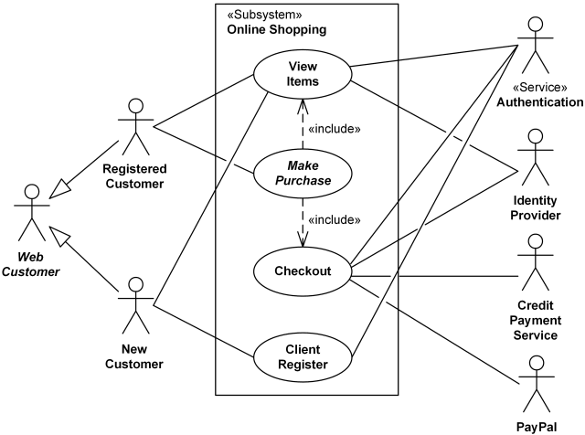

Figure 4.5 Use case diagram for customer

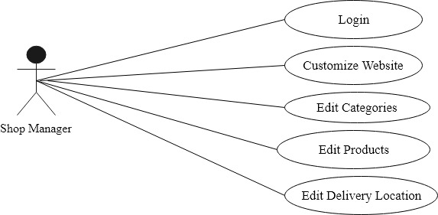

Figure 4.6 Use case diagram for Shop Owner

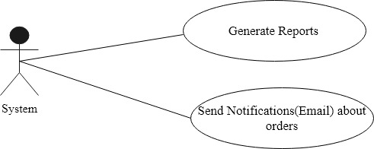

Figure 4.7 Use case diagram for system

Application Use Case Scenarios

Table 4.1 Customer Registration
Use Case Name | Register
Actor | Customer
Description | Enables new customers to create an account by
 | entering their credentials.
Steps Performed | 1. | Click on sign up
 | 2. | Enter personal details and password.
 | 3. | Click on sign up button.

Table 4.2 Customer login
Use Case Name | Login
Actor | Customer
Precondition | Customer should have already registered.
Description | Enables existing customers to have access to
 | the system’s functionality using valid
 | credentials.
Steps Performed | 1. | Click on login
 | 2. | Enter username and password.
 | 3. | Click on login.

Table 4.3 View Products
 | Use Case Name | View Products
 | Actor | Customer
 | Description | Enables a customer to view products available
 |  | together with their prices.
 | Steps Performed | Go to the website using a web browser.
 | Table 4.4 Placing Orders
 | Use Case Name | Placing an Order
 | Actor | Customer
 | Precondition | Customer can login or choose not to login.
 | Description | Enables customers to order products which is
 |  | successful after they have proceeded with the
 |  | payment.
 | Steps Performed | 1. |  | Enter quantity
 |  | 2. |  | Click on add to cart button to add
 |  |  |  | product to cart.
 |  | 3. |  | Click on Proceed to checkout.
 |  | 4. |  | Enter confirmation and payment details
 |  |  |  | and click on Place now.
 |  | 5. |  | Proceed with payment using either
 |  |  |  | debit card.
Table 4.5 Shop Manager Login
Use Case Name |  |  | Login
Actor |  |  | Manager
Description |  |  | Enables a manager to access the system’s
 |  |  | functionality available to perform managerial
 |  |  | duties.
Steps Performed |  |  | 1. |  | Proceed to admin Panel.
 |  |  | 2. |  | Enter username and password.
 |  |  | 3. |  | Click on login.

Table 4.6 Editing Products
Use Case Name | Edit Products
Actor | Manager
Description | Enables a manager to make changes to available products such as adding new product, deleting product not available as well as upload images for the various products.
Precondition | Manager should login.
Steps Performed | 1. | Click on products.
 | 2. | Make changes to the product by adding,
 |  | editing or deleting.

Table 4.7 Edit Product Category
Use Case Name | Edit Product category
Actor | Manager
Description | Enables the manager to group products based on its category.
Precondition | Manager should login.
Steps Performed | 1. | Click on categories
 | 2. | View all categories.
 |  | 3. Make the necessary changes by adding, editing or deleting categories.

Table 4.8 Report Generation
Use Case Name | Generate Report
Actor | System
Description | Generates reports on periodic basis.
 | 1. | Click on report on the manager’s
Steps Performed |  | interface.
 | 2. | Enter the period, that is start and end
 |  | date desired for report.

Table 4.9 Send SMS/Email
Use Case Name | Send SMS/Email
Actor | System
Description | Sends order confirmation to the customer and
 | order details to the vendor via Email.
 | When an order is successful after payment, the
Steps Performed | system automatically sends an email
 | to the customer.

4.5.2 SEQUENCE DIAGRAM
Sequence diagrams are the most common kind of interaction diagrams that shows how actors and objects interact to realize a use case scenario. It focuses on the message interchange between a number of lifelines. The Sequence Diagram models the collaboration of objects based on a time sequence. It shows how the objects interact with others in a particular scenario of a use case. We normally draw a sequence diagram if we have a use case, to describe how the main components of the system interact. Then again sequence diagram helps us identify messages arriving at an interface of a component, to describe how the internal parts of the component interact.

Table 4.10 Sequence diagram symbols and their meanings

SYMBOL |  |  |  |  | TERM & MEANING
 |  |  |  |  | An actor: Is an entity or system that derives benefit from and is external to the system. Participates in a sequence by sending and/or receiving messages.
 |  |  |  |  | An object: Participates in a sequence by sending and/or receiving messages.
 | An Object: a class
 |  |  |  |  | A lifeline: Represents the life of an object during a sequence.
 |  |  |  |  | A focus of control: Is a long narrow rectangle
 |  |  |  |  | placed on or above a lifeline. Denotes when an
 |  |  |  |  | object is sending or receiving messages.
 |  |  |  |  | A message: Conveys information from one
 |  |  |  |  | object to another.
 | A Message ()
 |  |  |  |  | Object destruction: An X is placed at the end
 | X |  |  |  | of an object’s lifeline to show that it is going
 |  |  |  |  | out of existence

Sequence Diagram for Customer Use Case



:Home |  | :Login |  | : Login |  | :Dashboard |  | :Logout
 |  | Page |  | Page
Customer
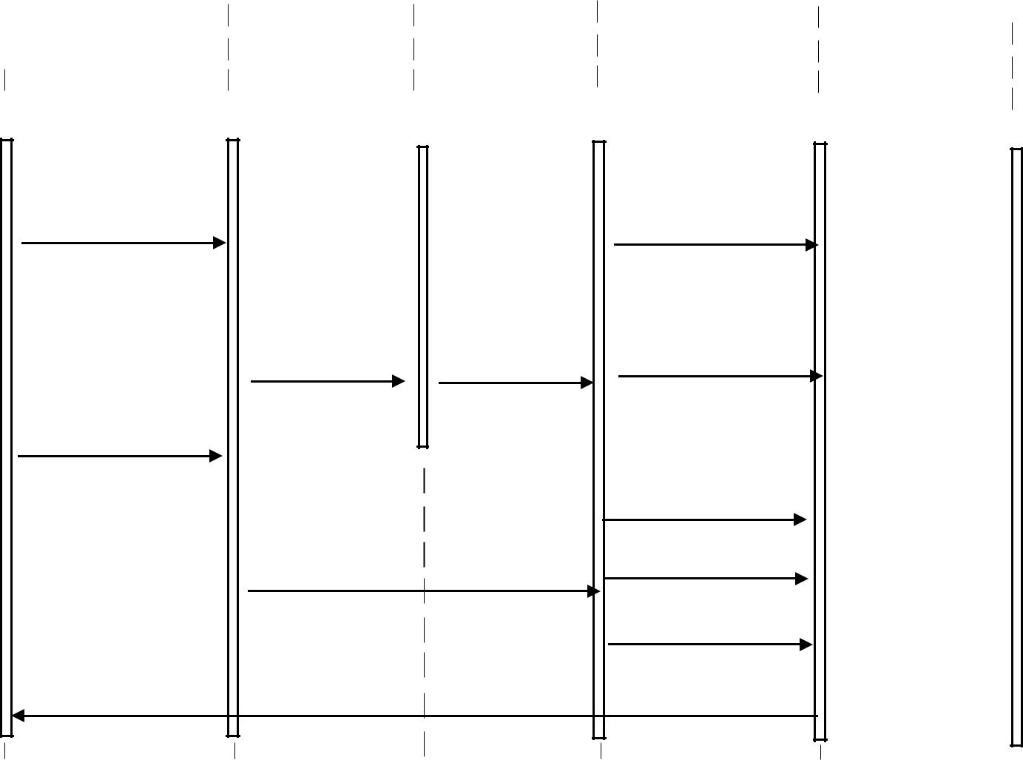

Visit Shop() |  | View Product()
New Customer
signup() | logon() | Send feedback()

View Product()

Place order()

Existing Customer logon() Make payment() logout()

Checkout()

Success messages()

Figure 4.8 Sequence diagram for the customer use case.

Sequence Diagram for Manager Use Case

:Manager |  | :Manager |  | :Other |  | :Logout
Login Page |  | Dashboard |  | Activities


Manager

 |  |  |  |  |  |  | Customize website()
Manager logon() |  |  |  |  |  |  | Edit Product category()
 |  |  |  |  |  |  | Edit menu()
Move |  |  | manager to dashboard() |  |  |  | Edit Delivery locations()
 |  |  |  |  |  |  | Approve Orders() |  |  | logon()
 |  |  | Success messages() |  |  |  | Approve Orders() |  |  | logon()
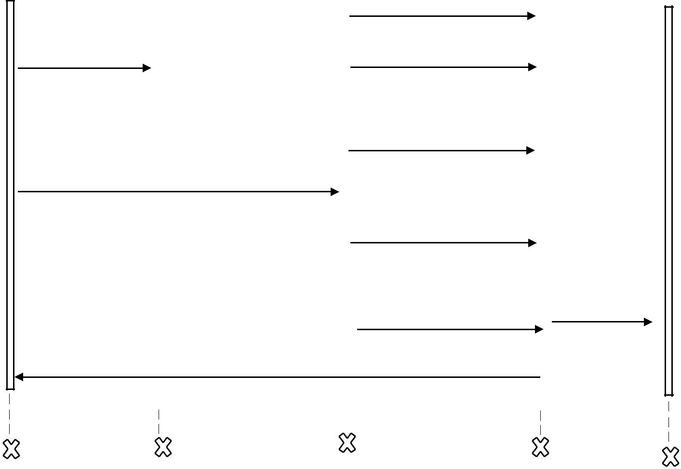

Figure 4.9 Sequence diagram for the Manager use case.

4.5.3 ACTIVITY DIAGRAM
Activity diagrams are graphical representations of workflows of stepwise activities and actions with support for choice, iteration and concurrency. It describes the flow of control of the target system, such as the exploring complex business rules and operations, describing the use case also the business process. In the Unified Modelling Language, activity diagrams are intended to model both computational and organizational processes (i.e. workflows).
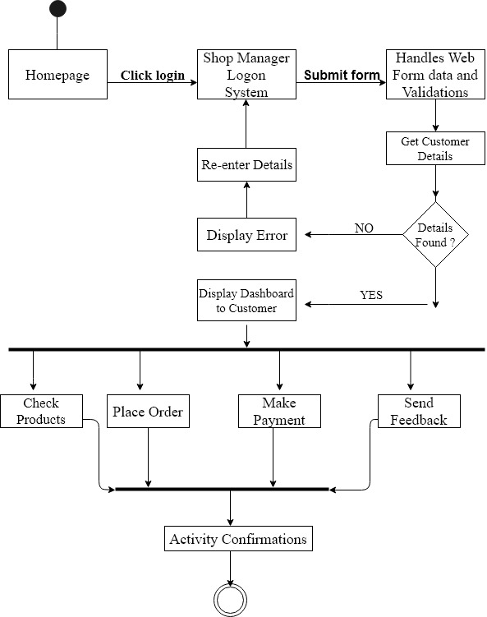

Figure 4.10 Activity diagram for the customer’s use case

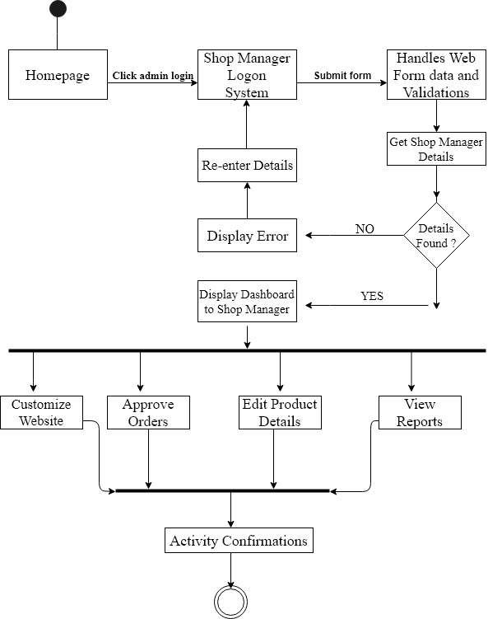

Figure 4.11 Activity diagram for the Manager use case

4.5.4 CLASS DIAGRAM
The class diagram is a central modelling technique that runs through nearly all object-oriented methods. This diagram describes the types of objects in the system and various kinds of static relationships which exist between them.
- Relationships
There are three principal kinds of relationships which are important:
- Association - represent relationships between instances of types (a person works for a company a company has a number of offices.
- Inheritance - the most obvious addition to ER diagrams for use in OO. It has an immediate correspondence to inheritance in OO design.
- Aggregation - Aggregation, a form of object composition in object-oriented design.
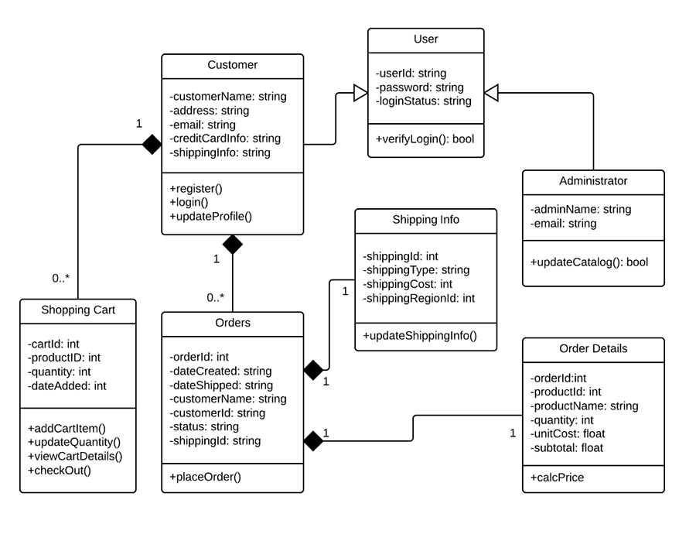

Figure 4.12 Class diagram for the ecommerce system

4.6 DATABASE DESIGN
Database is any collection of data, or information, that is specially organized for rapid search and retrieval by a computer. Databases are structured to facilitate the storage, retrieval, modification, and deletion of data in conjunction with various data-processing operations. A database is stored as a file or a set of files on magnetic disk or tape, optical disk, or some other secondary storage device. The information in these files may be broken down into records, each of which consists of one or more fields. Fields are the basic units of data storage, and each field typically contains information pertaining to one aspect or attribute of the entity described by the database. Records are also organized into tables that include information about relationships between its various fields.
Database Design is a collection of processes that facilitate the designing, development, implementation and maintenance of enterprise data management systems. The main objectives of database designing are to produce logical and physical designs models of the proposed database system.
The logical model concentrates on the data requirements and the data to be stored independent of physical considerations. It does not concern itself with how the data will be stored or where it will be stored physically.
The physical data design model involves translating the logical design of the database onto physical media using hardware resources and software systems such as database management systems (DBMS).
A well-designed database gives access to up-to-date and accurate information. The Entity-Relationship (ER) model, Unified Modelling Language (UML), Relational Model (RM) among others are some of the models used by database designers. The Entity-Relationship (ER) model was used for our database design.

4.6.1 ENTITY RELATIONSHIP MODEL
An entity relationship diagram (ERD), also known as an entity relationship model, is a graphical representation of an information system that depicts the relationships among people, objects, places, concepts or events within that system. An ERD is a data modelling technique that can help define business processes and be used as the foundation for a relational database.
An ER diagram is a means of visualizing how the information a system produces is related. There are five main components of an ERD:

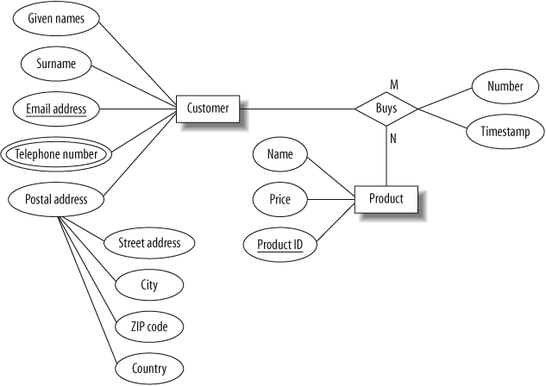

Figure 4.13 ER diagram for the customer model

4.7 NORMALIZATION
Database Normalization is a technique of organizing the data in the database. Normalization is a systematic approach of decomposing tables to eliminate data redundancy(repetition) and undesirable characteristics like Insertion, Update and Deletion Anomalies. It is a multi-step process that puts data into tabular form, removing duplicated data from the relation tables.
Normalization is used for mainly two purposes: Eliminating redundant(useless) data and ensuring data dependencies make sense i.e. data is logically stored.
- Insertion Anomaly:
It occurs when certain attributes cannot be inserted or entered into the database without the presence of other attributes.
- Update Anomaly:
An update anomaly exists when one or more instances of duplicated data is updated but not all.
- Deletion Anomaly:
This is when certain attributes are lost because of the deletion of other attributes.

4.7.1 NORMALIZATION RULE
Normalization rules are divided into the following normal forms:
- First Normal Form
- Second Normal Form
- Third Normal Form
- Boyce and Codd Normal Form (BCNF)
First Normal Form (1NF):
The rule for First Normal Form states that no two rows of data must contain repeating group of information, therefore each set of columns must have a unique value. To ensure tables in the project are in First Normal Form, it should follow the following 4 rules:
- It should only have single(atomic) valued attributes/columns.
- Values stored in a column should be of the same domain
- All the columns in a table should have unique names.
- And the order in which data is stored, does not matter.
Second Normal Form (2NF):
A table is said to be in 2NF if it is in 1NF and there is no partial dependency of any column on the primary key. To ensure tables in the project are in the Second Normal Form:
- It should be in the First Normal form.
- And, it should not have Partial Dependency.

Third normal Form (3NF):
It applies that a table must be in 2NF and every non-prime attribute of the table must be dependent on the primary key and hence cannot be determined by another non-prime attribute. To ensure tables in the project are in the Third Normal Form:
- It is in the Second Normal form.
- And, it doesn't have Transitive Dependency.
- Boyce and Codd Normal Form (BCNF)
Boyce and Codd Normal Form is a higher version of the Third Normal form. This form deals with certain type of anomaly that is not handled by 3NF. A 3NF table which does not have multiple overlapping candidate keys is said to be in BCNF. To ensure tables in the project are in the BCNF, following conditions must be satisfied:
- R must be in 3rd Normal Form
- and, for each functional dependency (X → Y), X should be a super Key.
The database for this project is normalized in the Third Normal Form (3NF) to ensure data redundant data is eliminated that is, all data is stored in only one place and also to ensure data dependencies are logical which means all related data items are stored together.

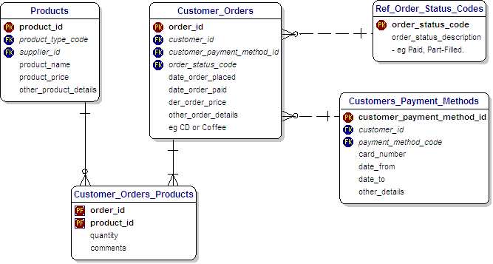

Figure 4.14 Normalized database for all tables

4.8 USER INTERFACE DESIGN
User interface design or UI design generally refers to the visual layout of the elements that a user might interact with in a website, or technological product. This could be the control buttons of a radio, or the visual layout of a webpage. User interface designs must not only be attractive to potential users but must also be functional and created with users in mind. The goal of user interface design is to make the user's interaction as simple and efficient as possible, in terms of accomplishing user goals (user-cantered design). Good user interface design facilitates finishing the task at hand without drawing unnecessary attention to itself.
During the system development phase, several UI design features like input controls which includes textboxes, radio buttons, checkboxes, date fields, dropdown lists etc. For example, when a customer wants to place an order, recommendations will be made on the products they select to help the customer order with ease. The use of navigation components such as pagination, search field, slider, icons, tags etc. will be used to make user interactions with the website easier. Information components like notifications, messages boxes, contact forms etc. will also be used to help the user get quick feedbacks from the system.
The following best User interface design practices used in Software and website Development will be used in the user interface (UI) design for this project:
- Clarity:
The interface will be designed with the customer who will make the orders in mind. The information content is conveyed quickly and accurately. The interface will be simple for the customer to navigate easily.

- Consistency:
A unique design, conformity with user's expectation in mind. The UI design elements that would be used in the system implementation will be consistent throughout the site. This will help the user to be familiar with certain UI elements so that they will not be using different elements for similar operations.

- Conciseness:
Users will not be overloaded with extraneous information. Consideration would be made for the spatial relationships between items on the page and structure the page based on importance. Careful placement of items would help draw attention to the most important pieces of information and can aid scanning and readability.
- Strategically use color and texture:
Direct attention would be drawn towards or redirected away from items using colour, light, contrast, etc. The intention is to blend colors that will make the website nice and simple.
- Detectability:
Carefully consideration will be made on how to use typeface to help draw the user's attention towards information required. Different sizes, fonts, and arrangement of the text to help increase scan ability, legibility and readability of the user.
- Comprehensibility:
It is imperative to inform users of location, actions, changes in state, or errors. The use of various UI elements to communicate status and, if necessary, next steps can reduce frustration for users and that is exactly what will be done during the implementation of the system. This makes the meaning clearly understandable, unambiguous, interpretable, and recognizable.
- Thinking about the defaults:
By carefully thinking about and anticipating the goals people bring to our site, we can create defaults that reduce the burden on the user. This becomes particularly important when it comes to form design where you might have an opportunity to have some fields pre-chosen or filled out.

4.9 SUMMARY
This chapter focused on the analysis and design of the system which were the general system and application architecture, requirements specification, functional and non-functional requirements, use case modelling, the database design, Entity Relationship diagram, Normalization, and User interface design. Outline for the requirement specification of the system which included both functional and non-functional requirements and the hardware requirements were explained. Further explanation on the various Unified Modelling languages used in modelling the system were discussed. This included use case diagrams, activity diagrams, class diagrams and sequence diagrams. These diagrams provided a pictorial view of the relationships between the various entities or users of our system. Also, the design of the system’s database including the Entity-Relationship (ER) diagram and the importance of database normalization were elaborated including the database being normalized in the third normal form (3NF). Finally, the user interface was looked at including how the user interface will look and why it was necessary for the interface to be user friendly.

CHAPTER FIVE

5.0 SYSTEM IMPLEMENTATION

5.1 INTRODUCTION
System implementation and deployment is the part in which the system will be implemented and deployed into real life to be used. The system can only be implemented and deployed when the system design and analysis is completed.
This chapter details out the implementation of the system. This include mapping logical design onto physical platform, the construction which consist of screen shots of forms, databases and reports among others. The chapter will also outline the various testing that were performed on the system, that is unit and system testing and the results obtained.

5.2 MAPPING LOGICAL DESIGN ONTO PHYSICAL PLATFORM
Logical design involves arranging data into a series of logical relationships called entities and attributes. Here, we defined the various fields for the database schema. Customer first names, e-mail, shipping address and other details were converted into first_name, email and shipping_address respectively. The Django framework and the other development tools were used to develop the various model of the project and linked them together. The next sub-topic gives a graphical view of the various outputs after transforming the logical design into executable codes.

5.2.1 HARDWARE REQUIREMENTS

The minimum hardware requirement in develop this system are listed as below:

Table 5.0 Hardware Requirements
Hardwar Description | Minimum Requirements
Processor | Intel Pentium D 3.4GHz / AMD Athlon II X2 250 u (Minimum)  Intel Core 2 Duo E4400 2.0GHz / AMD Athlon 64 X2 Dual Core 4600+ (Recommended)
Memory | 1 GB RAM Recommended, 256 MB RAM (Minimum)
Hard Disk Space | Up to 3 GB Recommended
Display | 65536 colours, set to at least 1024 X 768 Resolution

5.2.2 SOFTWARE REQUIREMENTS

The minimum software requirement in develop this system are listed as below:

Table 5.1 Software Requirements

Software Description | Minimum Requirements
Operating System (OS) | All 32-bits Microsoft Windows  (95/98/2000/XP/7/8)
Web Browsers | Mozilla Firefox (15.0 & above), Internet  Explorer (8.0 & above), Google Chrome  (20.0 & above).

5.3 CONSTRUCTION
This section focuses on the pictorial view of the user interface including the various forms, databases and reports. Below are various screen shots showing how the system was constructed.
The screenshots of the various tables constructed are shown below:

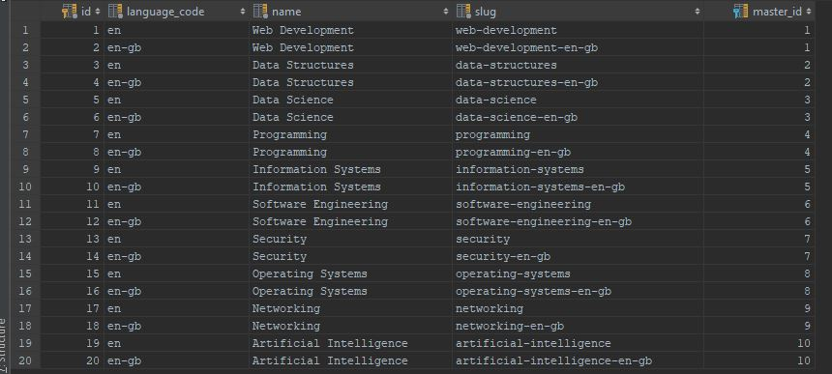

Figure 5.0 Database table for categories

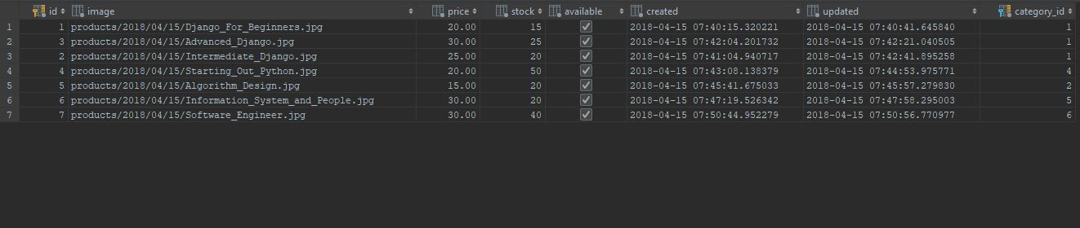

Figure 5.1 Database table for product

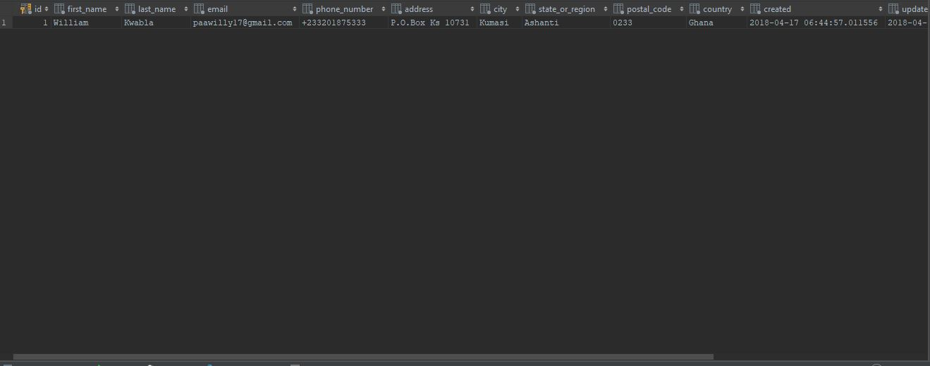

Figure 5.2 Database table for orders

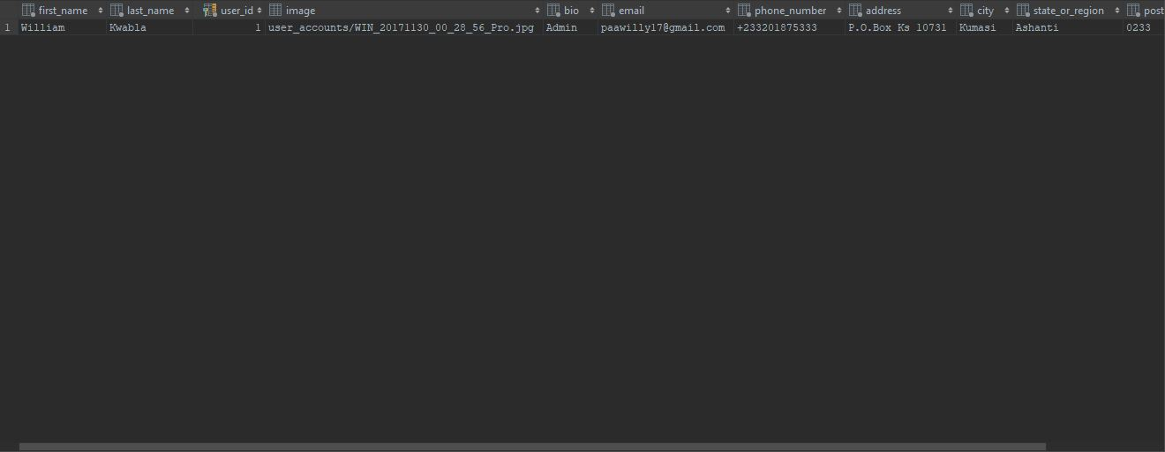

Figure 5.3 Database table Customer Profiles

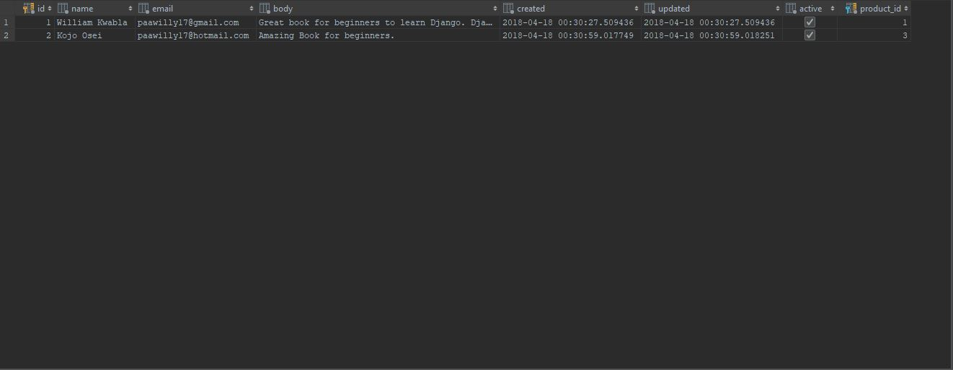

Figure 5.4 Database table for Product Review

5.3.1 USER INTERFACES
As we mentioned in the previous chapter about how the user interface would be designed, below are the narrations and screenshots of the various user interfaces of the system.
- Narration for Customers and Online Shoppers who will use the system
Once a user visits the e-shopper website, it takes them to the homepage of the website (Figure 5.5) where they can choose a language of their choice (Figure 5.6) before they start shopping. For example, when they choose Spanish, the website converts every text to Spanish (Figure 5.7). The user can then click on the shop in the menu bar and it takes them to shop page with a list of all book categories and the books listed (Figure 5.8). Once they select a particular book, it takes them to the book’s detail page where they can find detailed information about the book, they can also select the quantity of the book they want to buy and can write review on the book. The system also recommends other books people buy with the book the user has selected (Figure 5.9). Once the user selects the quantity of books they want to buy and add it to the cart, it takes them to the cart page where they see the total of their order, they can apply a coupon for discount and they can then click on the checkout button (Figure 5.10). The checkout takes them to the checkout page where they can fill in their shipping details and place their order (Figure 5.11). Once they place their order, the system sends them an email of the order and it takes them to the payment process page (Figure 5.13). When they click on the “Buy Now” on the payment process page, it sends them to the PayPal page to finalize the payment (Figure 5.14). PayPal sends them an email notification where the payment was successful (Figure 5.15) or not and then redirects them to either the system’s successful (Figure 5.16) or unsuccessful (Figure 5.17) page respectively. PayPal also sends notification of the transaction to the system for the shop manger to know whether the shopper has paid for their order before they ship out the order.
Shoppers can register on the site to be customers by clicking on the Account button in the navigation bar. It sends them to “Register Account” page where they can register as regular customers (Figure 5.18). The system sends them an email with a link for them to activate their account. When they click on the link, it takes them to the “Login” page for them to login into the system (Figure 5.19). After a successful login, it takes them to their dashboard where they can create their profiles if they have none (Figure 5.20 and Figure 5.21). Once they logout of the system, it takes them to “Logout” page (Figure 5.22).
Customers and Shoppers can contact customer service either through a “live chat” support (Figure 5.23) or contact form on the “Contact Us” page (Figure 5.24). After they submit message successfully, it takes them to “Message sent” page indicating the message was sent successfully with a notification they will get a feedback soon.
- Narration for the Shop Manager who will use the system.
A shop manager will use the system to add, delete, modify categories, products and orders. The system will give them analytics of the number of people visiting the website every day. They can also see the number customers registered and can send newsletters to subscribers. The shop managers can also add coupons and create separate accounts for different users like marketers, sales managers, customer service and accounts managements.
The shop managers can navigate to the management page by visiting eshopper.com/shop-admin where they would be greeted by a “Login” page (Figure 5.26) for them to login. Once they login, it takes them management dashboard which has different tabs for various tasks such as a tap for the analytics of the number of people visiting the website every day, also various tab for them to add, delete, modify categories, products, orders, coupons, approve reviews, and recent actions (Figure 5.27).

- Below are screenshots of the various user interfaces of the system

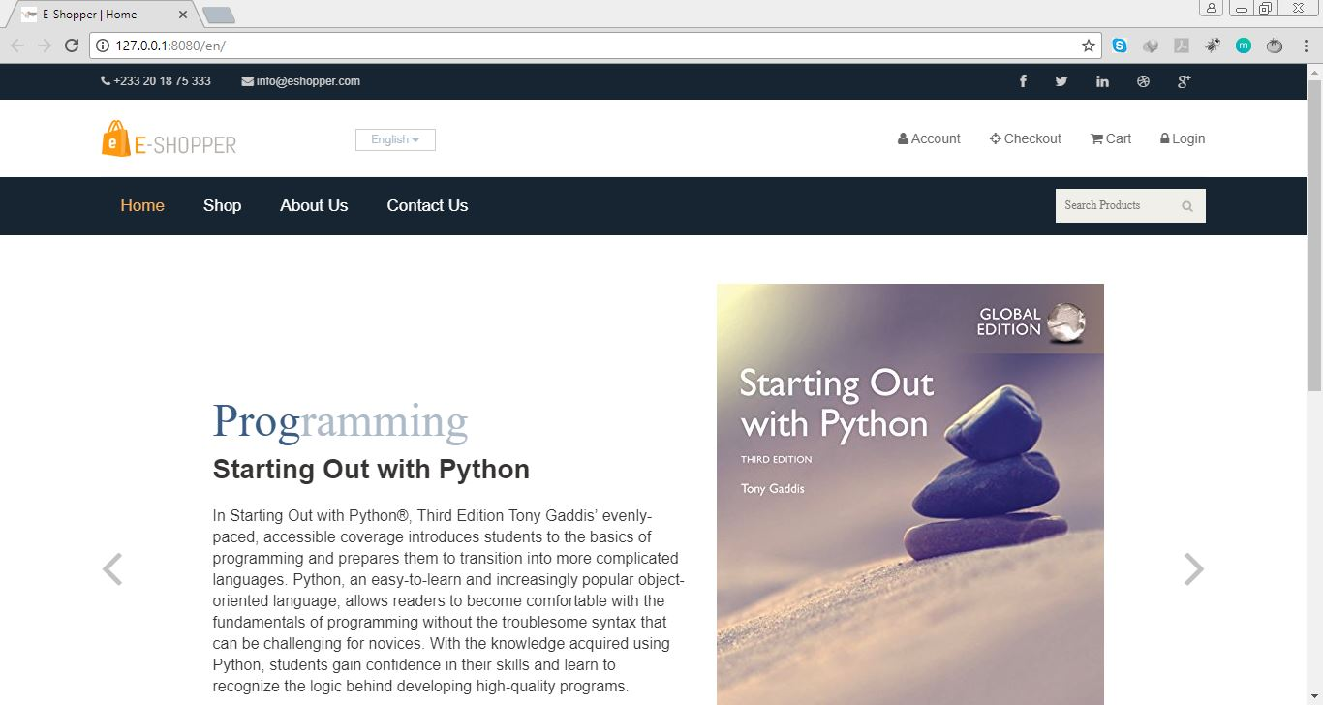Figure 5.5 Homepage of the application with a slideshow of some of the books sold.

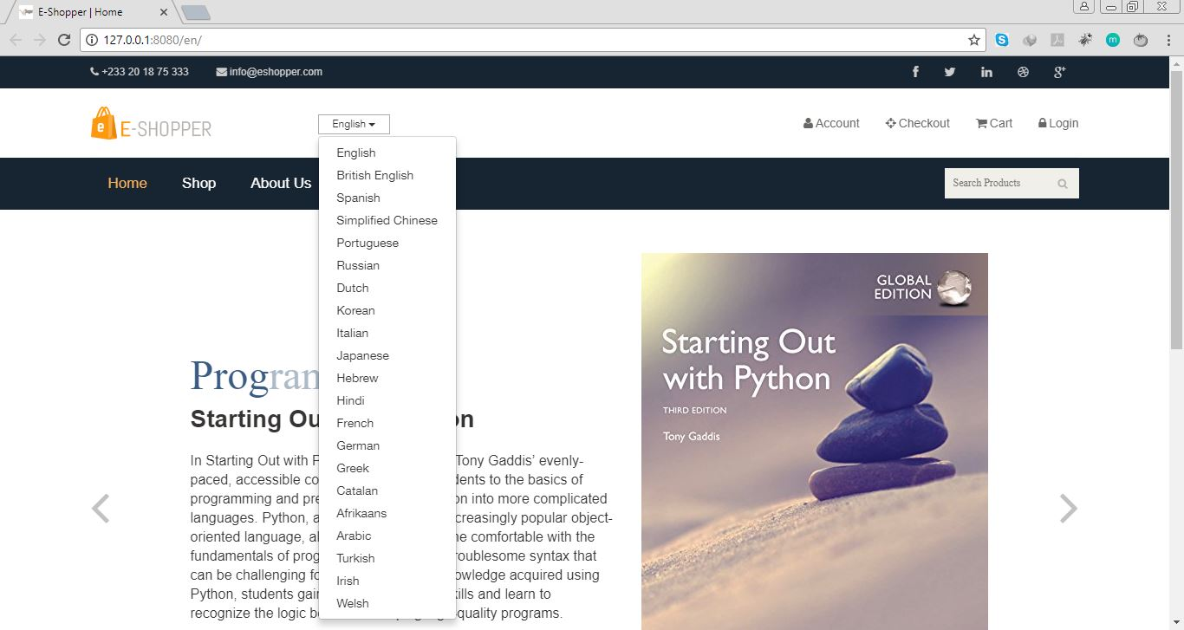Figure 5.6 Homepage with a dropdown of 21 languages available for customers to choose before they start shopping.
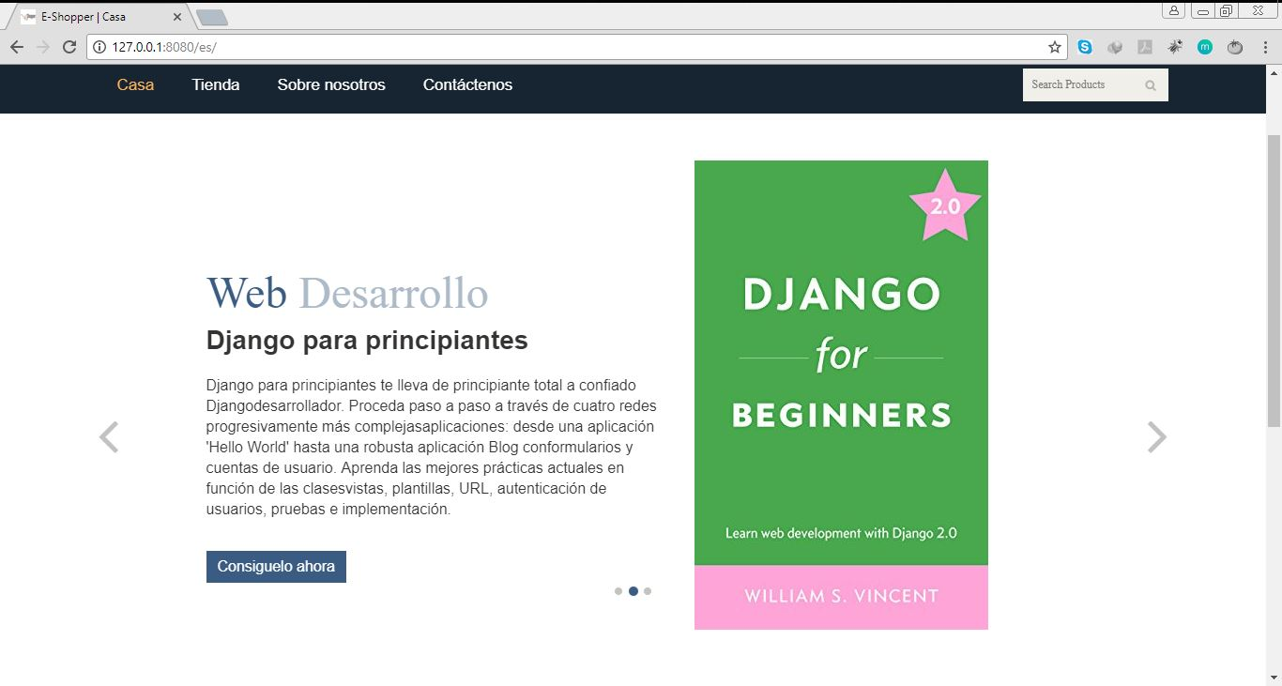

Fig 5.7 Homepage and URL after Spanish is selected.

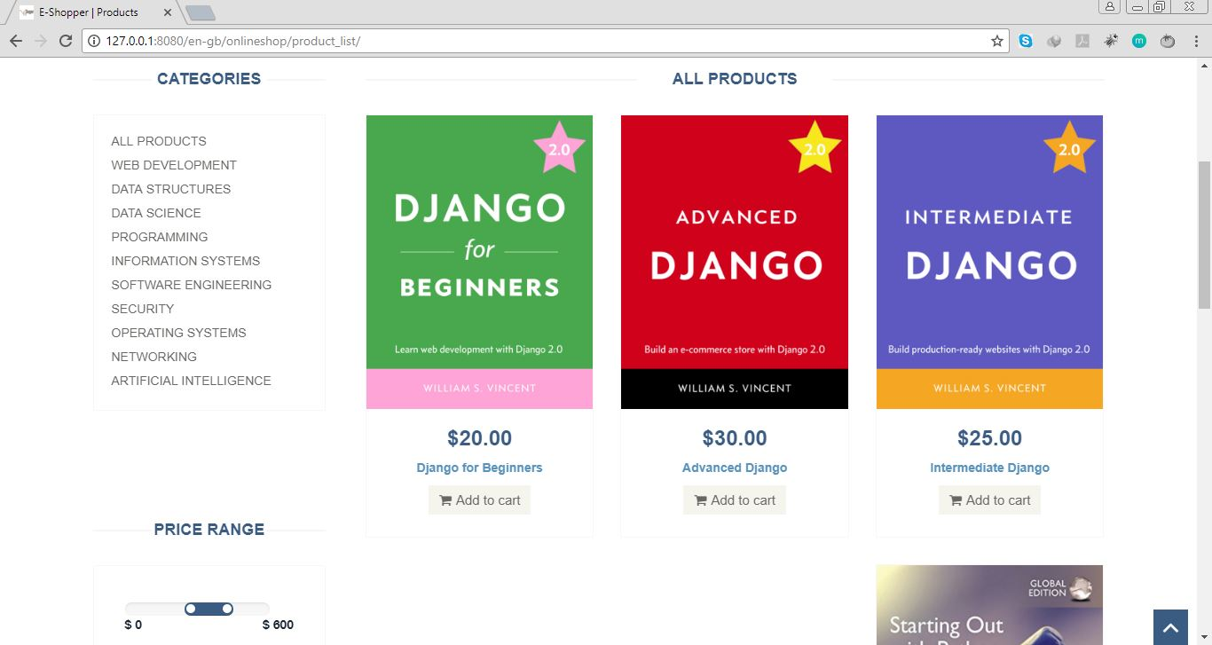

Fig 5.8 Shop or Product list page with Categories



Figure 5.9 Product Detail Page

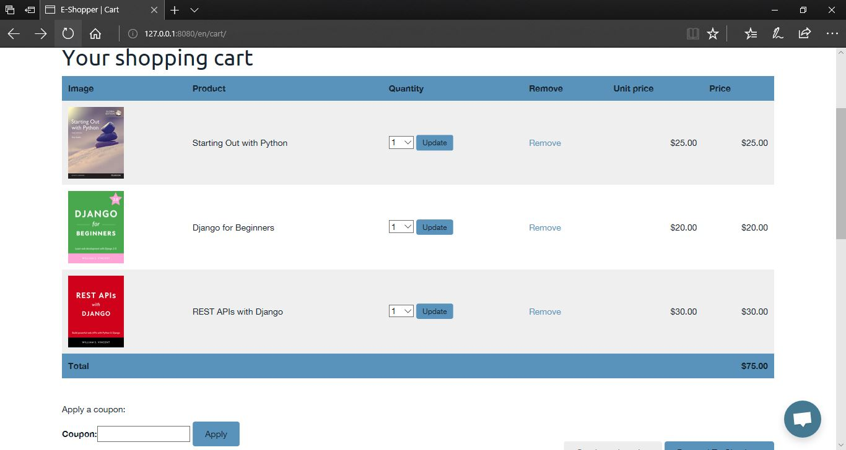

Figure 5.10 Cart Page

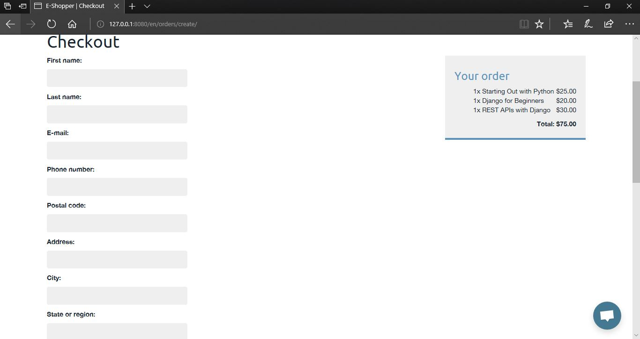

Figure 5.11 Checkout Page with cart.
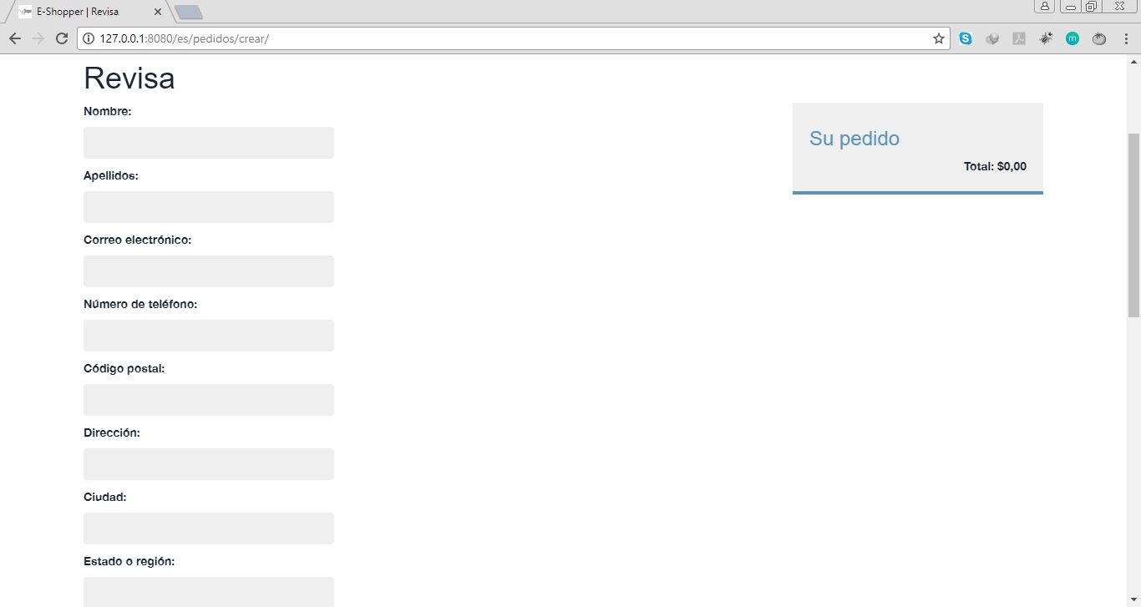

Figure 5.12 Checkout Page with empty cart in Spanish.

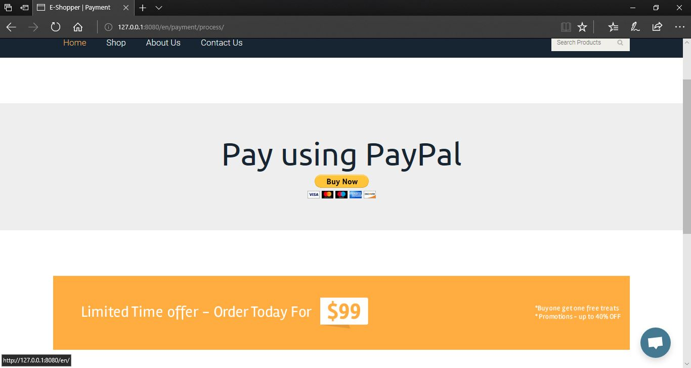

Figure 5.13 Proceed to Payment Page

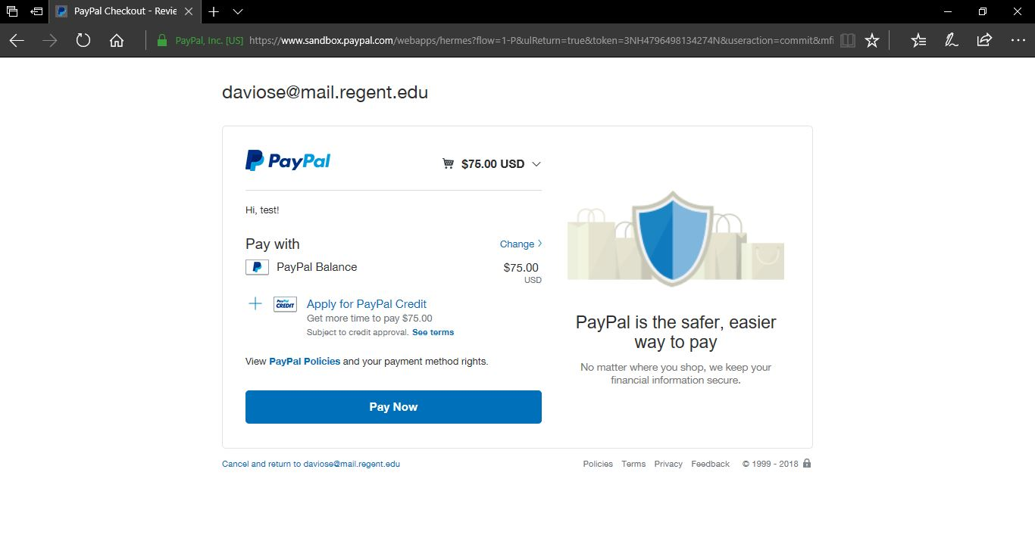

Figure 5.14 PayPal Payment page

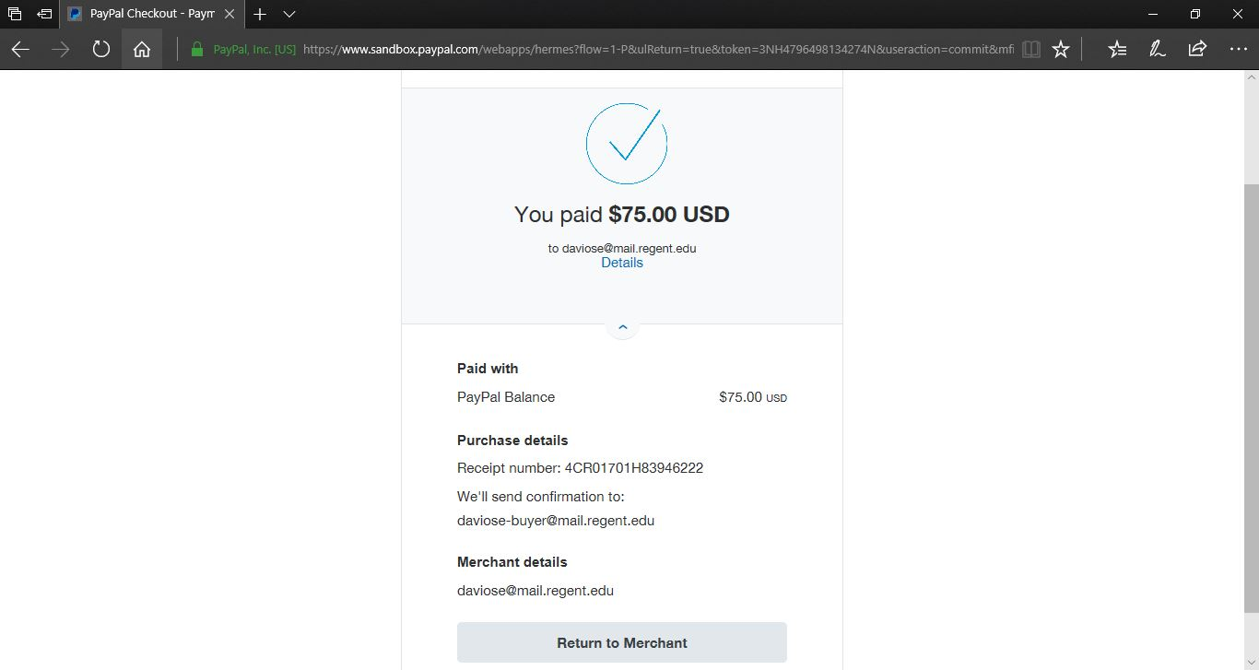

Figure 5.15 PayPal Successful Payment page

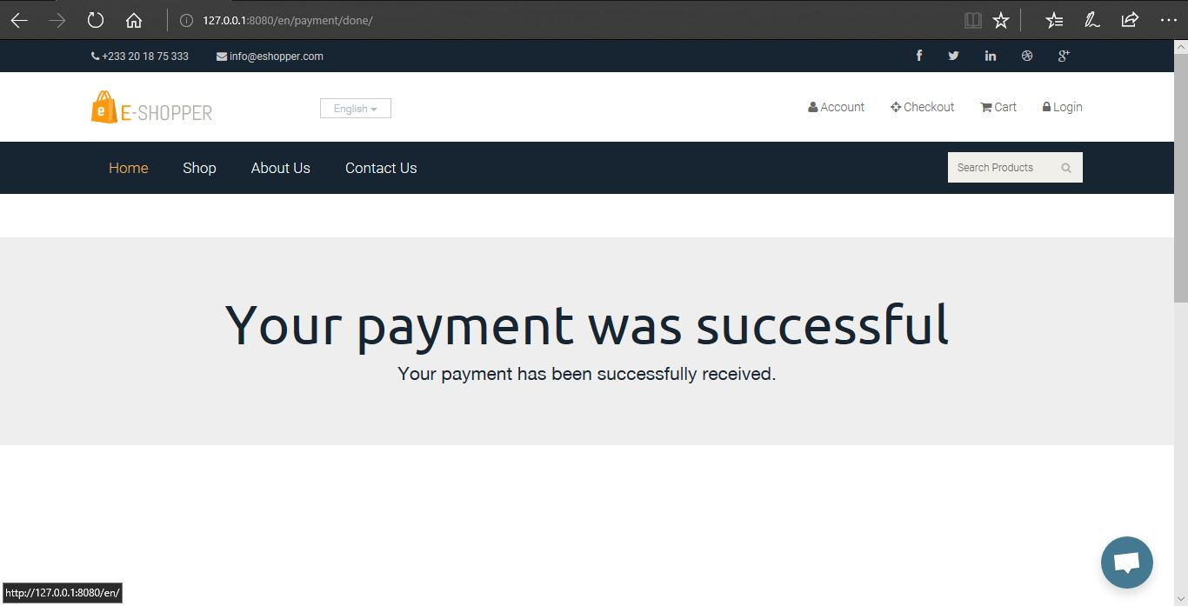

Figure 5.16 Successful Payment Page

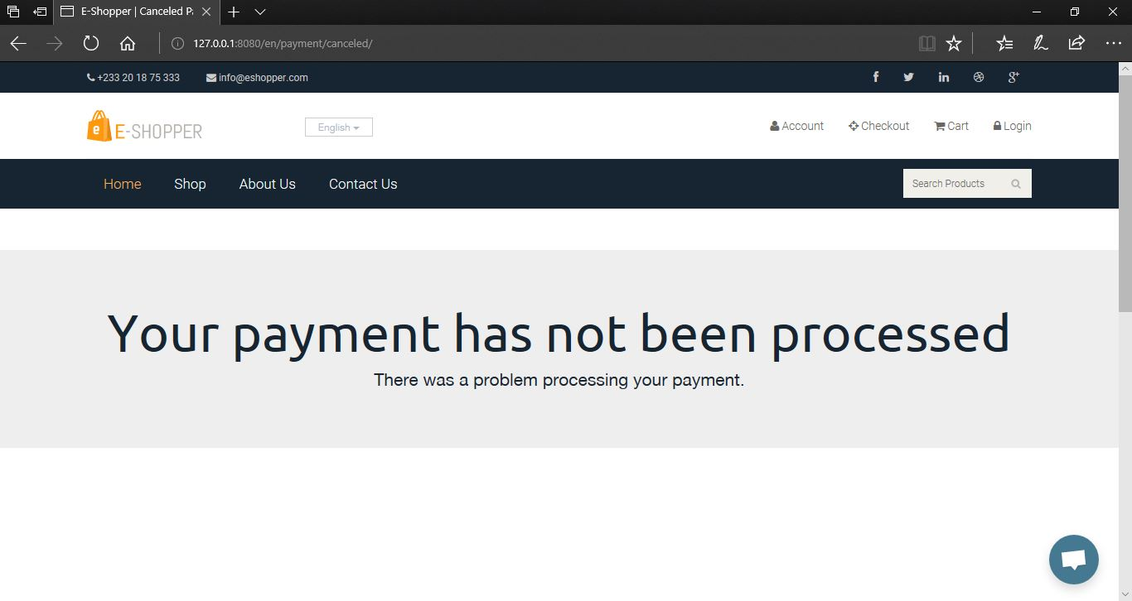

Figure 5.17 Cancelled or Unsuccessful Payment Page.

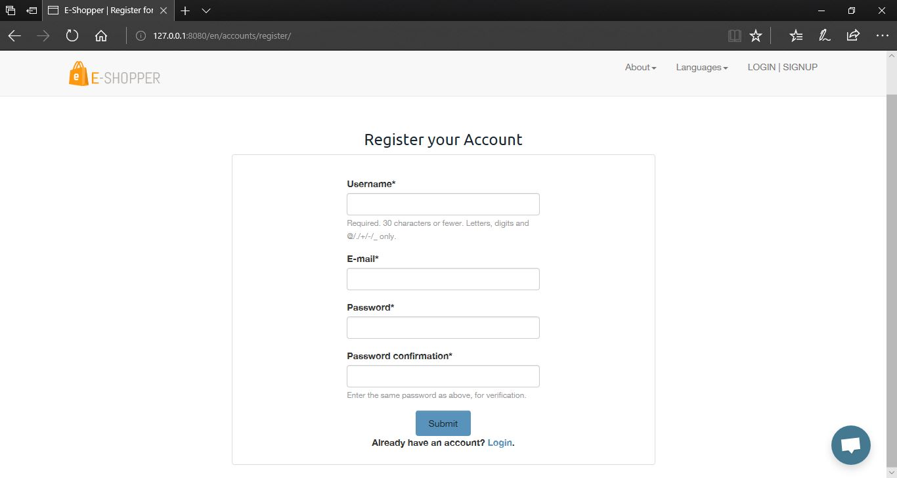

Figure 5.18 Customer Register Account Page

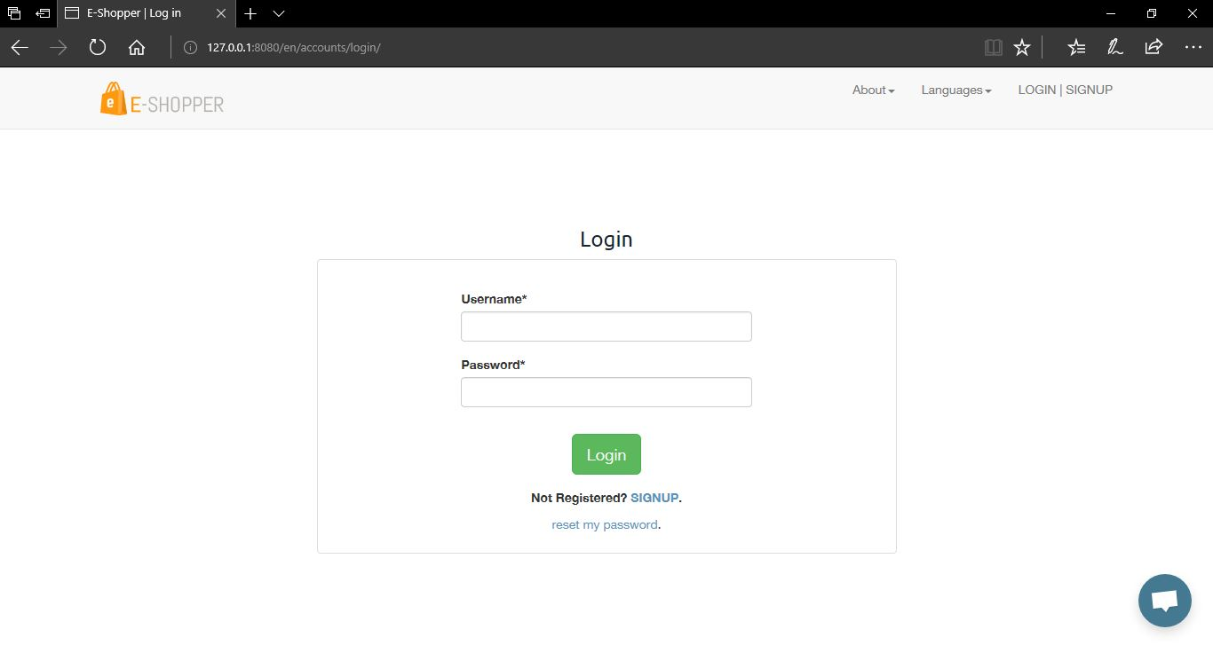

Figure 5.19 Customer Login Page

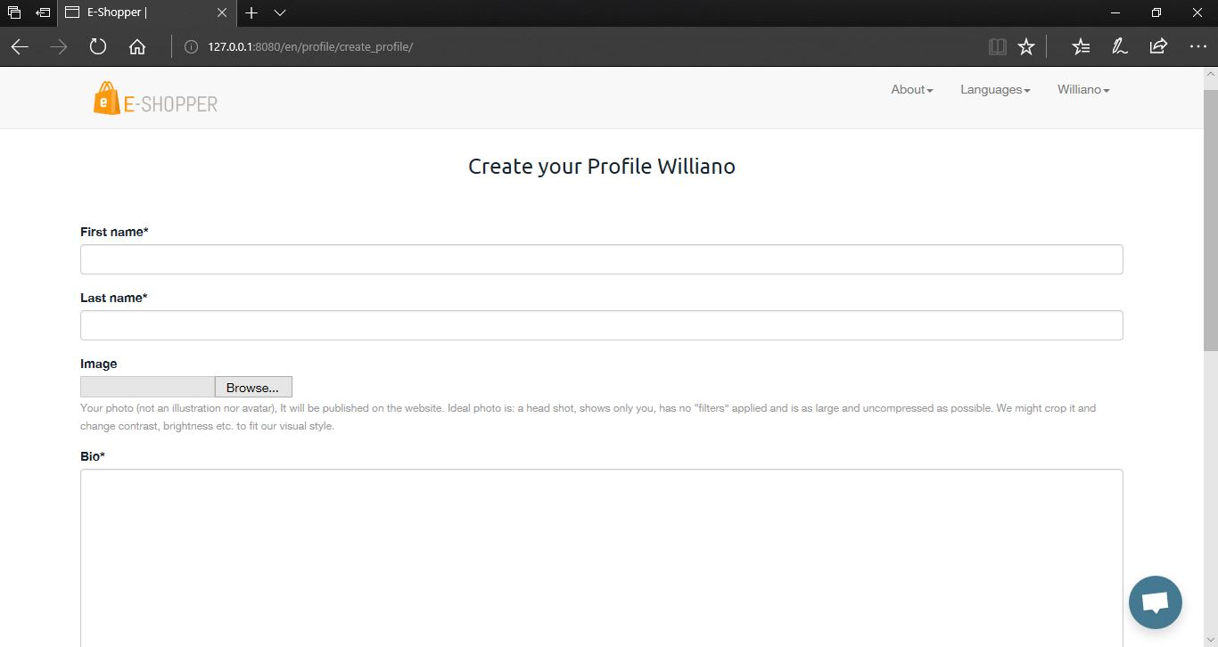

Figure 5.20 Customer Create Profile Page

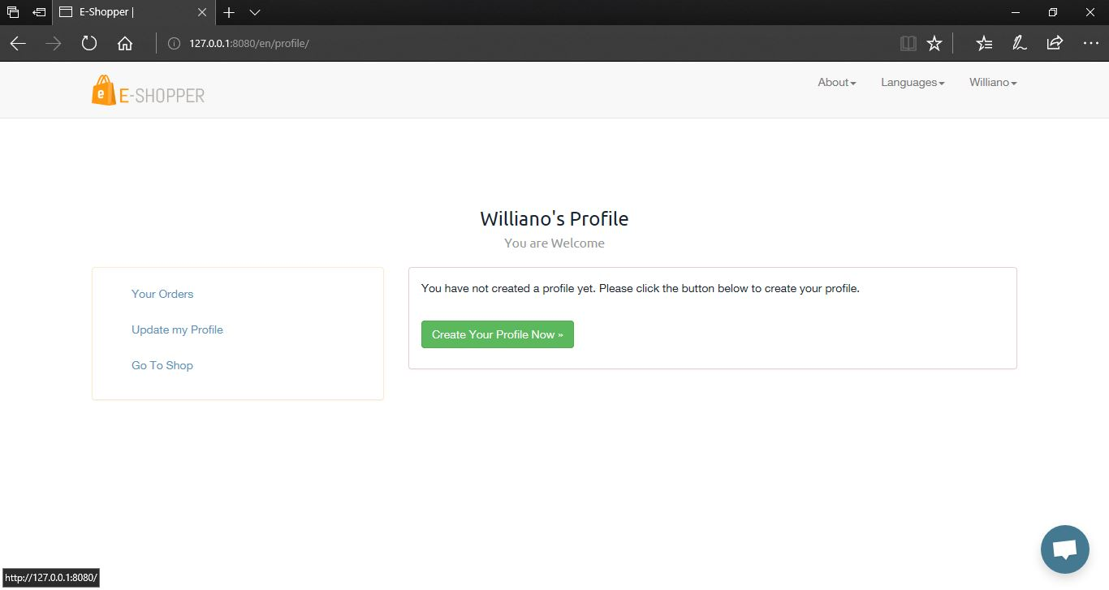

Figure 5.21 Customer Profile Dashboard

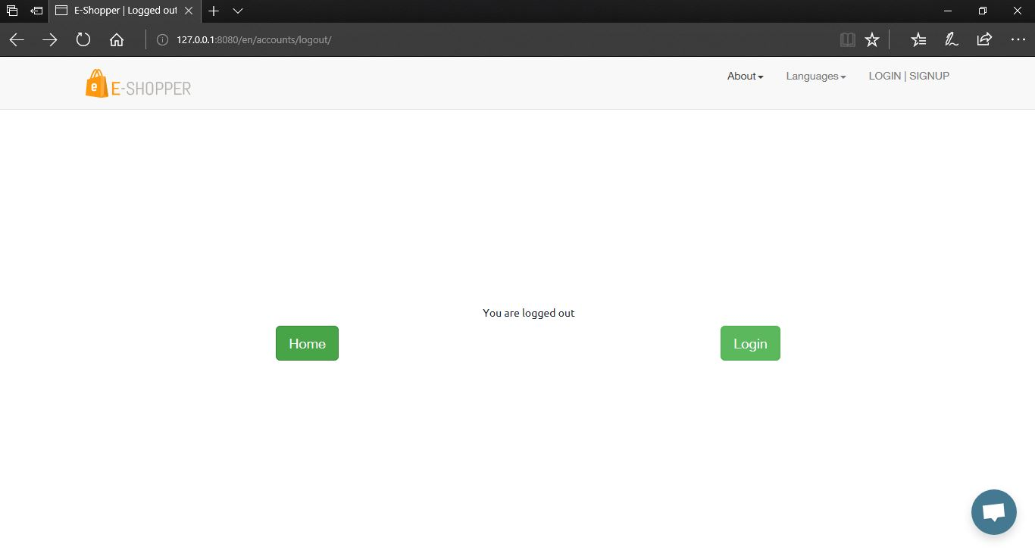

Figure 5.22 Customer Logout Page

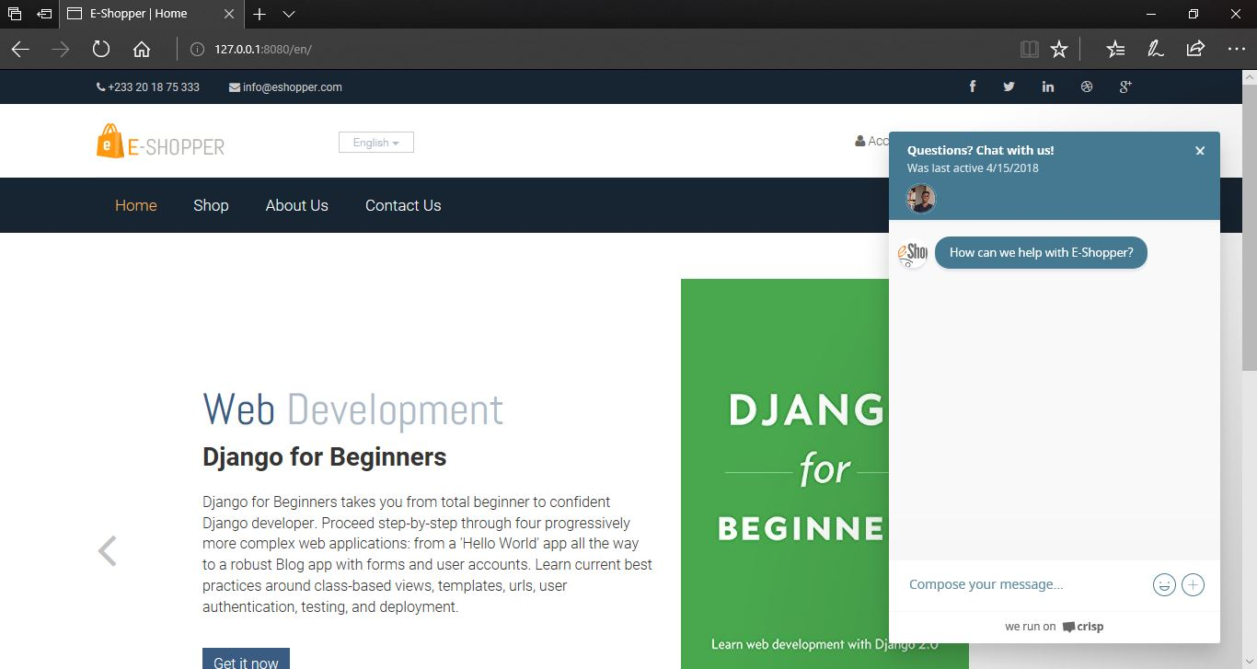

Figure 5.23 Live Chat Support

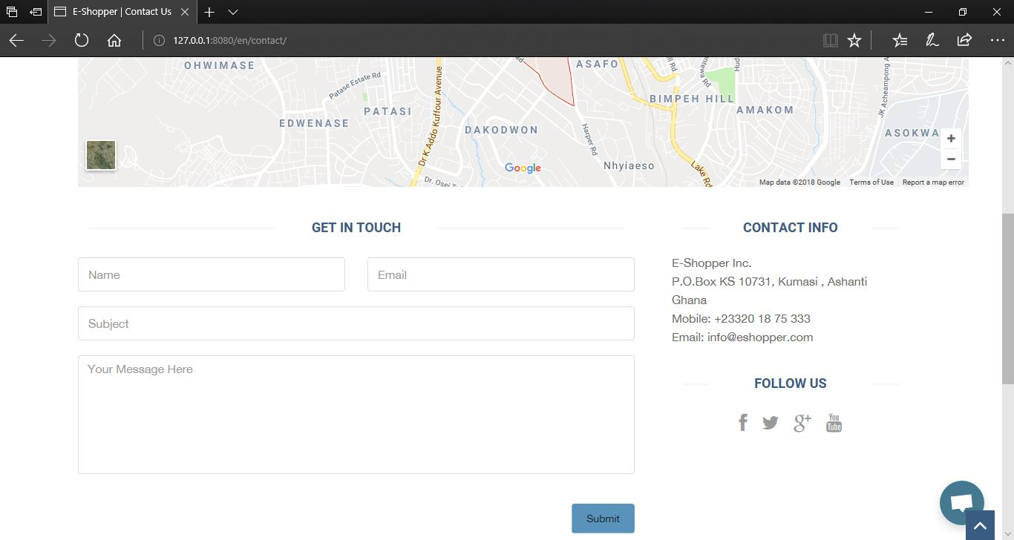
Figure 5.24 Contact Us Page
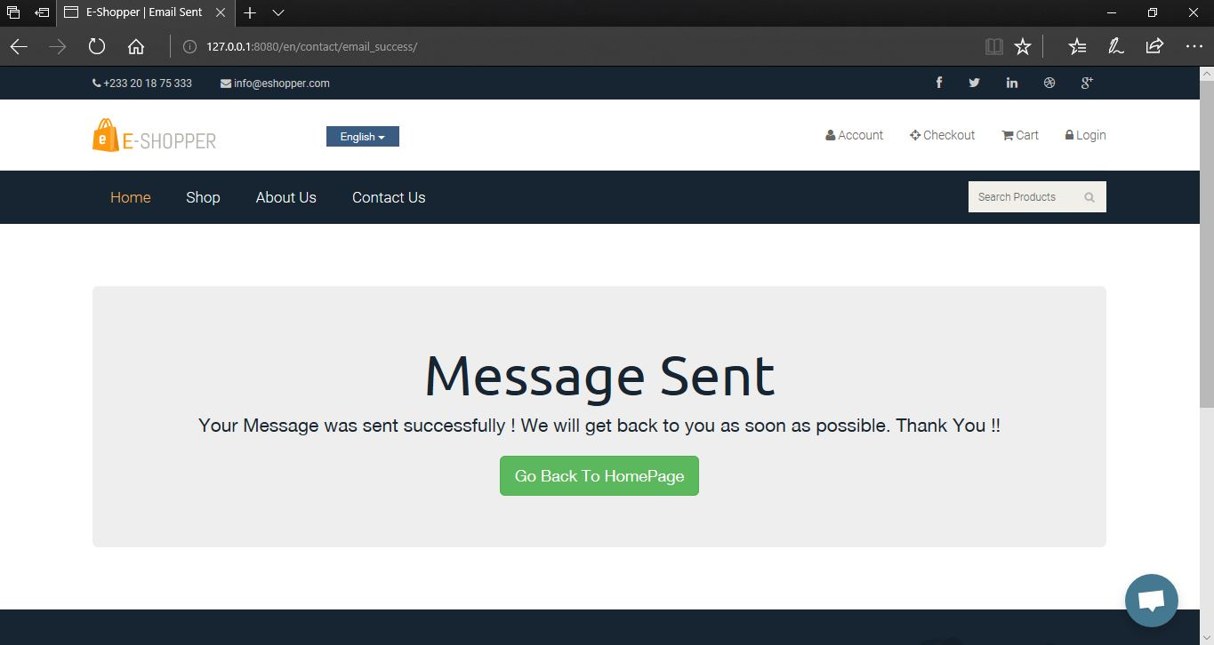

Figure 5.25 Successful Contact Us Message sent page

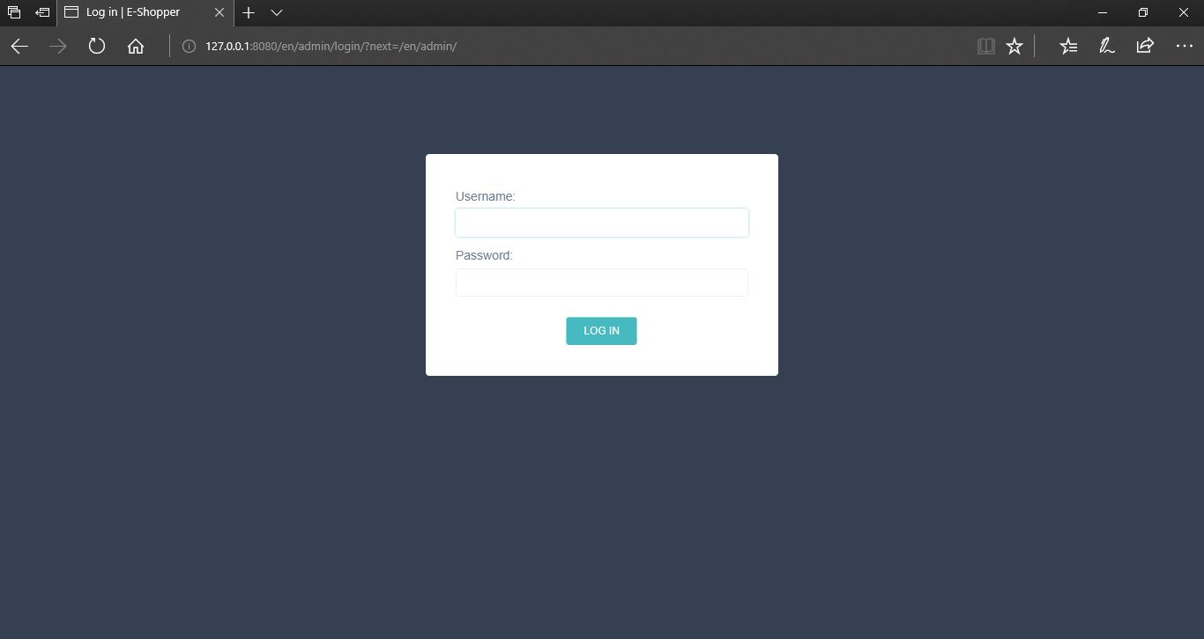
Figure 5.26 Shop Owner or Manager Login Page
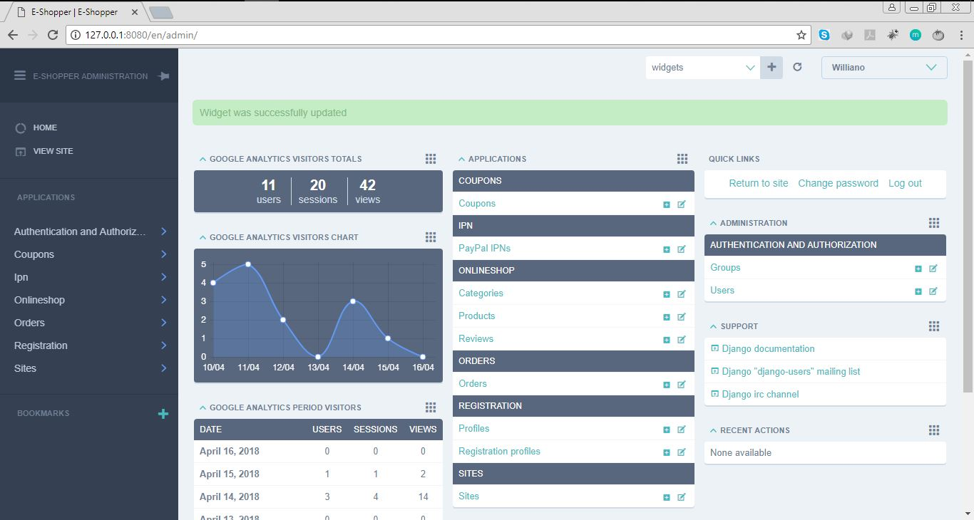

Figure 5.27 Shop Manager or Owner Dashboard to accept orders, add products, add categories, add coupons with Analysis of people visiting the website

5.4 TESTING
After the system developed, process of system testing must be carry on in order to test if the system is free of bugs. If during the system testing, there are bugs or errors detected, the developer may need to correct and fix the bugs immediately.
Testing is the process of evaluating a software or system to detect differences between given input and expected output. Testing is conducted to assess the quality of a system hence can be said to be a validation and verification process. This ensures that system meets the technical requirements that guided its design and development, works as expected and can be implemented with the same characteristics.
There are few types of system testing that must be performed which include the unit testing, integration testing, system testing, and acceptance testing. System testing is not a testing that is limited only to the development team but it also requires the help from specific outsider (beta-tester) to test on the system acceptance.

5.4.1 UNIT TESTING
Unit testing is a testing which requires the developer to test on every single part or component in the system. It is the practice of testing certain functions and areas known as units of a source code. This is important because it helps to verify whether the various units are functioning as expected, hence are returning the proper values, therefore it helps in identifying failures or errors in a source code. Every single step of unit testing will be recorded to the test plan for later testing review purposes. In the unit testing, the testing only involves members from the development team which mean beta-tester is not required.
With this system, various units were tested such as the product order unit, customer registration unit, payment unit among others to ensure they were returning the expected values. This system has two main units; one for the customer and one for the shop owner (manager). The two were tested to ensure that they functioned independently without errors in either of the two units affecting each other. This is relevant because it also helps in ensuring that the various units were error free and working in the most efficient manner.

5.4.2 INTEGRATION TESTING
Integration testing is a testing that must be conduct in order to test the integration between multiple pages of the system. After the unit testing, the entire units are integrated to form a complete system. The purpose of the integration testing is to make sure that there are no defects during the integration of multiple pages or modules. This is to detect inconsistencies between the various units after which system testing is performed on the system as a whole.
It is usually conducted after the unit testing. During the unit testing, the tester might not find any of the errors but it does not mean that the system will totally free of bugs since the system might not properly integrated which causes errors.

5.4.3 SYSTEM TESTING
System testing is a testing that must be conduct in order to test the complete system as a whole. The purpose of system testing is to test the whole application after it is considered completed. System testing is a very important testing since it requires the system to meets the requirements and quality set by the users.
This testing is conducted to evaluate the systems compliance with its specified requirements that is both functional and non- functional requirements.

In conducting system testing, some invalid input was entered into the system such as negative order quantity to ensure the system does not accept such values. This was successful because the system responded by alerting that the input was invalid. Also, the same was done with the date on which the order is to be delivered by entering dates that are past the default date. The system also alerted that the date was invalid. This enforced the fact that the system is validated and will not accept invalid input.
Also, the system’s payment process was tested to ensure that an order is only successful when payment is successful. This also was successful; hence the system performs in harmony with the functional requirements.
With the non-functional requirements, the system is very interactive in that it gives feedback to the user for every required function. The system is also easy to use since it has an easy and friendly looking interface. The system was also tested on other platforms apart from the laptop such as a mobile phone and a tablet, and the system fit onto those devices and functioned well. This proved that the system is also scalable as required.

5.4.4 ACCEPTANCE TESTING
Acceptance testing which will involve the outsider (my supervisor) to test the system in order to find out if the system meets their requirements from all perspectives. Acceptance testing is usually the final testing conducted to ensure the system to be delivered meets the specifications and purpose.
Once the system successfully goes through all the testing, the system will more likely to be delivered to the real world for use.

5.4.3 RESULTS OF TESTING
Below are some screenshots from the various testing we carried out to ensure that the system was functioning in line with the requirements analysis we gathered from users.
When a user is entering his/her details and forgets a field, the system prompts them that the field is required (Figure 5.28). Also, when they try to login into their accounts with wrong credentials, the system prompts them to enter the correct credentials (Figure 5.29). When they are signing up and skip a field, the system prompts them to fill the required field (Figure 5.30).
Also, when a shop manager tries to login into the backend of the system with wrong credentials, the system prompts them to enter the correct credentials.
As stated above, during the system testing, the application did not accept negative inputs.
Below are screenshots of the various system testing:
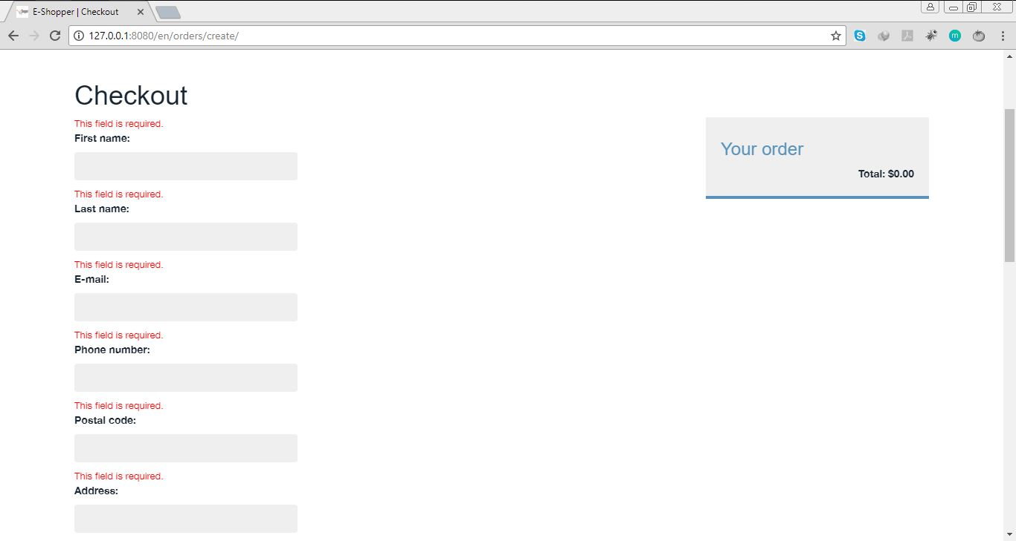

Figure 5.28 Testing for a Customer checkout details.

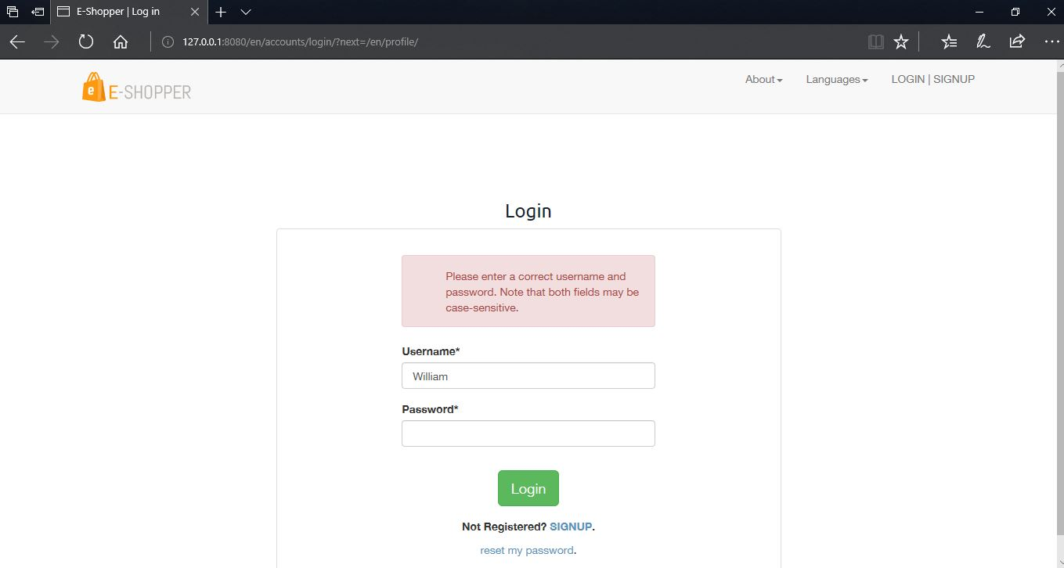Figure 5.29 Testing for a Customer login details.
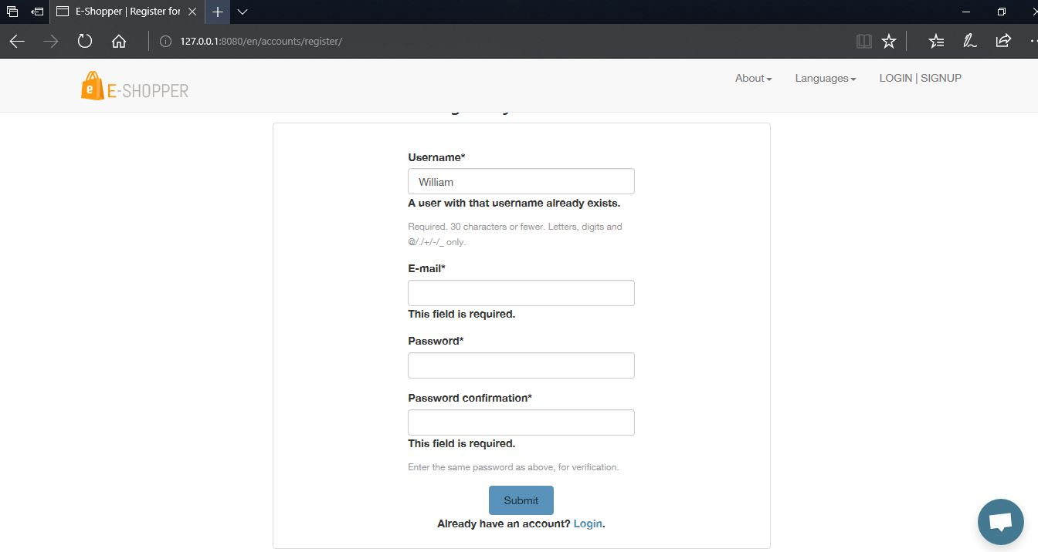

Figure 5.30 Testing for a Customer Register details.

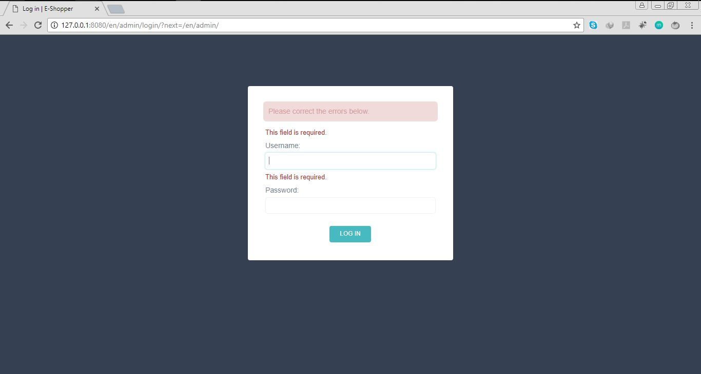

Figure 5.31 Testing to ensure that the admin enters the right login in details.

5.5 EVALUATION OF THE PROJECT
The purpose of evaluation is to assess the system as to whether it does what it is expected to do and if it is working properly. From the testing phase, the system was analyzed to ensure is functioning well according to the specified requirements.
One of the aims for designing and developing the online shop included easing customers of the stress they go through when shopping online. This system provides the solution to that, in that customers in their comfort can choose the language of their choice and place their orders. They also receive email confirming their order has been received and being processed which is very assuring.
The system is said to have an interactive interface which is also easy to use because the various products available are displayed on the shop or product listing page for customers to view and select their choice. The various products (books) have also been sorted into categories such as Web development, Software Engineering, Programming, Data Structures for easy searching and selection. Customers can therefore use the system as first timers without difficulties. These therefore will increase customer satisfaction as perceived in chapter one of this documentation.
Also, a payment system was implement as stated in the project scope. Customers can therefore only have a successful product order after payment has been done.
On the side of shop owners or managers, they can perform some managerial duties with the system such as edit products by adding books available or deleting books unavailable. With Google Analytics added, they can also see the number of people visiting their website. They can also reply to feedbacks from customers by sending them a direct email. They can generate reports in the form of PDF or Excel of the various orders received. This will help them access their performance over a specified period of time.
From the above, a conclusion can be made that from the evaluation of our project, the project meets its overall aim as stated in chapter one which is to design and implement a multi-lingual e-commerce system to enable online shoppers order products.

5.5.1 EVALUATION OF SOLUTION
Testing and evaluating the system has helped to realized that the system serves as a solution to the problem statement in chapter one. All that customers have to do is choose the language of their choice and make their orders without any language barrier. The problem of e-commerce having poor records is also solved. This is because managers can use the application to access reports and status of orders and can also download them in PDF or Excel format for record keeping.
From the above, a conclusion can be made that the system is a solution to the problem aimed to address and solve.

5.5.2 EVALUATION OF METHODOLOGY
The agile method with the incremental software process model was adopted to develop the application as stated in chapter three. This approach best suits E-commerce website development because the application was developed in increments and based on the suggestions of my supervisor, the necessary changes were made until the final phase was reached. This made the development much easier and helped to meet the various user and system requirements.

5.6 CONCLUSION
In this chapter, mapping the logical design onto the physical platform was looked at where the logical database schema was transformed into executable codes. A look at constructions where we the various user interfaces displayed were discussed in the previous chapter. Screen shots of the various forms, reports, etc. were captured under construction. Testing of the whole system was examined. Both unit, integration, system and acceptance testing were performed to ensure the software was working as required. Finally, evaluation of the project where highlights of the various efforts put in place to make this project a success was looked at.

CHAPTER SIX

6.0 FINDINGS AND CONCLUSION

6.1 INTRODUCTION
Findings and conclusion concerns itself with all the information gathered including facts and figures compiled to fulfil the objectives of a research or the development of a project as well as the illations drawn from the findings. Also included is the principal results of a research project as well as what the project suggested or indicated and the interpretations of the relevance of the findings of a project.
This final chapter will consist of findings and conclusion. This will include summary of various problems faced in the development of the system, achievements and challenges, recommendations as well as enhancements that can be made to the system in future.

6.2 SUMMARY OF PROBLEMS
Every research or project has challenges and this project is no exception. A number of problems were encountered during the development of the project. Mobile Money payment is a major payment platform in Africa and my goal was to integrate it into this project to easy payment for users. These major mobile money networks don’t provide an API for developers to interface other apps to use these services. There are third party companies that provide API but in only few programming languages like PHP and Java. I used the Python programming language to develop this project but all the effort to use this API’s was not successful because there was no API for the language. I made an effort to contact them but all of them said there was no API for the Python programming language. Because of this, I had to use PayPal as the only payment gateway to accept payments for both debit and credit cards.
The above were basically the problems encountered while working on this project.

6.3 ACHIEVEMENTS AND CHALLENGES

ACHIEVEMENTS
Through dedication, determination, effort, skill and hard work a number of successes and achievements were achieved these are stated below:
- Working alone has helped me to develop new skills like completing a project within a specific time. I used to do a lot of side projects but never finished any of them but this project has taught me to break-up projects into smaller pieces and accomplished them within a specific time.
- The development of the project required the use of a Python framework known as Django and also a database known as Postgresql which my first time of was using them but I was able to learn and use it for the development of the project. This have therefore helped me to enhance my knowledge and programming skills.
- Implementing the online shop in different languages was the ultimate goal for this project. This is an achievement because the main motivations for undertaking this project included making online shopping easy for shoppers and shop owners. By means of internationalization and localization that problem is tackled.

6.3.2 CHALLENGES
- Although the development of the project was a success, a number of challenges were encountered as well because every research or project has challenges and this project is no exception.
These include:
- One of the challenges faced was to complete the project on time. This is as a result of the fact that I had to make time for classes, mid-semester exams, final examinations and also for developing the project.
- Implementing the Mobile Money Payment system was the biggest challenge of this project. This was very difficult from the onset because there was no API’s for the Python programming language.

6.4 FUTURE WORK
In future, I hope to delve more into the integration of Mobile Money payments. This is because the payment aspect of the system does not offer this to the user. The hope is to expand the choices available to the shoppers. Also, I hope to add multiple currency to make users choose the currency of their choice before they start shopping.

6.5 RECOMMENDATIONS
Recommendations involve additions, suggestions or courses of actions that could be added to the project in the future.
Some recommendations for the system include:
- The project is purely web-based hence we recommend that a mobile version could be developed to make it more convenient for users to use especially now that mobile devices are abundant.
- Another recommendation is that more payment options should be added especially for the mobile money section. We have options only for either debit or credit cards hence limiting those who can use the application.
- Adding multiple currencies for user to choose their currency of choice before they start shopping is one recommendation for future works.

6.6 CONCLUSION
The Internet has become a major resource in modern business, thus electronic shopping has gained significance not only from the entrepreneur’s but also from the customer’s point of view. For the entrepreneur, electronic shopping generates new business opportunities and for the customer, it makes comparative shopping possible.
As per a survey, most consumers of online stores are impulsive and usually make a decision to stay on a site within the first few seconds. “Website design is like a shop interior. If the shop looks poor or like hundreds of other shops the customer is most likely to skip to the other site.
Hence, the project has been designed to provide the user with easy navigation, retrieval of data and necessary feedback as much as possible. In this project, the user is provided with a multi-lingual ecommerce web site that can be used to buy books online. To implement this as a web application Django was used as the Technology. Django has several advantages such as enhanced performance, scalability, built-in security and simplicity.
To build any web application using the Django framework, the programming language needed is Python. Python was the language used to build this application. For the client browser to connect to the Django framework, Web Server Gateway Interface (WSGI) was used as the Web Server.
Django uses Object-Relational Mapping (ORM) to interact with the database as it provides in-memory caching that eliminates the need to contact the database server frequently and helps protect against SQL injection attack. PostgreSQL was used as back-end database since it is one of the most popular and open source databases, and it provides fast data access, easy installation and simplicity.
A good shopping cart design must be accompanied with user-friendly shopping cart application logic. It should be convenient for the customer to view the contents of their cart and to be able to remove or add items to their cart. The shopping cart application described in this project provides a number of features that are designed to make the customer more comfortable. This project helps in understanding the creation of an interactive web page and the technologies used to implement it. The design of the project which includes Data Model and Process Model illustrates how the database is built with different tables, how the data is accessed and processed from the tables.
The building of the project has given me a precise knowledge about how Django is used to develop a website, how it connects to the database to access the data and how the data and web pages are modified to provide the user with a shopping cart application.

REFERENCES
10ecommercetrends. (2017, November 20). 10 Ecommerce Trends 2017. Retrieved from 10 Ecommerce Trends : http://10ecommercetrends.com/
Ahiabenu, K. (2017, November 15). How can e-commerce transform your business? Retrieved from Graphic Online: https://www.graphic.com.gh/features/opinion/how-can-e-commerce-transform-your-business.html
Amazon (company). (2017, November 20). Retrieved from Wikipedia: https://en.wikipedia.org/wiki/Amazon_(company)
ARM Worldwide . (2017, November 17). What are the E-Commerce Tech Trends in 2018. Retrieved from ARM Worldwide: https://armworldwide.com/e-commerce-tech-trends/
Boampong, P. B. (2017, November 13). Breakthrough of E-commerce in Ghana. Retrieved from Ghana Web: https://www.ghanaweb.com/GhanaHomePage/NewsArchive/Breakthrough-of-E-commerce-in-Ghana-347247
Codecademy. (2018, April 05). MVC: Model, View, Controller. Retrieved from Codecademy: https://www.codecademy.com/articles/mvc
Django Software Foundation. (2017). Django Documentation. USA: Django Software Foundation.
Django Stars. (2018, January 15). Why We Use Django Framework. Retrieved from Django Stars: https://djangostars.com/blog/why-we-use-django-framework/
eCommerce Report: Ghana’s Top 20 eCommerce Websites. (2017, November 22). Retrieved from Modern Ghana: https://www.modernghana.com/news/640481/ecommerce-report-ghanas-top-20-ecommerce-websites.html
Frederick, J. (2017, November 22). 4 Emerging Ecommerce Technology Innovations. Retrieved from PFS Web: http://www.pfsweb.com/blog/4-emerging-ecommerce-technology-innovations/
Gary, H. (2017, November 22). 15 Must-Have Features for E-commerce Sites. Retrieved from Search Engine Journal: https://www.searchenginejournal.com/15-must-have-features-for-e-commerce-sites/181974/
Gaur, R. (2018, April 05). Software Architecture: One-Tier, Two-Tier, Three Tier, N Tier. Retrieved from TECHYNEWS4U: https://techynews4u.com/software-architecture-one-tier-two-tier-three-tier-n-tier/
George, N. (2017). Build your first website with Python and Django. Hamilton NSW, Australia: GNW Independent Publishing.
Inflectra. (2018, April 06). What are System Requirements Specifications/Software (SRS)? Retrieved from Inflectra: https://www.inflectra.com/ideas/topic/requirements-definition.aspx
Investopedia. (2017, November 20). Business To Consumer - B To C. Retrieved from Investopedia: https://www.investopedia.com/terms/b/btoc.asp
Kramek, A. (2018, April 05). Introduction to Client Server Architecture. Retrieved from Foxite: http://weblogs.foxite.com/andykramek/2008/09/29/introduction-to-client-server-architecture/
Mele, A. (2015). Django By Example . BIRMINGHAM - MUMBAI: Packt Publishing.
Miva. (2017, November 26). The History Of Ecommerce: How Did It All Begin? Retrieved from Miva: https://www.miva.com/blog/the-history-of-ecommerce-how-did-it-all-begin/
Nicole, F. (2016, April 5). 4 Issues Your E-Commerce Business Needs to Address. Retrieved from Business News Daily: https://www.businessnewsdaily.com/8947-research-roundup-ecommerce-issues.html
Nige, B. (2018, January 15). Why Django? Retrieved from Django Book: https://djangobook.com/tutorials/why-django/
Openhatch. (2018, April 05). Django for Designers/Basic views. Retrieved from Openhatch: http://wiki.openhatch.org/Django_for_Designers/Basic_views
Opoku, J. (2017, November 25). Setting up an e-commerce business in Ghana. Retrieved from Sidekick Gh: https://www.sidekickgh.com/setting-up-an-e-commerce-business-in-ghana/
Opoku, J. (2017, October 17). Why Responsive Websites are Awesome. Retrieved from Sidekick Gh: https://www.sidekickgh.com/why-responsive-websites-are-awesome/
Post, J. (2017, December 19). How to Beat 4 Big Challenges for Small E-Commerce Retailers. Retrieved December 19, 2017, from Business News Daily: https://www.businessnewsdaily.com/6028-small-ecommerce-challenges.html
Rajkumar. (2018, April 05). Software Architecture: One-Tier, Two-Tier, Three Tier, N Tier. Retrieved from SoftwareTestingMaterial: https://www.softwaretestingmaterial.com/software-architecture/
Sheppy. (2018, January 17). CSS: Cascading Style Sheets. Retrieved from MDN web docs: https://developer.mozilla.org/en-US/docs/Web/CSS
SmartDraw. (2018, April 09). Entity Relationship Diagram. Retrieved from SmartDraw: https://www.smartdraw.com/entity-relationship-diagram/
Smith, L. (2018, January 25). What PostgreSQL has over other open source SQL databases: Part I. Retrieved from Compose: https://www.compose.com/articles/what-postgresql-has-over-other-open-source-sql-databases/
studytonight. (2018, April 09). Normalization of Database. Retrieved from studytonight: https://www.studytonight.com/dbms/database-normalization.php
Tawiah, A. (2017, November 22). Ghana’s Top 12 eCommerce Websites. Retrieved from IT News Africa : http://www.itnewsafrica.com/2015/09/ghanas-top-12-ecommerce-websites/
Team, P. C. (2017, November 23). 7 Key Features Online Shoppers Demand From an Online Store. Retrieved from PinnacleCart: https://www.pinnaclecart.com/blog/7-key-features-online-shoppers-demand-from-an-online-store/
The Editors of Encyclopaedia Britannica. (2018, April 06). Database. Retrieved from Britannica: https://www.britannica.com/technology/database
Visual Paradigm. (2018, April 06). What is Unified Modeling Language (UML)? Retrieved from Visual Paradigm: https://www.visual-paradigm.com/guide/uml-unified-modeling-language/what-is-uml/
Wikibooks. (2017, December 21). Introduction to Computer Information Systems/E-Commerce. Retrieved from Wikibooks: https://en.wikibooks.org/wiki/Introduction_to_Computer_Information_Systems/E-Commerce#Manufacturer_and_E-Tailer_Sites
Wikipedia. (2018, April 09). User interface design. Retrieved from Wikipedia: https://en.wikipedia.org/wiki/User_interface_design

APPENDIX
Code for Database Tables for Categories, Products, and Product reviews

from django.db import models
from parler.models import TranslatableModel, TranslatedFields
from django.core.urlresolvers import reverse

class Category(TranslatableModel):
translations = TranslatedFields(
name=models.CharField(max_length=200, db_index=True),
slug=models.SlugField(max_length=200, db_index=True, unique=True)
)

class Meta:
# ordering = ('name',)
verbose_name = 'category'
verbose_name_plural = 'categories'

def __str__(self):
return self.name

def get_absolute_url(self):
return reverse('onlineshop:product_list_by_category', args=[self.slug])

class Product(TranslatableModel):
translations = TranslatedFields(
name=models.CharField(max_length=200, db_index=True),
slug=models.SlugField(max_length=200, db_index=True),
description=models.TextField(blank=True)
)
category = models.ForeignKey(Category, related_name='products')
image = models.ImageField(upload_to='products/%Y/%m/%d', blank=True)
price = models.DecimalField(max_digits=10, decimal_places=2)
stock = models.PositiveIntegerField()
available = models.BooleanField(default=True)
created = models.DateTimeField(auto_now_add=True)
updated = models.DateTimeField(auto_now=True)

class Meta:
ordering = ('available',)
# index_together = (('id', 'slug'),)

def __str__(self):
return self.name

def get_absolute_url(self):
return reverse('onlineshop:product_detail', args=[self.id, self.slug])

# Model for Product Reviews

class Review(models.Model):
product = models.ForeignKey(Product, related_name='reviews')
name = models.CharField(max_length=100)
email = models.EmailField()
body = models.TextField()
created = models.DateTimeField(auto_now_add=True)
updated = models.DateTimeField(auto_now=True)
active = models.BooleanField(default=True)

class Meta:
ordering = ('created',)

def __str__(self):
return 'Review by {} on {}'.format(self.name, self.product)

Code for Views of the product list (shop) page and product details page.
from django.shortcuts import render, get_object_or_404
from django.core.paginator import Paginator, EmptyPage, PageNotAnInteger
from cart.forms import CartAddProductForm
from .models import Category, Product, Review
from .forms import ReviewForm
from .recommender import Recommender

def product_list(request, category_slug=None):
category = None
categories = Category.objects.all()
products = Product.objects.filter(available=True)
if category_slug:
language = request.LANGUAGE_CODE
category = get_object_or_404(Category, translations__language_code=language,
translations__slug=category_slug)
products = products.filter(category=category)
cart_product_form = CartAddProductForm()
return render(request, 'onlineshop/product/product-list.html',
{'category': category,
'categories': categories,
'products': products,
'cart_product_form': cart_product_form,
})

def product_detail(request, id, slug):
language = request.LANGUAGE_CODE
product = get_object_or_404(Product, id=id, translations__language_code=language,
translations__slug=slug, available=True)
# List of active comments for this product.
reviews = product.reviews.filter(active=True)

if request.method == "POST":
# A review form was posted.
review_form = ReviewForm(request.POST)
print(review_form)
if review_form.is_valid():
# Create Review object but do not save to database yet.
new_review = review_form.save(commit=False)
# Assign the current product to the review
new_review.product = product
# Save the review to the database
new_review.save()
else:
review_form = ReviewForm()

cart_product_form = CartAddProductForm()
r = Recommender()
recommended_products = r.suggest_products_for([product], 3)
return render(request, 'onlineshop/product/product-detail.html', {'product':product,'reviews': reviews, 'review_form': review_form,
'cart_product_form': cart_product_form, 'recommended_products': recommended_products})

Code for Database Tables for Orders, Products, and Product reviews

from django.db import models
from onlineshop.models import Product
from decimal import Decimal
from django.core.validators import MinValueValidator, MaxValueValidator, RegexValidator
from django.utils.translation import gettext_lazy as _
from coupons.models import Coupon

class Order(models.Model):
phone_regex = RegexValidator(regex=r'^\+?1?\d{9,15}$', message="Phone Number must be entered in the format: "
"'+999999999'. Up to 15 digits allowed.")
email_regex = RegexValidator(regex=r'^[a-zA-Z0-9_.+-]+@[a-zA-Z0-9-]+\.[a-zA-Z0-9-.]+$')

first_name = models.CharField(_('first name'), max_length=50, blank=False)
last_name = models.CharField(_('last name'), max_length=50, blank=False)
email = models.EmailField(_('e-mail'), validators=[email_regex], blank=False)
phone_number = models.CharField(_('phone number'), validators=[phone_regex], max_length=17, blank=False)
address = models.CharField(_('address'), max_length=250, blank=False)
city = models.CharField(_('city'), max_length=100, blank=False)
state_or_region = models.CharField(_('state or region'), max_length=100, blank=False)
postal_code = models.CharField(_('postal code'), max_length=5, blank=False)
country = models.CharField(_('country'), max_length=100, blank=False)
created = models.DateTimeField(_('created'), auto_now_add=True)
updated = models.DateTimeField(_('updated'), auto_now=True)
paid = models.BooleanField(_('paid'), default=False)
coupon = models.ForeignKey(Coupon, related_name='orders', null=True, blank=True)
discount = models.IntegerField(_('discount'), default=0,
validators=[MinValueValidator(0),
MaxValueValidator(100)])

class Meta:
ordering = ('-created',)

def __str__(self):
return 'Order {}'.format(self.id)

def get_total_cost(self):
total_cost = sum(item.get_cost() for item in self.items.all())
return total_cost - total_cost * (self.discount / Decimal('100'))

class OrderItem(models.Model):
order = models.ForeignKey(Order, related_name='items')
product = models.ForeignKey(Product, related_name='order_items')
price = models.DecimalField(max_digits=10, decimal_places=2)
quantity = models.PositiveIntegerField(default=1)

def __str__(self):
return '{}'.format(self.id)

def get_cost(self):
return self.price * self.quantity

